


Version 1.3(E)

CONTENTS
1. Deployments - October To December 2011 7
1.1 Employee Information Screen 7
1.2 Calculate Income Tax 7
1.3 Hindi Incentive Payment thru Over and Above Payments 8
1.4 Medical Claim Bills 8
1.5 Computation of 25% increase in allowances for IDA III and IV employees on DA Revision more than 50 % DA 8
1.6 Earning and deduction report can be taken out category wise 8
1.7 Income tax report category wise 9
1.8 Hindi first in pay slip. Cadre and FPS No also shown in the report 9
1.9 Invoice Report - New Report to print individual invoice 9
1.10 Single report for Income tax deductions from Income Tax from Salary, Other Payments and Incentive 9
1.11 Maintain Work-slip detail 9
1.12 Deduction entry thru Maintain Direct Payroll during Incentive stage 9
1.13 CPF Deduction on OTA Incentive for Departmental Labour 10
1.14 Double OTA on Holiday 10
1.15 ATTENDANCE DETAILS 10
1.15.1 Maintain Handling Attendance 10
1.15.2 Maintain Ancillary Attendance 12
1.16 Employee Separation & Final Settlement for Employee/DPS/Dept. Labours 14
1.17 Maintain DPS/DEPT Labour Details / DPS/DEPT Admin Screen 16
1.18 Maintain Gang Details (DPS & Dept) 18
1.19 DPS Labour SOR Information 20
1.20 Pay Image Details. 22
1.21 Labour incentive details report (DPS/Dept.) 24
1.22 Labour incentive computation details report (DPS/Dept.) 25
1.23 Form 16 Report 26
1.24 IT Forecast Report 27
1.25 Last Pay Certificate Report 28
1.26 Online Pay Slip Report 29
1.27 PLI Payment Report 30
1.28 Remittance Invoice Report 31
1.29 Salary Invoice Report 32
1.30 Maintain External Savings 33
1.31 Maintain Internal Savings 35
1.32 Maintain Loan Fore closure 37
1.33 Maintain Loan Rescheduling 39
1.34 Maintain Loan/Advance Details 42
1.35 Initialize Payroll Data 44
1.36 Create Pay Roll Transaction 46
1.37 .Monthly Payroll 47
1.38 Generate Basic Arrear 48
1.39 Compute Income Tax 50
1.40 Perform Month End Update 51
1.41 Post Salary Invoices to AP 52
1.42 Undo Payroll Transactions 53
1.43 Initialize Actual Work Done (DPS/ Dept) 54
1.44 Calculate Dept Labour Incentive 55
1.45 Calculate DPS Piece Rate Wage 56
1.46 Perform Month End for Incentive (DPS/ Dept) 57
1.47 Perform Month End for Work Done (DPS) 57
1.48 Post Incentive to AP (Dept) 58
1.49 Post Work Done Invoices to AP (DPS) 59
1.50 Incentive Undo Incentive (Dept) 60
1.51 Undo Actual Work done (DPS) 61
1.52 Post Remittances to AP (Dept) 62
1.53 Post Remittances to AP (DPS) 63
1.54 Post Year End Remittances to AP (DPS) 64
1.55 Supplementary Payment 65
Note:- 68
2. Deployments - January 2012 69
2.1 Population percentage added in Lease accommodation 69
2.2 PAN no duplicity check 69
2.3 Employee separation process 69
2.4 Medical Claim validation 69
2.5 Leave Functionality in DPS Labour 69
2.6 Work slip entry mandatory on transfer from one Depot or DO. 70
2.7 CPF Final payment calculation 70
2.8 CPF interest on intervening period calculation 70
3 Deployments – February 2012 71
3.1 Work slip entry modifications to facilitate easy data entry. 71
3.2 Transfer functionality in DPS 71
3.3 CPF yearend Interest calculation for the financial year 2011-12 completed for Employee. 72
4 Deployments – March 2012 to 15th May 2012 73
4.1 Compute Income Tax 73
4.2 CPF update for Supplementary payments 73
4.3 Bulk Reimbursement Screen 73
4.4 Last pay Certificate 74
4.5 Lease Accommodation 74
4.6 Workslip Entry 74
4.7 EPS Separations 74
4.8 Special Compensatory Allowance 74
4.9 Remittances and Income Tax report having minor difference of Rs1,2,3 etc. 74
4.10 The remittances for FCI Deputation Expense 74
4.11 CPF to be deducted in advance for 3 months before retirement. 75
4.12 Nominee and Dependent Details 75
4.13 CPF Stop/Start 75
4.14 Leave Encashment 77
5 Deployments – 16th May2012 to 31st July 2012 79
5.1 Income Tax Calculation Sheet 79
5.2 Transport Rebate entry screen 79
5.3 Changes in supplementary payment screen 79
5.4 Changes in Over and above payment screen 79
5.5 Changes in Maintain Direct Payroll screen 79
5.6 Changes in Internal savings screen 80
5.7 Release incentive thru release salary screen 80
5.8 Changes in Other payments Screens for DPS and Departmental Labour 80
5.9 Changes in Attendance Screen DPS and Departmental Labour 80
5.10 Gang in Labour Information Screen 80
5.11 Changes in pay Code vs Agency Code map screen 81
5.12 Invoice Report for DPS and Departmental labour 81
5.13 No CPF Deduction on Non-paid holiday 81
5.14 Labour Payslip for a Deport or a Gang 81
5.15 Separate Earning and Deduction Reports for Transferred / Suspended employees after Release Salary 81
5.16 Calculation of hourly rate for OTA in case of DPS Labour 81
5.17 Payment of MGW in DPS Labour 82
5.18 Temporary Advance Limit in DPS Labour 82
5.19 Correction in first Sunday marking for split week in DPS Labour 82
6 Deployments – 01st Aug 2012 to 30st Nov 2012 83
6.1 Pay Slip Report for DPS Labors 83
6.2 Changes in MDP Bulk 83
6.3 Maintain Leave Detail for Departmental & DPS labors. 83
6.4 Employee Master Search 83
6.5 Work slip of Departmental & DPS labors 83
6.6 Labor Attendance for Departmental & DPS labors 83
6.7 Release Incentive for Departmental and DPS labors in Employee separation. 84
6.8 Festival Advance validation modified for labors 84
6.9 PLI Advance Payment through PLI Screen 84
6.10 Quarterly E - returns through Discoverer 84
6.11 Release Incentive in Case of Transfer of labors 84
6.12 Maintain Employee Promotion/Reversal for DPS Labours 84
6.13 Maintain Employee Suspension/Revocation for DPS Labours 86
6.14 DPS Labour ASOR Details 87
6.15 Perform Single Month-end (DPS) 89
6.16 LIC Recovery Report (EMPLOYEE/DPS/DEPT) 90
6.17 Miscellaneous Schedule Report/Bank Loan /FCI Society Recovery Report for (EMPLOYEE/DPS/DEPT) 91
6.18 Earning Deduction Report (Departmental/DPS) 93
1. Labour salary earning detail 93
2. Labour salary earning summary 93
3. Labour salary deduction detail 93
4. Labour salary deduction summary 93
5. Actual work done/incentive earning detail 93
6. Actual work done/incentive earning summary 93
7. Actual work done/incentive deduction detail 93
8. Actual work done/incentive deduction summary 93
6.19 Pay Slip (DPS/Dept.) 94
6.20 Unmatched CPF Details 95
6.21 PF Slip Report 97
6.22 Final Bill. 99
6.23 CPF slip. 101
6.24 Calculate Interest 102
6.25 View Parameter 104
1. View PF Interest Rate. 105
7 Deployments – 1st Dec 2012 to 28th Feb 2013 107
8 Deployments – 1st March 2013 to 31st March 2013 108
8.1 Promotion from category 3 to category 2 in deployment cases 108
9 Deployments - – 1st April 2013 to 30th April 2013 109
9.1 Leave functionality in departmental labour 109
9.2 Basic arrear incentive in departmental labour 109
9.3 Suspension in departmental labour 109
10 Deployments – 1st May 2013 to 31st May 2013 110
10.1 CPF Schedule – eSeva 110
11 Deployments – 1st June 2013 to 30th June 2013 111
11.1 Handling of deduction more than earning 111
11.2 Posting date of remittance should be last day of the month. 111
11.3 Professional tax handling in labour. 111
11.4 Lease accommodation for dept. labour. 111
12 Deployments – 1st July 2013 to 31st July 2013 112
12.1 Employee Penalty 112
12.2 CR-161 (Employee to Supplier creation process automation) 112
12.3 CPF Approval/Rejection 112
12.4 Zone Surrender 112
12.5 Employee Joining (Transfer) 113
12.6 Employee Selection Grade/Reversal 116
12.7 Employee Separation and Compute Final Settlement 119
12.8 Maintain Employee Suspension/Revocation 122
12.9 PM Relief Fund 127
13 Deployments – 1st Aug 2013 to 31st Aug 2013 128
13.1 Arrear Report (DEPARTMENTAL LABOURS) 128
13.2 Over and Above Arrear 129
12.View Location Details 133
13.Maintain Employee Designation For 6th Pay 134
14.Maintain Interest Rates of Loan 135
15.Miscellaneous Allowance Six Pay 136
16.Special Compensatory Allowance 6 pc 136
17.View City Type and Location Mapping 137
18.Lease Accommodation Details 138
19.Loan/Advance Details(Admin) 139
20.Loan/Advance Details(Bulk) 140
21.Loan/Advance Details(Super User) 141
22.Maintain Direct Payroll transaction(Bulk) 142
23.Post Year End Remittances to AP 144
24.Arrear Payment(LE) 144
25.IT Supplimentary Payment Report 146
26.Advance Outstanding Report 146
27.Loan Outstanding Report 147
28.Loan Sanctions Report 148
29.Loan/Advance Sanctions Report 148
30.DA/HRA ARREAR Report 149
31.Maintain Cafeteria Approach Details 149
32.Employee Transfer 150
33.Maintain Employee Details 151
34.Maintain Employee Details(Super User) 152
35.Employee Increment Information 153
36.Maintain Employee Leave 154
37.Employee Reinstate details 156
38. Maintain Location Details 157
39.Maintain DA Rates 158
40.Maintain Employee Designation 159
41.Maintain HRA Rates 160
42.Maintain Pay Codes 161
43.Maintain Pay Scale 161
44.Maintain Transport Allowance 162
45.Maintain House Rent Receipt Details 163
46.Medical Reimbursement ( Bulk) 164
47.Generate DA/HRA ARREAR 166
48.Arrear Payments 167
49.LTC Encashment 168
50.OTA Payment 169
51.Over & Above Payment 170
52.PLI Payment 171
53.Supplementary Payment 172
54.Maintain Direct Payroll Audit Report 174
55.Medical Register Report 175
56.Pay Not Drawn Details 175
57.BF Recovery Report 176
58. License Fee Recovery Report 177
59.Medical Health Scheme Deduction Report 177
60.CPF Deduction Report 178
61.Monthly PF Detail Report 179
62.Professional Tax Schedule Report 179
63.Deduction Details Report 180
64.Deduction Depot wise Report 181
65.Earnings Details Report 181
66. Generate Pay Slip Report 182
Note: 183
Payslip report of the separated employees will not be available after they are made inactive in the system. 183
67.Salary Control Register Report 183
68.Maintain Annual Income 183
69.Maintain Detail Income 184
70.Maintain External Savings 185
71.Maintain Internal Savings 186
72.Maintain Transport Rebate 187
73.Employee Promotion/Reversal Information 188
74.Maintain Suspension /Absconding/ Revocation Information 188
75.Part-Final can be sanctioned under following Reason head. 189
76.System Generated Sanction Number. 189
78.Define Cafeteria Approach. 190
80. LOAN AND ADVANCES ADJUSTMENT SCREEN 192
81. CPF Supplementary Payment 195
82. Online I.T. Forecast Report 197
83. Online Salary Control Register Report 198
84. Calculate Labour Incentive 200
85. Labor Incentive Details (Departmental/DPS) 201
86. IOCPF advice and sanction order reports to be generated in the system for CPF Advance, Part final and final payment. 204
87. Deployments – 1st July 2014 to 31st July 2014 209
88. Deployments – 1st February 2019 to 28th February 2019 210
89. PLI Adjustment Screen. 213
90. REPORT. 217
91. MODIFICATION IN ANNUAL INCREMENT. 219
92. reports Moved from Discoverer to Oracle Apps. 222
93. ADDITIONAL FIELD IN FAP MAINTAIN EMPLOYEE DETAIL. 223
94. TO GENERATE REPORT FOR NPS. 224
95. MODIFICATION IN FCI PENSION DETAIL REPORT. 225
96. FIELD IN FAP MAINTAIN EMPLOYEE DETAIL (SCREEN) AS NPS PAYMENT,PRAN NO.. 226
97. TO INSERT PRAN AND MEMBER ID COLUMN IN EMPLOYEE MASTER QUERY REPORT.. 227
98. AMENDMENTS IN INCOME TAX ACT MADE VIDE FINANCE ACT, 2023.. 228
99.HRMS PAYROLL INTEGRATION 229

Deployments - October To December 2011

Employee Information Screen

For category I employees the FPS/EPS number is generated with prefix ‘HH’.

For category II, III, IV, FPS/EPS number is generated with first character of parent zone as pre-fix. The following pre-fix is assigned:

North Zone -‘NN’
South Zone -‘SS
East Zone - EE’
West Zone -‘WW’
North East -‘FF’

FPS/EPS prefix changes on promotion from Category II to category I as under:

North Zone -‘HN’
South Zone -‘HS
East Zone -HE’
West Zone -‘HW’
North East -‘HF’

Calculate Income Tax
Following functionality is included
- Taxable Medical Reimbursements are considered for Income Tax calculation after the applicable rebate
- Transport allowance rebate in proportion to the months in-service in the current financial years for retirement cases
- Children Education Allowance to be considered for income tax after applicable exemption.
For IDA I and II Category the applicable exemption is to be entered for the employee thru External savings screen under Pay Code 587 (Children Education Allowance Rebate)
.
For other employees the rebate will be provided for the reimbursement done thru Over and Above payments made thru pay Code 116 ( Children Education Allowance )

Hindi Incentive Payment thru Over and Above Payments

New Paycode 224 is created for Hindi Incentive payment. The payment can be made thru Over and Above Payments Screen.

Medical Claim Bills

Medical Claim Bills screen changed to capture Period ( from and To Date.
Validation added to validate the dependent details for the specified period.

Computation of 25% increase in allowances for IDA III and IV employees on DA Revision more than 50 % DA
The following allowances will increase automatically by 25 % whenever DA crosses 50%.
- Washing Allowance
- Transport Allowance
- Operational Allowance
- Dusting Operator
- Lunch Subsidy
- Special Compensatory Allowance
  - Remote Area Allowances
  - Hill Area Allowance
  - Tribal Area Allowance
  - Bad Climate Allowance
  - Project Allowance

Cash Handling Allowance is to be entered directly thru Employee Information screen. Arrears are to entered directly thru Maintain Direct Payroll. No Arrears will be generated thru System

Conveyance Reimbursements arrears are to be paid directly thru Over and Above screen.

Quarterly Medical Reimbursements Arrears are to be paid thru Medical Claim Bills under the option Quarterly Medical Reimbursements – Arrears.

Earning and deduction report can be taken out category wise

Enter Category as 1,2,3,4, All.
The report will be generated for the respective category.
Cadre is also incorporated in Earning/ Deduction reports and depotwise reports

Income tax report category wise
Enter Category as 1,2,3,4, All
The report will be generated for the respective category.

Hindi first in pay slip. Cadre and FPS No also shown in the report
The Hindi captions are displayed before the English captions in the Payslip report.
Cadre and FPS Numbers are also displayed in the payslip now.

Invoice Report - New Report to print individual invoice

Invoice Report can be taken out to print the invoices generated thru the payroll module. The invoice can be generated by providing the corresponding Pay code and the other parameters .

Invoices for salary, Other Payments and medical payments, can also be printed

Single report for Income tax deductions from Income Tax from Salary, Other Payments and Incentive

Now single report will give the details of Income Tax deducted from salary, Other payments and incentives.

Maintain Work-slip detail
Check is incorporated for not to allow giving End date to a gang when the workslip is entered for the subsequent dates

Deduction entry thru Maintain Direct Payroll during Incentive stage

Allow deduction entry thru maintain direct payroll after the month end of MGW / Salary ( Departmental payroll) processing.

CPF Deduction on OTA Incentive for Departmental Labour

CPF to be allowed on incentive earned during OTA hours for Departmental labour

Double OTA on Holiday
Double OTA is to be given on Holiday for DPS labour

ATTENDANCE DETAILS

Maintain Handling Attendance

Task Name: Maintain Handling Attendance

Task Description:

The screen allows the user to maintain Handling Labour attendance. Sardar and Mandal are also included in this. Labours should be attached to a gang first, for their attendance to be maintained.
The following abbreviations are used in the screen :-
- A- Absent*
- F- Half Pay Leave*
- M- Med Leave*
- W- On Work
- H- Holiday
- K- Work on Holiday
- D- Attend Day
- V- Privilege Leave*
- B- Booked On Nonpaid Holiday
- C- Casual Leave*
- I- Disability Leave*
- T- Maternity Leave *
- P- Present
- S- Pre Sanction Leave
- L- Leave Without Pay

* For dept labour abbreviations W,H,K,D,B can be directly entered through ‘Maintain Handling Attendance’ screen while abbreviations A,F,M,V,C,I,T would be populated through leaves entered from ‘Current Month Leaves’ screen.
* For DPS Labours only Leave Without Pay is applicable

Prerequisites for performing the task:

None

Users who can perform the task:

Users from HR/EDP/Finance departments.

Task Procedure
- In the main menu select Masters→ Labour Information→ Handling Labour Attendance.
- The Maintain Handling Attendance screen appears in Query mode.
- To view the existing attendance, select the Depot/Location Name and Click on the Execute icon. User can also view specific attendance records, by selecting the Gang Name and Year Month and then clicking on the Execute icon.
- To insert the attendance, user can click on the Insert icon, select the Depot/Location Name and enter the Year Month and to insert Gang wise, select the Gang Name (Optional). Click on the Get Details button, all the labours of the location are displayed with a default “W” for each day. User can change the value and save the data.
- If attendance for any of the day in last week is marked as ‘A’ then system would make changes automatically in current month attendance, but changes would be visible after user saves the attendance(for DPS labour only).
- To save a record, click on the Save button. After successfully saving “Data successfully saved” is displayed.
- GO button can be used to switch between different records.
- To close the screen click on the Exit button.

Field Description (Header)

Field Name | Field Type | Data Type | Description
Depot/Location Name | Mandatory | Date | Select the Depot/Location Name from the LOV
Gang Name | Mandatory | Characters | Select from the LOV
Enter Year and Month (YYYYMM) | Mandatory | Numeric | Enter the Year & Month

Note:
- For dept. labour user is not allowed to enter/change any leave type through ‘Maintain Handling Attendance’ screen. Leaves will be populated automatically in attendance when saved through “Current Month Leaves” Screen.
- Once attendance is saved it can be viewed in ‘Query’ mode only. In order to save the attendance for the first time in a month use ‘Insert mode’ and to query or to edit the saved attendance use ‘Query’ mode.
- To change the attendance during salary process first undo payroll using ‘Undo payroll transaction’ and then update attendance.
- Once month end of salary is completed attendance cannot be changed for that month.
- In case of handling labour attendance can be filled only if labour is present in any gang.

The DPS labour is allowed to enter 15 Leave Without Pay (LWP) during a calendar year. More than it is not allowed while feeding the attendance.

The notation for LWP is ‘L’.

For the same leaves entered, no MGW will be paid but coming Sunday will be checked to be paid or nor by the system.

Maintain Ancillary Attendance

Task Name: Maintain Ancillary Attendance

Task Description:

The screen allows the user to maintain Ancillary Labour attendance. Labours should be attached to a gang first, for their attendance to be maintained.
The following abbreviations are used in the screen :-

- A- Absent*
- F- Half Pay Leave*
- M- Med Leave*
- W- On Work
- H- Holiday
- K- Work on Holiday
- D- Attend Day/ Present On Holiday But No Work
- V- Privilege Leave*
- B- Booked On Nonpaid Holiday
- C- Casual Leave*
- I- Disability Leave*
- T- Maternity Leave *
- P- Present
- S- Pre Sanction Leave
- L- Leave Without Pay

*For dept labour abbreviations W,H,K,D,B can be directly entered through ‘Maintain Handling Attendance’ screen while abbreviations A,F,M,V,C,I,T would be populated through leaves entered from ‘Current Month Leaves’ screen.
* For DPS Labours only Leave Without Pay is applicable

Prerequisites for performing the task:

None

Users who can perform the task:

Users from HR/EDP/Finance departments.

Task Procedure
- In the main menu select Masters→ Labour Information→ Ancillary Labour Attendance
- The Maintain Ancillary Attendance screen appears in Query mode.
- To view the existing attendance, select the Depot/Location Name and Click on the Execute icon. User can also view specific attendance records, by selecting the Year Month and then clicking on the Execute icon.
- To insert the attendance, user can click on the Insert icon, select the Depot/Location Name and enter the Year Month. Click on the Get Details button, all the labours of the location are displayed with a default “W” for each day. User can change the value and save the data.
- To save a record, click on the Save button. After successfully saving “Data successfully saved is displayed”.
- GO button can be used to switch between different records.
- To close the screen click on the Exit button.
Note : The DPS labour is allowed to enter 15 Leave Without Pay (LWP) during a calendar year. More than it is not allowed while feeding the attendance. The notation for LWP is ‘L’.

For the same leaves entered, no MGW will be paid but coming Sunday will be checked to be paid or nor by the system.

Employee Separation & Final Settlement for Employee/DPS/Dept. Labours
Task Name: Employee Separation & Final Settlement for DPS/DEPT Labours

Task Description:

The screen allows the user to separate labors and final settlement will be done for DPS Labours. For separated labour the amount regarding to salary and incentive is calculated and his invoice would be send separately as of other labors at site through release salary and release incentive tab. His deductions would be made on priority bases as from Salary, Incentive and Gratuity.

Prerequisites for performing the task:

None

Users who can perform the task:

Users from HR/EDP/Finance departments.

Task Procedure
- In the main menu select Labour Information→Employee Separation & Final Settlement.
- In Insert mode first select the employee number from the LOV.
- Choose the Separation date and separation type of the labour you want to separate.
- To save a record, click on the Save button. After successfully saving “Data Saved Successfully” is displayed.
- Once the entry is saved and after running the payroll the deductions will be shown in right hand side.
- For any remaining deductions there is an ‘Add row’ button.
- For Final Settlement the user has to send the invoice for Gratuity ‘Gratuity Invoice number’.
- Through this screen all the recovery and earnings are done and last payment will be made to the labour.
- To close the screen click on the Exit button.

Field Description:

Field Name | Field Type | Data Type | Description
Employee Number | Mandatory | Number | Select from the LOV
Separation Date | Mandatory | Date | Enter the date
Separation Type | Mandatory | Character | Enter the Type of separation through labour has separated
Pay code | Optional | Number | Deduction according to the pay code
Description | Optional | Character | For pay code deduction to be done
Amount | Optional | Float | Amount to be deducted

Note:
1. Pay slip report of the separated employees will not be available after they are made inactive in the system.

2. The employees can be separated on the last day of the month even if the month-end has already done, before processing the payroll of next month.
E.g. if an employee needs to be separated on 31st December, even if the month – end of December has already been done , he should be separated on 31st itself before running the payroll of January.

3. Separation date cannot be greater than retirement date.

Maintain DPS/DEPT Labour Details / DPS/DEPT Admin Screen

Task Name: DPS Labour Information

Task Description:

The screen allows the user to view/create the DPS Labour Details. Any new labour can be made to join the organization using this screen.
The screen is divided into two parts. The Payroll and HRMS details of the labour are also maintained here.
Prerequisites for performing the task:

None

Users who can perform the task:

Users from HR/EDP/Finance departments.

Task Procedure
- In the main menu select Masters→ Labour Information → Maintain DPS Labour Details
- The DPS Labour Details screen appears in Query mode.
- To view all the existing labour records click on the Execute icon.
- To view specific records, specify the available field and click on the Execute icon.
- To insert a new labour into the organization, click on the Insert icon. Fill the relevant data and save the record.
- To save a record, click on the Save button. After successfully saving “Data successfully saved is displayed”.
- GO button can be used to switch between different records.
- To close the screen click on the Exit button.

Field Descriptions (Detail Information of Employee)

Field Name | Field Type | Data Type | Description
Prefix | Optional | Drop Down List | Select the prefix from Drop Down List
First Name | Mandatory | Characters | Enter the first name of the employee
Middle Name | Optional | Characters | Enter the middle name of the employee
Last Name | Mandatory | Characters | Enter the last name of the employee
Designation | Mandatory | Characters | Select from the LOV
PF Type | Read Only | Characters | Filled automatically
CPF Code | Mandatory | Numeric | Enter the CPF Code
Parent Zone | Mandatory | Drop Down List | Select from the Drop Down List
Present Place of Posting | Mandatory | Characters | Select from the LOV
Date of Joining FCI | Optional | Date | Select the Date
Date of Joining (Present Place of Posting) | Mandatory | Date | Select the Date
Employee Status | Mandatory | Drop Down List | Select from the Drop Down List

Field Descriptions (Payroll Details)

Field Name | Field Type | Data Type | Description
Pay Status | Mandatory | Drop Down List | Select from the Drop Down List
Pay Status Changed Date | Mandatory | Date | Select the Date
FPS Number | Optional | Numeric | Enter the FPS Number
EPS Payment | Mandatory | Drop Down List | Select from the Drop Down List
Entitlement Date | Mandatory | Date | Select the Date

Field Descriptions (HRMS Details)

Field Name | Field Type | Data Type | Description
Date of Birth | Mandatory | Date | Select the Date
Gender | Mandatory | Drop Down List | Select from the Drop Down List
Marital Status | Mandatory | Drop Down List | Select from the Drop Down List
Father’s Name | Mandatory | Characters | Enter the father’s name
Home town | Optional | Characters | Enter the home town of the employee
Handicapped | Optional | Drop Down List | Select from the Drop Down List
Handicapped eff Date | Mandatory | Date | Select the Date
Retirement Date | Optional | Date | Enter the Date

Note :- The screen allows to change pay status of permanent employees from inactive to active . But it doesn’t allow to change pay status of permanent employee from active to inactive

Maintain Gang Details (DPS & Dept)

Task Name: Maintain Gang Details

Task Description:

The screen allows the user to view/create Gang Details. A Gang can have Sardar, Mandal, Ancillary as well as Handling Labours. Both the DPS and Departmental Labour should be attached to a gang before their attendance is maintained. These Gang Details are used for calculating the Work slip for the respective Gang. The validity of a particular labour to appear in a workslip is taken care of by using the Effective To date of the labour.

Prerequisites for performing the task:

None

Users who can perform the task:

Users from HR/EDP/Finance departments.

Task Procedure
- In the main menu selectMasters→ Maintain Gang Details
- TheMaintain Gang Detailsscreen appears in Query mode.
- To view the existing records, select the Location/Depot Name and Gang name then click on theGet Detail button.
- To insert a new row, click on the Add Row button, a new blank row is inserted at the end.
- To delete an empty row, select the row & then click on the Delete Row button. Already saved records cannot be deleted.
- To insert a new Gang, click on the Insert icon. Select the Location/Depot Name, enter the Gang Name and click on the Add Row button. Fill the fields and save the data.
- To save a record, click on the Save button. After successfully saving “Data successfully saved is displayed”.
- GO button can be used to switch between different records.
- To close the screen click on the Exit button.

Field Description (Header)

Field Name | Field Type | Data Type | Description
Location/ Depot Name | Mandatory | Numeric | Select from the LOV
Gang Name | Mandatory | Characters | Enter the gang name

Field Description (Details)

Field Name | Field Type | Data Type | Description
Member Name | Mandatory | Characters | Select the member name from the LOV
Designation | Read Only | Characters | Member’s designation is filled automatically
Basic | Read Only | Numeric | Basic of the member is filled
Effective From | Mandatory | Date | Select the Effective From Date for the member
Effective From (HH :MM) | Mandatory | Numeric | Enter the Effective from Time(HH:MM)
Effective To | Optional | Date | Select the Effective To Date
Effective To (HH:MM) | Optional | Numeric | Enter the Effective To Time (HH:MM)

DPS Labour SOR Information

Task Name:Maintain DPS Labour SOR Information

Task Description:

The screen allows the user to view/create DPS Labour SOR Details.
The SoR (Schedule of Rate) is different in different region. When the ASOR rates are changed at the Headquarter location, proportionately the SOR rates are automatically updated.

Prerequisites for performing the task:

None

Users who can perform the task:

Users from HR/EDP/Finance departments.

Task Procedure
- In the main menu select Masters→DPS Labour SOR Details
- TheDPS Labour SOR Detailsscreen appears in Query mode.
- To view all the existing SOR rates records click on the Execute icon. To view records specific to the Effective Date, select the effective Date and then click on the Execute icon. To get the details of the rates, click on the Get Detail button.
- To insert new SOR rates, click on the Insert icon. Select the Effective From date. To add an operation, click on the Add row button, fill the relevant fields and save the data. While inserting, the previous operations are not maintained. Effective Date cannot be lesser than the previous Effective Date. When the new rates are saved, the previous rates are automatically End Dated.
- To save a record, click on the Save button. After successfully saving “Data successfully saved is displayed”.
- GO button can be used to switch between records.
- To close the screen click on the Exit button.

Field Descriptions (Header)

Field Name | Field Type | Data Type | Description
Region | Read Only | Characters | Filled automatically
Effective From | Mandatory | Date | Select the Effective Date of the SOR rates
Effective End Date | Read Only | Date | Filled automatically, whenever new rates are saved

Field Descriptions (Details)

Field Name | Field Type | Data Type | Description
Kind of Service/Operation | Mandatory | Characters | Enter the kind of operation done
Orig Rate  (Bag Up to 65 kg) | Mandatory | Numeric | Enter the amount of bags up to 65 kg
Orig Rate  (Above 65 kg) | Mandatory | Numeric | Enter the amount of bags up to 65 kg

Pay Image Details.

Task Name: Enquire Pay Image

Task Description:

When the payroll computation is over, all the salary transaction details come to the Enquire Pay Image screen. The screen also displays the gross earning, gross deduction and net earning of the employee. Previous month’s financial details can also be viewed using this screen. The user can only view the screen. No updating, insertion or deletion is allowed through the screen.
Prerequisites for performing the task:

None

Users who can perform the task:

Users from HR/EDP/Finance departments.

Task Procedure
- In the main menu select Monthly Payroll → Pay Image Details.
- The Enquire Pay Image screen appears in Query mode.
- To view all the records click on the Execute icon. Header records are populated.
- To view records specific to an Employee, Select the Employee No from the LOV & execute the query. Similarly to view records specific to a Year Month, select the Year Month from the LOV and click on the Execute icon.
- To view detail portion click on the Get Detail button.
- GO button can be used to switch between different records.
- To close the screen click on the Exit button.

Field Descriptions (Header)

Field Name | Field Type | Data Type | Description
Employee No | Mandatory | Numeric | Select employee Number from the LOV.
Cadre | Read Only | Characters | Filled automatically after execution
Category | Read Only | Numeric | Filled automatically after execution
Designation | Read Only | Characters | Filled automatically after execution
Year Month | Optional | Numeric | Select from LOV

Field Descriptions (Details)

Field Name | Field Type | Data Type | Description
Pay Code | Read Only | Numeric | Pay Code.
Description | Read Only | Characters | Description of the Pay Code
Srl No | Read Only | Numeric | Serial Number.
Pay Mode | Read Only | Numeric | Pay Mode.  1. Current Payment.  2. Current Recovery.  4. Arrear Payment.  5. Arrear Recovery.
Amount | Read Only | Numeric | Transaction Amount.
Gross Earning | Read Only | Numeric | Gross Earning amount.
Gross Deduction | Read Only | Numeric | Gross Deduction amount.
Net earning | Read Only | Numeric | Net Earning Amount.

Labour incentive details report (DPS/Dept.)

Task Name: Labour incentive details report (DPS/Dept.)
Task Description:

The Labour incentive details report (DPS/Dept.) Report provides the basis for incentive and over time given to the Labors for each day of a particular month for which work slip was filled. Details include days on which incentive has been given, incentive for each norm and overtime of an employee.

Prerequisites for performing the task:

None

Users who can perform the task:

Users from HR/EDP/Finance departments.

Task Procedure
- In the main menu select Reports→Labour incentive details.
- The Labour incentive details report screen appears in Query mode.
- To view incentive details for a particular employee day-wise, select employee number from LOV, year month & then click on the Generate Report button.
- To view incentive details for each employee of a particular gang day-wise, select gang name from LOV, year month & then click on the Generate Report button.
- To view incentive details for a particular gang day-wise, select gang name from LOV, year month & then click on the Day Wise Incentive Report button.
- To close the screen click on the Exit button.

Field Description

Field Name | Field Type | Data Type | Description
Employee number | Optional | Number | Select employee number from LOV
Year Month | Mandatory | Date | Enter year month for which the report is needed
Gang Name | Optional | Characters | Select gang name from LOV

Note : With reference to CR 284 : Labour Incentive Detail report additional columns have been introduced such as no. of bags, total no. of handling labours, start time and end time.

Labour incentive computation details report (DPS/Dept.)

Task Name: Labour incentive computation details report (DPS)
Task Description:

The Labour incentive computation details report (DPS) Report provides the basis for incentive and over time given to the Labors for the desired number of days. Details include total bags, actual bags on which incentive has been given, incentive and overtime of an employee.

Prerequisites for performing the task:

None

Users who can perform the task:

Users from HR/EDP/Finance departments.

Task Procedure
- In the main menu select Reports→Labour incentive computation detail.
- The Labour incentive computation detail report screen appears in Query mode.
- To view incentive details for a particular employee, select employee number from LOV, work slip date & then click on the Generate Report button. To close the screen click on the Exit button.

Field Description

Field Name | Field Type | Data Type | Description
Employee number | Optional | Number | Select employee number from LOV
Work slip date | Mandatory | Date | Enter dates for which the report is needed

Form 16 Report

Task Name: Form 16 Report
Task Description:

The Form No.16 Report will be used to get income Tax details of all employees at given location. This will be a monthly report.

Prerequisites for performing the task:

None

Users who can perform the task:

Users from HR/EDP/Finance departments.

Task Procedure
- In the main menu select Reports → Form 16
- The Form 16 Report screen appears in Query mode.
- To view the report for all the Employees, enter the Financial Year and then click on the Generate Form 16 Report button. To view the report for a particular Employee, select the Employee No or CPF code from the LOV and then click on the button.
- To close the screen click on the Exit button.

Field Description (Details)

Field Name | Field Type | Data Type | Description
Employee Number | Optional | Numeric | Select from the LOV
Financial Year | Mandatory | Numeric | Enter the Financial Year

IT Forecast Report

Task Name: IT Forecast Detail Report
Task Description:

The IT Forecast Detail Report will be used to get projected tax details of all the employees at given location.
Report will be available for a particular employee for a particular month.

Prerequisites for performing the task:

None

Users who can perform the task:

Users from HR/EDP/Finance departments.

Task Procedure
- In the main menu select Reports → IT FORECAST Report
- The IT FORECAST Report screen appears in Query mode.
- To view the report for all employees for particular month, enter the Year month (YYYYMM) and click on the Generate IT FORECAST Report button. To view the report for a particular Employee, select the Employee Number or CPF code from the LOV, enter Year month (YYYYMM) and then click on the Generate IT FORECAST Report button.
- To close the screen click on the Exit button.

Field Description (Details)

Field Name | Field Type | Data Type | Description
Employee Number | Optional | Numeric | Select the Employee Number from the LOV
Year month | Mandatory | Numeric | Enter the Year month (YYYYMM) for which the report is needed

NOTE :
As per the Central Finance Budget 2013, a new Income Tax Section has introduce under section 87A, where can get relief as well as Rebate Maximum Rs. 2,000/- who’s taxable income up to 5,00,000/-.
The same has been deployed in our system and the rebate can be shown in the IT Forecast Report.

Last Pay Certificate Report

Task Name: Last Pay Certificate Report
Task Description:

The Last Pay Certificate Report will be used to generate the Last Pay Certificate for an employee after transfer order.

Prerequisites for performing the task:

None

Users who can perform the task:

Users from HR/EDP/Finance departments.

Task Procedure
- In the main menu select Reports → Last Pay Certificate Report
- The Last Pay Certificate Report screen appears in Query mode.
- To view the report, select the Employee No or CPF code from the LOV and click on the Generate Last Pay Certificate Button.
- To close the screen click on the Exit button.

Field Description (Details)

Field Name | Field Type | Data Type | Description
Employee Number | Optional | Numeric | Select the Employee Number from the LOV

Online Pay Slip Report

Task Name: Pay Slips Report
Task Description:

The Online Pay-Slip Report will be used for generating individual employee pay-slip or pay-slip for all employees at particular location for given Year Month.
Report Details includes Earning components, Deduction components, Loan/Advance/Other Recovery Instalments details i.e. No of Paid/Unpaid Instalments, Projection i.e. (Taxable Earning, Income Tax), YTD i.e. (Taxable Earning, Income Tax, Professional Tax, CPF, VPF) and Annual Details i.e. (Transport, HR Rebate, Rebate u/s 80) also.

Prerequisites for performing the task:

None

Users who can perform the task:

Users from HR/EDP/Finance departments.

Task Procedure
- In the main menu select Reports → Online Pay Slip
- The Online Pay Slip Report screen appears in Query mode.
- To view the report, enter the Year Month, Employee No, Access Key and click on the Generate Pay Slip Report button. To view the report for a particular Employee, select the Employee No or CPF code from the LOV and then click on the button.
- To close the screen click on the Exit button.

Field Description (Details)

Field Name | Field Type | Data Type | Description
Year Month | Mandatory | Numeric | Enter the Year Month for which the report needs to be generated
Employee Number | Mandatory | Numeric | Select the Employee Number from the LOV
Access Key | Mandatory | Password Type | Enter Password in to Access Key

Note:
Online Pay slip report of the separated employees will not be available after they are made inactive in the system.

PLI Payment Report

Task Name: Pay Slips Report
Task Description:

The PLI Payment Report will be used for generating employees PLI Payemnt report for employees at particular location for given Year Month.
Report Details includes Earning components, Deduction components, Loan/Advance/Other Recovery Instalments details i.e. No of Paid/Unpaid Instalments, Projection i.e. (Taxable Earning, Income Tax), YTD i.e. (Taxable Earning, Income Tax, Professional Tax, CPF, VPF) and Annual Details i.e. (Transport, HR Rebate, Rebate u/s 80) also. This report will show Invoice Number, PLI Advance amount and PLI Balance Amount of a particular employee for that Financial Year

Prerequisites for performing the task:

None

Users who can perform the task:

Users from HR/EDP/Finance departments.

Task Procedure
- In the main menu select Reports → Online Pay Slip
- The PLI Payment Report screen appears in Query mode.
- To view the report, enter the Year Month, Employee No and click on the Generate PLI Report button. To view the report for a particular Employee, select the Employee No or CPF code from the LOV and then click on the button.
- To close the screen click on the Exit button.

Field Description (Details)

Field Name | Field Type | Data Type | Description
Year Month | Mandatory | Numeric | Enter the Year Month for which the report needs to be generated
Employee Number | Optional | Numeric | Select the Employee Number from the LOV

Remittance Invoice Report

Task Name: Remittance Invoice Report
Task Description:

The Remittances Invoice Report will be used for generating employees Remittances Invoice report for employees at particular location for given Year Month.

Prerequisites for performing the task:

None

Users who can perform the task:

Users from HR/EDP/Finance departments.

Task Procedure
1. In the main menu select Reports → Remittances Invoice Report
2. The Remittances Invoice Report screen appears in Query mode.
3. To view the report, enter the Year Month and click on the Generate Remittance Invoice Report button.
4.To close the screen click on the Exit button.

Field Description (Details)

Field Name | Field Type | Data Type | Description
Year Month | Mandatory | Numeric | Enter the Year Month for which the report needs to be generated

Salary Invoice Report

Task Name: Salary Invoice Report
Task Description:

The Salary Invoice Report will be used for generating employees Salary Invoice report for employees at particular location for given Year Month.

Prerequisites for performing the task:

None

Users who can perform the task:

Users from HR/EDP/Finance departments.

Task Procedure
- In the main menu select Reports → Salary Invoice Report
- The Salary Invoice Report screen appears in Query mode.
- To view the report, enter the Year Month and click on the Generate Salary Invoice Report button.
- To close the screen click on the Exit button.

Field Description (Details)

Field Name | Field Type | Data Type | Description
Year Month | Mandatory | Numeric | Enter the Year Month for which the report needs to be generated

Maintain External Savings

Task Name: Maintain External Savings

Task Description:

The screen allows the user to view/create External Savings Details. It configures the different external savings that are to be declared by the employee in order to get tax benefits only without affecting the salary. Once external savings are declared, they can be used to recalculate the projected and later actual YTD figures During the payroll process, no Updation or deletion is allowed in the screen.
.
Prerequisites for performing the task:

None

Users who can perform the task:

Users from HR/EDP/Finance departments.

Task Procedure
- In the main menu select Savings & YTD Figures → Maintain External Savings
- The Maintain External Savings screen appears in Query mode.
- Select the Financial Year from the LOV.
- Select between the Savings Code Wise/ Employee Code Wise/ Miscellaneous options. To view/enter External Savings details, Savings Code wise, select the Savings Code option and then select the Saving Code. To view/enter details Employee Wise, select the Employee Wise option and then select the Employee No. To view all the details select the miscellaneous option.
- To get the details, click on the Get Detail button.
- To insert a new External Saving, click on the Insert icon. Enter the Financial Year and Select the respective tab option.
- To add a row, click on the Add row button.
- To delete a row, select the row and then click on the Delete Row button.
- To save a saving, click on the Save button. After successfully saving, the message “Data successfully saved is displayed”.
- GO button can be used to switch between different pages.
- To close the screen click on the Exit button.

Field Descriptions (Header)

Field Name | Field Type | Data Type | Description
Financial Year | Mandatory | Numeric | Select/Enter the Financial Year
Savings Code Wise | Optional | Check Box | Select to view records Savings Code Wise
Employee Wise | Optional | Check Box | Select to view records Employee No wise
Miscellaneous | Optional | Check Box | Select to view all the records

Field Descriptions (Details)

Field Name | Field Type | Data Type | Description
Emp No | Mandatory | Numeric | Select the employee number from the LOV
Name | Read Only | Characters | Filled automatically after selecting the Emp No
Savings Code | Mandatory | Numeric | Select the Savings Code from the LOV
Description | Read Only | Characters | Filled automatically after selecting the Savings Code
Type | Mandatory | Characters | Select the Savings Type from the Drop Down List
Savings Number | Optional | Characters | Enter the savings number
Savings Year | Optional | Numeric | Enter the Savings Year
Amount | Mandatory | Numeric | Enter the Savings amount

Maintain Internal Savings

Task Name: Maintain Internal Savings

Task Description:

The screen allows the user to view/create Internal Savings Details of the Employees. The screen maintains all the savings that are done through the salary. It configures the different internal savings that are directly used by the organization for tax deduction at source. The Saving’s Valid up to Year Month cannot be lesser than the current year month. Updation/Deletion of internal savings is not allowed after the savings have been processed.
Prerequisites for performing the task:

None

Users who can perform the task:

Users from HR/EDP/Finance departments.

Task Procedure
- In the main menu select Savings & YTD Figures → Maintain Internal Savings
- The Maintain Internal Savings screen appears in Query mode.
- Select between the Savings Code Wise/ Employee Code Wise/ Miscellaneous options. To view/enter Internal Savings details, Savings Code wise, select the Savings Code option and then select the Saving Code. To view/enter details Employee Wise, select the Employee Wise option and then select the Employee No. To view all the Internal Savings details select the miscellaneous option.
- To get the details of the Savings click on the Get Detail button.
- To insert a new Internal Saving, click on the Insert icon. Select the respective option.
- To add a row, click on the Add row button. A new row is added at the end.
- To delete a row, select the row and then click on the Delete Row button.
- To save a saving, click on the Save button. After successfully saving, the message “Data successfully saved is displayed”.
- GO button can be used to switch between different pages.
- To close the screen click on the Exit button.

Field Descriptions (Header)

Field Name | Field Type | Data Type | Description
Savings Code Wise | Optional | Radio Button | Select to view records Savings Code Wise
Employee Wise | Optional | Radio Button | Select to view records Employee No wise
Miscellaneous | Optional | Radio Button | Select to view all the records

Field Descriptions (Details)

Field Name | Field Type | Data Type | Description
Emp No | Mandatory | Numeric | Select the employee number from the LOV
Name | Read Only | Characters | Filled automatically after selecting the Emp No
Savings Code | Mandatory | Numeric | Select the Savings Code from the LOV
Description | Read Only | Characters | Filled automatically after selecting the Savings Code
Savings Number | Optional | Characters | Enter the savings number
Valid Up to (YYYYMM) | Mandatory | Numeric | Enter the Year Month (YYYYMM)
Savings Date | Mandatory | Date | Select the Savings Date
Amount | Mandatory | Numeric | Enter the Savings amount

Maintain Loan Fore closure

Task Name: Maintain Loan Foreclosure

Task Description:

This screen enables the user to foreclose an existing loan or advance. User can pay the remaining amount of the loan/advance as a whole lump sum payment and the interest is adjusted accordingly.

Prerequisites for performing the task:

The relevant loan type should exist in the module.

Users who can perform the task:

Users from HR/EDP departments who are dealing with Payroll/HR.

Task Procedure
- From the main menu select Misc Transactions→ Loan Fore Closure
- The Loan Foreclosure screen appears in Query mode.
- To view all the loans/advances foreclosed from the current location, click on the Execute icon. To view loans/advances foreclosed, specific to an employee, select the Employee No from the LOV and then click on the Execute icon.
- To foreclose a new loan/advance, select the Employee from the LOV, Employee’s details appear on the screen. Select the loan/advance to be foreclosed from the LOV, the outstanding Principal as well as outstanding Interest amount also appears in the LOV. The details regarding the selected Loan/Advance appear on the screen, along with the adjusted interest during foreclosure.
- To foreclose the Loan/Advance, enter the Receipt No & Receipt amount and click on the Fore Close button. The record gets saved and the message “Data saved successfully” appears on the screen. Receipt amount shouldn’t be lesser than the summation of Paid Principal & Paid Interest during foreclosure.
- GO button can be used to switch between records.
- To close the screen click on the Exit button.

Field Descriptions (Header for Employee Details)

Field Name | Field Type | Data Type | Description
Employee No | Mandatory | Numeric | Select the Employee No from the LOV
Employee Name | Read Only | Characters | Filled automatically after selecting the Employee No
Designation | Read Only | Characters | Filled automatically after selecting the Employee No
Category | Read Only | Characters | Filled automatically after selecting the Employee No
Employee Type | Read Only | Characters | Filled automatically after selecting the Employee No
Employee Status | Read Only | Characters | Filled automatically after selecting the Employee No
CPF Code | Read Only | Characters | Filled automatically after selecting the Employee No

Field Descriptions (Loan/Advances Details)

Field Name | Field Type | Data Type | Description
Loan/Advance | Mandatory | Numeric | Select the Loan/Advance from the LOV
Description | Read Only | Characters | Filled automatically after selecting the Loan/Advance
Outstanding Principal | Read Only | Numeric | Filled automatically after selecting the Loan/Advance
Outstanding Interest | Read Only | Numeric | Filled automatically after selecting the Loan/Advance
Loan Amount | Read Only | Numeric | Filled automatically after clicking on the Get Details button
Total no of Principal Installs | Read Only | Numeric | Filled automatically after clicking on the Get Details button
Total no of Interest Installs | Read Only | Numeric | Filled automatically after clicking on the Get Details button
Balance no of Principal Installs | Read Only | Numeric | Filled automatically after clicking on the Get Details button
Balance no of Interest Installs | Read Only | Numeric | Filled automatically after clicking on the Get Details button
Monthly Principal Installment Amount | Read Only | Numeric | Filled automatically after clicking on the Get Details button
Monthly Interest Installment Amount | Read Only | Numeric | Filled automatically after clicking on the Get Details button
Paid Principle during foreclosure | Read Only | Numeric | Lump Sum Amount paid during foreclosure
Paid Interest during Foreclosure | Read Only | Numeric | Calculated automatically after clicking on the Calculate Interest button
Receipt No | Non Mandatory | Characters | Receipt No of the Loan/Advance foreclosed
Foreclosure Date | Read Only | Date | Foreclosure date

Maintain Loan Rescheduling

Task Name: Maintain Loan Rescheduling

Task Description:

This screen enables the user to reschedule an existing loan or advance. It provides the provision to change the number of Installments of a Loan/Advance and hence adjusting the interest amount accordingly.

Prerequisites for performing the task:

The relevant loan type should exist in the module.

Users who can perform the task:

Users from HR/EDP departments who are dealing with Payroll/HR.

Task Procedure
- From the main menu select Misc Transactions→ Loan Reschedule
- The Loan Reschedule screen appears in Query mode.
- To view all the loans/advances rescheduled from the current location, click on the Execute icon. To view loans/advances rescheduled, specific to an employee, select the Employee No from the LOV and then click on the Execute icon.
- To reschedule a new loan/advance, select the Employee from the LOV, Employee’s details appear on the screen. Select the loan/advance to be rescheduled from the LOV, the outstanding Principal as well as outstanding Interest amount also appears in the LOV. The details regarding the selected Loan/Advance appear on the screen.
- Enter the new number of Principal/Interest installments. Based on the number entered, the new monthly principal and the new monthly interest amount are calculated and appear on the screen. If the principal recovery of a Loan/Advance is going on, user is allowed to change only the principal number of installments. If the interest recovery of a loan is going on, user is allowed to change only the number of interest installments. Incase of a Benevolent Fund Loan, the interest installment number is filled automatically equal to the changed number of Principal Installments.
- To reschedule the Loan/Advance, click on the Reschedule button. The record gets saved and the message “Data saved successfully” appears on the screen.
- GO button can be used to switch between records.
- To close the screen click on the Exit button.

Field Descriptions (Header for Employee Details)

Field Name | Field Type | Data Type | Description
Employee No | Mandatory | Numeric | Select the Employee No from the LOV
Employee Name | Read Only | Characters | Filled automatically after selecting the Employee No
Designation | Read Only | Characters | Filled automatically after selecting the Employee No
Category | Read Only | Characters | Filled automatically after selecting the Employee No
Employee Type | Read Only | Characters | Filled automatically after selecting the Employee No
Employee Status | Read Only | Characters | Filled automatically after selecting the Employee No
CPF Code | Read Only | Characters | Filled automatically after selecting the Employee No

Field Descriptions (Loan/Advances Details)

Field Name | Field Type | Data Type | Description
Loan/Advance | Mandatory | Numeric | Select the Loan/Advance from the LOV
Description | Read Only | Characters | Filled automatically after selecting the Loan/Advance
Outstanding Principal | Read Only | Numeric | Filled automatically after selecting the Loan/Advance
Outstanding Interest | Read Only | Numeric | Filled automatically after selecting the Loan/Advance
Loan Amount | Read Only | Numeric | Filled automatically after clicking on the Get Details button
Total no of Principal Installs | Read Only | Numeric | Filled automatically after clicking on the Get Details button
Total no of Interest Installs | Read Only | Numeric | Filled automatically after clicking on the Get Details button
Balance no of Principal Installs | Read Only | Numeric | Filled automatically after clicking on the Get Details button
Balance no of Interest Installs | Read Only | Numeric | Filled automatically after clicking on the Get Details button
Monthly Principal Installment Amount | Read Only | Numeric | Filled automatically after clicking on the Get Details button
Monthly Interest Installment Amount | Read Only | Numeric | Filled automatically after clicking on the Get Details button
New No of Principal Installments | Non Mandatory | Numeric | Enter the New number of principal Installments
New No of Interest Installments | Non Mandatory | Numeric | Enter the New number of Interest Installments
Reschedule Date | Read Only | Date | Reschedule Date is filled
New Monthly Principal Amount | Read Only | Numeric | The new monthly principal Installment amount is calculated and filled
New Monthly Interest Amount | Read Only | Numeric | The new monthly Interest Installment amount is calculated and filled

Maintain Loan/Advance Details

Task Name: Maintain Loan/Advance Details

Task Description:

This screen maintains the details regarding the disbursal of the loan/advances to the employees of the organization.

Prerequisites for performing the task:

The relevant loan type should exist in the module.

Users who can perform the task:

Users from HR/EDP departments who are dealing with Payroll/HR.

Task Procedure
- From the main menu select Misc Transactions→ Loan/Advance Details
- The Loan/Advance Details screen appears in Query mode.
- To view all the loans disbursed, click on the Execute icon. To view loans disbursed, specific to an employee, select the Employee No from the LOV and then click on the Execute icon.
- To disburse a new loan to this employee, click on the Add Row button. A new blank row is inserted at the end. Enter the relevant details and click on the save button.
- To delete a row, select the row and click on the Delete Row button. Already saved rows cannot be deleted.
- To disburse a new loan, click on the Insert icon. Select the Employee No from the LOV, fill in the relevant details and save the data.
- To save the data click on the Save button. After successful saving, message “Data Saved Successfully” is displayed.
- GO button can be used to switch between records.
- To close the screen click on the Exit button.

Note
- Whenever a new loan is disbursed, an invoice is send to the Accounts Payable Module for payment to employee.

Field Descriptions (Header for Employee Details)

Field Name | Field Type | Data Type | Description
Employee No | Mandatory | Numeric | Select the Employee No from the LOV
Designation | Read Only | Characters | Filled automatically after selecting the Employee No
Category | Read Only | Characters | Filled automatically after selecting the Employee No
Present Place of Posting | Read Only | Characters | Filled automatically after selecting the Employee No

Field Descriptions (Details)

Field Name | Field Type | Data Type | Description
Loan Type | Mandatory | Numeric | Select the Loan Type from the LOV
Loan Desc | Read Only | Characters | Loan Description, filled automatically after selecting the Loan Type
Loan Amount | Mandatory | Numeric | Enter the Loan Amount
Sanction Date | Mandatory | Date | Select the date of sanctioning of the loan
Sanction No | Mandatory | Numeric | Enter the loan sanction no
Recovery Start (YYYYMM) | Mandatory | Numeric | Enter the Year Month of starting the recovery of the loan
No of Principal Install | Mandatory | Numeric | Enter the no of Principal Installments
No of Interest Install | Mandatory in case of Loan and Optional in case of Advance | Numeric | Enter the no of Interest Installments
Install Amount | Mandatory | Numeric | Enter the Installment Amount
First Install Amount | Mandatory | Numeric | Enter the amount of first installment
Interest Install Amount | Read Only | Numeric | Filled automatically

Initialize Payroll Data

Task Name: Initialise Payroll Data

Task Description:
Retrieve leave related data from Leave Details & uses the same for the payroll process.
Initialize payroll should be the first task to be performed leading to the payroll run.

Prerequisites for performing the task:

All the Leave related information should be updated before initialize payroll process.

Users who can perform the task:

Users from EDP department who are dealing with Payroll.

Task Procedure
1. In the main menu select Monthly Payroll → Initialize Payroll Data.
- The Initialise Payroll Data screen appears in Query mode.
- Click on the Initialise Payroll Data button. The Initialize Payroll Update process begins to run.
- After completion message box “Initialize Payroll Data Done Successfully” is displayed.
- To close the screen click on the Exit button.

Checks on the Screen.
- Retirement Check ;
- This check display employee(s) who are going to retire in the current month.

- Duplicate FPS Check:
- System will pop-up a message displaying the employee number(s) of active employee(s) whose FPS number is matching with some other employee’s FPS in the system.

- Null FPS Check:
- System will display active employee number(s) whose FPS number is empty or null , considering the following conditions :
            - Employee’s company joining date is greater than 16th Nov, 1995.
            - Employee’s EPS Flag is ‘N’ and FPS number is null.
            - Employee status should be ‘Permanent’, ‘Transferred’ or ‘Suspended’.

Note
- Initialize payroll data should be the first process to be run in the Monthly payroll cycle.
- Initialize payroll data can be ran any number of times.
- Initialize payroll data cannot be run once monthly payroll has been run for the current month.
- Checks are incorporated in a single display message.
- Initialize button remain disabled until all checks are cleared.
- Initialize payroll will process the salaries of only those employees whose attendance has been marked. If the attendance is not marked then salary of that employee will not be processed for that month.

Create Pay Roll Transaction

Task Name: Create Payroll Transaction

Task Description:
The screen deals with the creation of different payroll related transactions related to leave, loans, and Savings. The objective is to store all transactions related to leave, attendance, loans, advances and salary savings so that transactions can be undone in case of any error and hence minimize total payroll computation time in case of multiple runs.

Prerequisites for performing the task:

None

Users who can perform the task:

Users from EDP department who are dealing with Payroll.

Task Procedure
- In the main menu select Monthly Payroll → Create Payroll Transactions.
- The Create Payroll Transaction screen appears in Query mode.
- Click on the Create Transaction button. The Transaction creation process is initiated.
- To close the screen click on the Exit button.

Types of Transactions

Name | Description
Leave/Attendance | It creates transactions related to leave
Loans | It creates transactions related to loans.
Advances | It creates transactions related to advances.
Salary Savings | It creates transactions related to salary savings.
PF Advances | It creates transactions related to PF Advances.

.Monthly Payroll

Task Name: Compute Monthly Payroll Process

Task Description:
The process computes the monthly payroll for the employees of the organization working on a particular location for the current month. Monthly payroll computation takes care of all kind of transactions, which are taking place through salary. It takes into account all leave information, which results in payment or deduction in employee monthly salary. Similarly the claims and settlement of advances through salary are being taken care of. Loan can be recovered through salary and the monthly installment amount is deducted periodically from the employee. Savings can also be done through salary. All earnings and deductions of an employee - both permanent and current month specific - should also be reflected in the pay slip. More over based on the income of the employee, yearly income tax is projected and monthly deductible amount is calculated. So, when the monthly payroll for the location is calculated, the payroll computation procedure ensures that all the above mentioned important activities are performed and are subsequently reflected in the monthly pay slip of the employee.

Prerequisites for performing the task:

Initialize Payroll process and Create Payroll Transactions should be completed before running the Monthly Payroll process. Besides, any DA, Basic arrears or income tax processing need to be processed before the monthly payroll process.

Users who can perform the task:

Users from EDP department who are dealing with Payroll.

Task Procedure
- In the main menu select Monthly Payroll → Monthly Payroll
- The Compute Monthly Payroll Process screen appears in Query mode.
- Click on the Compute Monthly Payroll button. After successful saving, the message “Monthly payroll ran successfully for the current month” is displayed.
- To close the screen click on the Exit button.

Note
- Compute Monthly Payroll cannot be run unless and until all transactions have been created for the employee.

Generate Basic Arrear

Task Name: Generate Arrear Transaction for Basic

Task Description:

The screen maintains and computes Basic Arrear Transaction for the employees. It computes the arrear of the employees due to change in basic (due to promotion) of an employee. It calculates the arrear amount, payable to an employee, for the given time period. Basic and any other component depending on basic are taken into account while calculating the arrear amount. Option is provided for undoing basic arrear calculation if there is some error.

Prerequisites for performing the task:

None

Users who can perform the task:

Users from HR/EDP departments who are dealing with Payroll.

Task Procedure
- In the main menu select Monthly Payroll → Generate Basic Arrear.
- The Generate Arrear Transaction for Basic screen appears in Query mode.
- Click on the Execute icon to view all the records. To execute specific records, select the Payroll Year Month from the LOV and then click on the Execute icon.
- To view existing records/add new record/delete existing record click on the Get Detail button.
- For inserting a new row into the grid click on the Add Row button. A new blank row is inserted at the end of the grid as shown below.
- For deleting a row of the grid, select the row and click on the Delete Row button. The selected row is deleted.
- To insert a new set of record, click on the Insert toolbar icon. Enter the Year Month for processing.
- The Add Row button gets enabled. Click on the Add Row button and Insert new record.
- To save the data click on the Save button. After successful saving, message “Data Saved Successfully” is displayed.
- Data should be saved before clicking on the Generate Basic Arrear button to generate the arrear.
- GO button can be used to switch between records
- To undo the arrear, select the Payroll Year Month and click on the Undo Basic Arrear.
- To close the screen click on the Exit button.

Note
- Generate Basic Arrear has to be run before monthly payroll for the current month is done.
- Generate Basic Arrear cannot be undone once monthly payroll for the current month has been completed.
- Basic arrear incentive would be generated automatically with basic arrear salary.

Field Descriptions (Header)

Field Name | Field Type | Data Type | Description
Payroll Year Month | Mandatory | Numeric | It is the Year Month of payroll for arrear calculation.  In the Query mode the user has to click on the LOV and select the Payroll Year month from the look-up screen.  In the Insert mode the user has to enter the value of Payroll Year Month.

Field Descriptions (Details)

Field Name | Field Type | Data Type | Description
Employee No | Mandatory | Numeric | The user has to click on the LOV and select the Employee Number from the look-up screen.
Employee Name | Read Only | Characters | It is the name of the employee. Filled automatically after selecting the Employee No
From Date | Mandatory | Date | It is the date from which arrear will be given. The user has to select the “From Date” from the calendar.
Up to Month (YYYYMM) | Mandatory | Date | It is the month up to which arrear will be given. The user has to enter this value.

Compute Income Tax

Task Name: Compute Income Tax

Task Description:

The screen computes Income Tax for employees based on projected/actual savings made by the employee. It will compute monthly IT deduction of the employees based on the actual earnings of employees till date and the projected earnings for the remaining period in the financial year. Income Tax computation is mandatory from March-2011 onwards for Employee Payroll whereas for labour payroll, it is optional. For the months of January and February, only the actual savings are considered. System will also take care of Rebate for Infrastructure Bonds under Section 80CCF.

Prerequisites for performing the task:

None
Users who can perform the task:

Users from EDP department who are dealing with Payroll.

Task Procedure
  - In the main menu select Monthly Payroll → Compute Income Tax
  - The Compute Income Tax screen appears in Query mode.
  - Select the Consider Maximum Rebate check box, to consider the maximum rebate under Section 80C for all the employees.
  - Click on the Compute Income Tax button, to initiate the Income Tax computation process.
  - After successful completion, the message “Income Tax computation Successful” is displayed.
  - To close the screen click on the Exit button.

Following functionality is recently included
- Taxable Medical Reimbursements are considered for Income Tax calculation after the applicable rebate
- Transport allowance rebate in proportion to the months in-service in the current financial years for retirement cases
- Children Education Allowance to be considered for income tax after applicable exemption.
For IDA I and II Category the applicable exemption is to be dentered for the employee thru External savings screen under Pay Code 587 (Children Education Allowance Rebate)
.
For other employees the rebate will be provided for the reimbursement done thru Over and Above payments made thru pay Code 116 ( Children Education Allowance )

Perform Month End Update
Task Name: Perform Month End Update

Task Description:
This screen is used to do the month end update process. This process is done at the end of the month when payroll computation is successfully over. The process terminates the current month’s payroll related activities and keeps the system ready for the next month's activities. After this process is initiated, payroll for the current month is blocked and any Updation pertaining to current month’s payroll data is blocked. If loan recovery has started, then loan balance, installments paid and balance installment values are updated. CPF Balances are also updated. Employee wise year to month figures are updated. Payroll flags are updated. System is made ready for next month’s payroll activities.

Prerequisites for performing the task:

Monthly Payroll process needs to be completed.

Users who can perform the task:

Users from EDP department who are dealing with Payroll.

Task Procedure
- In the main screen, select Month End → Perform Month End Update
- The Perform month End Update screen appears in Query mode.
- Click on the Perform Month End button to start the month end update process.
- After successful execution, the success message is displayed.
- To close the screen click on the Exit button.

Post Salary Invoices to AP

Task Name: Post Salary Invoices to AP

Task Description:
This process posts the salary invoices of the location to the Accounts Payable of that location.

Prerequisites for performing the task:

Month End Updates should be performed first.

Users who can perform the task:

Users from EDP department who are dealing with Payroll.

Task Procedure
  - In the main screen, select Month End → Post Salary Invoices to AP.
  - The Post Salary Invoices to AP screen appears in Query mode.
  - Click on the Post Salary button to start the execution of the process.
  - After successful execution, the success message is displayed.
  - To close the screen click on the Exit button.

Important Note: The Invoice Number follows the nomenclature (YYYYMMNNNNNN) where YYYYMM is the Payroll Year-Month, NNNNNN is running serial number. User can search the invoice thru AP Invoices Enquiry screen in Oracle Apps for a particular month giving the supplier name/supplier number and Year-Month in YYYYMM format. The invoice date is the system date on which the invoice is sent from the payroll system.

Undo Payroll Transactions

Task Name: Undo Payroll Transactions

Task Description:

The screen is used to undo the monthly payroll and leave, loan, advance or salary savings transactions. After this process is executed, payroll transactions have to be created again and monthly payroll needs to be re-done. Once the payroll computation is over, before generating the pay slips the user can view the pay image. If any discrepancy is found or any change is required, the payroll process can be undone, rectification/Updation done and payroll computed once again.

Prerequisites for performing the task:

Create Payroll Transactions and Monthly Payroll done for all employees.

Users who can perform the task:

Users from EDP department who are dealing with Payroll.

Task Procedure
- In the main menu select Monthly Payroll → Undo Payroll Transactions.
- The Undo Payroll Transaction screen appears in Query mode.
- Click on the Undo Transaction button. After successful execution the message, “Payroll Transaction Undone Successfully” is displayed.
- To close the screen click on the Exit button.

Field Description

Name | Description
Leave/Attendance | It undoes Leave/Attendance related transactions.
Loan | It undoes Loan related transactions.
Advance | It undoes Advance related transactions.
Salary Savings | It undoes Salary Savings related transactions
PF Advance Recovery | It undoes all PF Advance related transactions.
Monthly Payroll | It is used to undo the main monthly payroll process executed at the time of running the process 'compute monthly payroll’.

Initialize Actual Work Done (DPS/ Dept)

Task Name: Initialise Actual Work Done

Task Description:
Retrieve work slip related data from Maintain Workslip Details & uses the same for the payroll process.
Initialize Incentive payroll should be the first task to be performed before running Incentive for current month.

Prerequisites for performing the task:

All the Work slip related information should be updated before initializing Incentive process.

Users who can perform the task:

Users from EDP department who are dealing with Payroll.

Task Procedure
- In the main menu select Monthly Payroll → Initialize Actual Work done.
- The Initialize Actual Work done screen appears in Query mode.
- Click on the Initialize Actual Work done button. The Initialize Actual Work done Update process begins to run.
- After completion message box “Initialize Actual Work Done Successfully” is displayed.
- To close the screen click on the Exit button.

Calculate Dept Labour Incentive

Task Name: Calculate Dept Labour Incentive

Task Description:

The screen allows the user to calculate the incentive of Departmental Labours.

Prerequisites for performing the task:

None

Users who can perform the task:

Users from HR/EDP/Finance departments.

Task Procedure
  - In the main menu select Labours→ Calculate Dept Labour Incentive.
  - The Calculate Departmental Labour Incentive screen appears in Query mode.
  - To view the Dept Labour, select the Location and Gang & then click on the Calculate Incentive button.
  - To close the screen click on the Exit button.

Field Description (Calculate Incentive)

Field Name | Field Type | Data Type | Description
Location | Mandatory | Characters | Select from the LOV
Gang | Mandatory | Characters | Select from the LOV

Calculate DPS Piece Rate Wage

Task Name: Calculate DPS Labour Piece Rate Wage

Task Description:

The screen allows the user to calculate the incentive of DPS Labours.

Prerequisites for performing the task:

None

Users who can perform the task:

Users from HR/EDP/Finance departments.

Task Procedure
- In the main menu select Labours→ Calculate DPS Labour Piece Rate Wage.
- The Calculate DPS Labour Piece Rate Wage screen appears in Query mode.
- To view the DPS Labour, select the Location and Gang & then click on the Calculate Actual Work done button.
- To close the screen click on the Exit button.

Perform Month End for Incentive (DPS/ Dept)

Task Name: Perform Month End for Incentive

Task Description:

The screen allows the user to perform month end for the actual work done.

Prerequisites for performing the task:

None

Users who can perform the task:

Users from HR/EDP/Finance departments.

Task Procedure
- In the main menu select Incentive→ Perform Month End for Incentive. The Perform Month End for Incentive done screen appears in Query mode.
- To perform the month end for the actual work done, click on the Perform Month End button. After successful execution the success message is displayed.
- To close the screen click on the Exit button.

Perform Month End for Work Done (DPS)

Task Name: Perform Month End for Work Done

Task Description:

The screen allows the user to perform month end for the actual work done.

Prerequisites for performing the task:

None

Users who can perform the task:

Users from HR/EDP/Finance departments.

Task Procedure
  - In the main menu select Incentive→ Perform Month End for Work Done.
  - The Perform Month End for Incentive done screen appears in Query mode.
  - To perform the month end for the actual work done, click on the Perform Month End button. After successful execution the success message is displayed.
  - To close the screen click on the Exit button.

Post Incentive to AP (Dept)

Task Name: Post Incentive to AP

Task Description:
This process posts the salary invoices of the location to the Accounts Payable of that location.

Prerequisites for performing the task:

Month End Updates should be performed first.

Users who can perform the task:

Users from EDP department who are dealing with Payroll.

Task Procedure
- In the main screen, select Month End → Post Incentive to AP.
- The Post Incentive to AP screen appears in Query mode.
- Click on the Post Invoices To AP button to start the execution of the process.
- After successful execution, the success message is displayed.
- To close the screen click on the Exit button.

Important Note: The Invoice Number follows the nomenclature (YYYYMMNNNNNN) where YYYYMM is the Payroll Year-Month, NNNNNN is running serial number. User can search the invoice thru AP Invoices Enquiry screen in Oracle Apps for a particular month giving the supplier name/supplier number and Year-Month in YYYYMM format. The invoice date is the system date on which the invoice is sent from the payroll system.

Post Work Done Invoices to AP (DPS)

Task Name: Post Work Done Invoices to AP

Task Description:
This process posts the salary invoices of the location to the Accounts Payable of that location.

Prerequisites for performing the task:

Month End Updates should be performed first.

Users who can perform the task:

Users from EDP department who are dealing with Payroll.

Task Procedure
  - In the main screen, select Piece Rate Wage → Post Work done Invoices to AP.
  - The Post Work done Invoices to AP screen appears in Query mode.
  - Click on the Post Work done Invoices to AP button to start the execution of the process.
  - After successful execution, the success message is displayed.
  - To close the screen click on the Exit button.

Important Note: The Invoice Number follows the nomenclature (YYYYMMNNNNNN) where YYYYMM is the Payroll Year-Month, NNNNNN is running serial number. User can search the invoice thru AP Invoices Enquiry screen in Oracle Apps for a particular month giving the supplier name/supplier number and Year-Month in YYYYMM format. The invoice date is the system date on which the invoice is sent from the payroll system.

Incentive Undo Incentive (Dept)

Task Name: Undo Dept Incentive
Task Description:

The screen is used to undo the monthly payroll and leave, loan, advance or salary savings transactions. After this process is executed, payroll transactions have to be created again and monthly payroll needs to be re-done. Once the payroll computation is over, before generating the pay slips the user can view the pay image. If any discrepancy is found or any change is required, the payroll process can be undone, rectification/ Updation done and payroll computed once again.

Prerequisites for performing the task:

Create Payroll Transactions and Monthly Payroll done for all employees.

Users who can perform the task:

Users from EDP department who are dealing with Payroll.

Task Procedure
- In the main menu select Monthly Payroll → Undo Dept Incentive.
- The Undo Dept Incentive screen appears in Query mode.
- Click on the Undo Incentive button. After successful execution the message, “Payroll Transaction Undone Successfully” is displayed.
- To close the screen click on the Exit button.

Undo Actual Work done (DPS)

Task Name: Undo DPS Incentive
Task Description:

The screen is used to undo the monthly payroll and leave, loan, advance or salary savings transactions. After this process is executed, payroll transactions have to be created again and monthly payroll needs to be re-done. Once the payroll computation is over, before generating the pay slips the user can view the pay image. If any discrepancy is found or any change is required, the payroll process can be undone, rectification/ Updation done and payroll computed once again.

Prerequisites for performing the task:

Create Payroll Transactions and Monthly Payroll done for all employees.

Users who can perform the task:

Users from EDP department who are dealing with Payroll.

Task Procedure
- In the main menu select Piece Rate Wage → Undo Labour Actual Work done.
- The Undo Labour Actual Work done screen appears in Query mode.
- Click on the Undo Labour Actual Work done button. After successful execution the message, “Incentive Transaction Undone Successfully” is displayed.
- To close the screen click on the Exit button.

Post Remittances to AP (Dept)

Task Name: Post Remittances to AP

Task Description:
This process posts the consolidated Remittances of the location to the Accounts Payable module of that location.

Prerequisites for performing the task:

Month End Updates should be performed and salary Invoices must be posted.

Users who can perform the task:

Users from EDP department who are dealing with Payroll.

Task Procedure
  - In the main screen, select Month End → Post Remittances to AP.
  - The Post Remittances to AP screen appears in Query mode.
  - Click on the Post Remittances to AP button to start the execution of the process.
  - After successful execution, the success message is displayed.
  - To close the screen click on the Exit button.

Important Note: The Invoice Number follows the nomenclature (YYYYMMNNNNNN) where YYYYMM is the Payroll Year-Month, NNNNNN is running serial number. User can search the invoice thru AP Invoices Enquiry screen in Oracle Apps for a particular month giving the supplier name/supplier number and Year-Month in YYYYMM format. The invoice date is the system date on which the invoice is sent from the payroll system.

Note:-
1. The Remittance amount of a pay code for the entire site will be remit to the agency for which a mapping of that pay code exist against that agency code in Pay Code vs Agency Code screen.
2. If an employee specifically mapped in screen Pay Code vs Agency Code then the remittance of the pay code for that employee will remit to the corresponding mapped agency. In case employee is transferred the mapping done by the transfer site for that employee would not come into effect. If applicable joining site will have to create a new mapping specifically for that employee in same screen.
3. If the mapping is done in Maintain Internal Savings then the remittance will go to the society which is mapped against a pay code for that employee. In case transfer mapping will keep exist
and remittance will keep going to the same society until or unless site does not remove that mapping from the screen.

Post Remittances to AP (DPS)

Task Name: Post Remittances to AP

Task Description:
This process posts the consolidated Remittances of the location to the Accounts Payable module of that location.

Prerequisites for performing the task:

Month End Updates should be performed and salary Invoices must be posted.

Users who can perform the task:

Users from EDP department who are dealing with Payroll.

Task Procedure
  - In the main screen, select Piece Rate Wage → Post Remittances to AP.
  - The Post Remittances to AP screen appears in Query mode.
  - Click on the Post Remittances to AP button to start the execution of the process.
  - After successful execution, the success message is displayed.
  - To close the screen click on the Exit button.

Important Note: The Invoice Number follows the nomenclature (YYYYMMNNNNNN) where YYYYMM is the Payroll Year-Month, NNNNNN is running serial number. User can search the invoice thru AP Invoices Enquiry screen in Oracle Apps for a particular month giving the supplier name/supplier number and Year-Month in YYYYMM format. The invoice date is the system date on which the invoice is sent from the payroll system.

Note:-
1. The Remittance amount of a pay code for the entire site will be remit to the agency for which a mapping of that pay code exist against that agency code in Pay Code vs Agency Code screen.
2. If an employee specifically mapped in screen Pay Code vs Agency Code then the remittance of the pay code for that employee will remit to the corresponding mapped agency. In case employee is transferred the mapping done by the transfer site for that employee would not come into effect. If applicable joining site will have to create a new mapping specifically for that employee in same screen.
3. If the mapping is done in Maintain Internal Savings then the remittance will go to the society which is mapped against a pay code for that employee. In case transfer mapping will keep exist
and remittance will keep going to the same society until or unless site does not remove that mapping from the screen.

Post Year End Remittances to AP (DPS)

Task Name: Post Remittances to AP

Task Description:
This process posts the consolidated Remittances of the location to the Accounts Payable module of that location.

Prerequisites for performing the task:

Month End Updates should be performed and salary Invoices must be posted.

Users who can perform the task:

Users from EDP department who are dealing with Payroll.

Task Procedure
- In the main screen, select Piece Rate Wage → Post Year End Remittances to AP.
- The Post Year End Remittances to AP screen appears in Query mode.
- Click on the Post Year End Remittances to AP button to start the execution of the process.
- After successful execution, the success message is displayed.
- To close the screen click on the Exit button
- This screen is used for running remittance at end of a fiscal year.

Note: This screen only appear when the site is on end of Financial Year that is when site is running monthly payroll of March.

Supplementary Payment

Task Name: Supplementary Payment

Task Description:

The screen allows paying arrear for the employees of the organization.

Prerequisites for performing the task:

Any user who has the knowledge and permission of the payroll section can use the screen.

Users who can perform the task:

Authorized usage. Only those can use who have access and permission to the screen.

Task Procedure
- From the main menu select Other Payments → Supplementary Payment.
- The Supplementary Payment screen appears in Query mode.
- To view details of all the employees who have received arrear Payment, select an Employee from the Employee LOV (Keep in mind that only those employees whose arrear has been paid can be searched in Query Mode). Then click on the Execute icon. Then click on Get Detail button to view the details. By default selected employees first transaction can be viewed. If the selected employee has been paid through multiple transactions then no. of transactions can be viewed at top right corner of the screen. Click on Header Next button and then click on the Get Detail button to view this employee’s second transaction and so on. Details include Pay Code, Pay Code Description, Pay Year, Pay Mode and amount to be paid.

- To make a new Payment, click on the Insert icon. Select an Employee from the Employee LOV then click Add Row button. Now fill in the details in the newly added row. Select the pay code from the Pay Code Lov. Pay code description will auto populate. Then fill in the pay year month (keep in mind that this year month cannot exceed the current year month). Then select the pay mode from the pay mode combo box. The combo contains four entries (1, 4 – arrear payment & 2, 5 – arrear deduction). Now enter the amount. Depending on the pay mode the CPF will be calculated. If income tax is supposed to be paid then fill in the tax amount at the bottom right corner of the screen in the text box provided for income tax.

- After filling up the relevant data click on the Save button. After successful saving, message “Data Saved Successfully” will be displayed. Now at the bottom of the screen you can find calculated CPF if applicable and NET AMOUNT. Now if another payment is needed to be done for the same employee & for the same transaction then go to execute mode. Then select the proper transaction and repeat the above operation again. If another payment is needed to be done for the same employee but in a completely different transaction then user can go into the insert mode by clicking on the Insert button and repeat the above operation.

- Now invoice of the employee can be sent by clicking on the send invoice button present at the bottom of the screen. When the user will click on the button the message ‘do you want to send invoice’, will pop up. Invoice will be sent depending on the user’s confirmation of the message. Once the invoice is sent successfully the message ‘Invoice is sent successfully’, will populate. The relevant invoice no will populate in the invoice no box present at the employee footer. Now the user cannot perform any modification on this employee for this transaction.

- GO button can be used to switch between pages.
- To close the screen click on the Exit button.

Field Descriptions (Supplementary Payment Header-Employee Header)

Field Name | Field Type | Data Type | Description
Employee | Mandatory  (Insert mode/ Execute mode) | Numeric | Click on the LOV. Select one employee from the populated list.
Name | Read Only | Characters | Filled automatically after selecting the Employee
Designation | Read Only | Characters | Filled automatically after selecting the Employee
Pay scale/Band | Read Only | Characters | Filled automatically after selecting the Employee
Staff Code | Read Only | Characters | Filled automatically after selecting the Employee
CPF Code | Read Only | Numeric | Filled automatically after selecting the Employee
Category | Read Only | Characters | Filled automatically after selecting the Employee

Field Descriptions (Supplementary Payment Footer)

Field Name | Field Type | Data Type | Description
CPF Deduction | Read Only | Numeric | Filled automatically after selecting the Employee
Invoice No | Read Only | Numeric | Filled automatically after selecting the Employee
Income Tax | Optional | Numeric | Input Field
Net Amount | Read Only | Numeric | Filled automatically after selecting the Employee

The CPF deducted thru Supplementary payments will be updated immediately at the time of payments now. Earlier this was done after 1st of next month.

(Also Refer Supplementary user Guide Section 4.2)

Note:-
CPF of Deputed employees can be recovered through Supplementary Payment Screen. Functionality is available.

Deployments - January 2012

Population percentage added in Lease accommodation
For FCI accommodation and Govt. accommodation, population percentage for lease perquisites is mandatory and user can select any one of the available options out of 7.5, 10 and 15. For spouse accommodation, no need to select population percentage For third party lease and self lease, population percentage is fixed by the system.

PAN no duplicity check
Uniqueness check in PAN no is now done for employee, Departmental Labour

PAN No is also added in DPS Module.

Employee separation process
If deduction is done from any of the income components (earned leave, half pay leave or gratuity) whether partly or fully, then that particular component(s) will be frozen and will not allow further updation by the user.

Also the deduction components will be frozen by after the adjustment is done.

Medical Claim validation
If medical code is quarterly payment, then only category III & IV employees will be fetched in the employee LOV.
For indoor and outdoor treatments, only category I & II employees will be fetched in the employee LOV.

Leave Functionality in DPS Labour
If the labour has been marked absent in the previous month and his absent leave is sanctioned in the current month. He can cancel the previous month leave and the Leave recovery will be paid in the current month salary.

Note-
If the labour is taking one LWP in week, the coming Sunday he will be getting MGW and count of LWP will increase to the no. of LWP entered.
LWP will be similar to other leaves already present in the system with only exception of Sunday.
These can be cancelled or approved in the next month through maintain leave screen.
Labour attendance screen will not allow user to enter more than 15 leaves for one calendar year.
As the leaves are cancelled or approved afterwards then the labour will get arrear or amount will be deducted from the labour’s account.

Work slip entry mandatory on transfer from one Depot or DO.
If a DPS labour is transferred from one gang to another in the same DO or some other DO then his work slip should will filled before the transfer date.

CPF Final payment calculation
If CPF of an employee is stopped before retirement, his/her interest will be calculated till sanction date irrespective of when his/her CPF is stopped.

CPF interest on intervening period calculation
Interest on intervening period will be given to an employee only if sanction date of final payment is after 20th of next month of his/her retirement date.

Deployments – February 2012

Work slip entry modifications to facilitate easy data entry.
Following changes in work slip entry of departmental and DPS labors are implemented.

- Now drop down option is provided for operation selection. The user does not need to search for operations each time add a new operation.
- Employee list is auto populated from second row onwards. Also default time is auto populated when norm type is selected.
- Now user can feed work slip of a particular gang for the whole month without changing the gang each time when go into insert mode.

Transfer functionality in DPS
Transfer functionality for DPS Labour is implemented in the system. The details are as under:
1. First go to the transfer screen and transfer the labour to the required depot.
Following validations are incorporated for transfer.
(a) Site should be at normal stage (i.e. before initialization)
(b) If the labour has work for any day in the previous site, then the attendance should be filled in the site for the period he has worked in the site. E.g, if he has worked for 10 days in the native site there should be attendance filled for 10 days to make the labour transfer.
(c) There should not be any entry in work slip after the transfer date.
(d) Gang will automatically have the end date as transfer date of the labour.
2. Previous DO Salary will come along with the salary of the current DO.
3. Incentive will be prepared on their respective DO and incentive of previous
DO will be paid through Salary Release screen in the current site.

CPF yearend Interest calculation for the financial year 2011-12 completed for Employee.
Interest calculation for staff employee for the financial year 2011-12 is done. New opening balances are populated for the financial year 2012-13.

Deployments – March 2012 to 15th May 2012

Compute Income Tax
The Compute Income Tax process is rectified for following:
- Gross Total Income and Net taxable income are now coming correctly
- Other issues like, Children Education Allowance Rebate, Lease Perquisites, HRA Rebate are also rectified
- Proportionate Transport allowance for promotion cases from III to II in the current financial year,
- Other Income to include:
- Vehicle Perquisites
- Honorarium
- Income thru NSC Interest
- Any other income declared under this head will be taxable
- Pay Advance
- Employer Contribution for CPF Advance Part Final is taxable
- TDS - Other Sources is also considered
- The Year end remittances are given separately for salary and other payments

CPF update for Supplementary payments
The CPF deducted thru Supplementary payments will be updated immediately at the time of payments now. Earlier this was done after 1st of next month.

Bulk Reimbursement Screen
Bulk Reimbursement Screen – Validation to check the retirement date for section of eligible employees for medical reimbursement to avoid the Medical reimbursement to retired employee even if the separation is not initiated thru the payroll system.

Bulk payment of conveyance allowance to be paid via “Bulk reimbursement screen”.

User will enter the payment amount , Year month of the payment and exclude the employee if required.

Last pay Certificate
The List of Values for selection of the employees to show all the employees for which the salary was made in a unit so that LPC can be taken out any time.

Lease Accommodation
Lease accommodation entry screen is available for use in Departmental Labour.

Workslip Entry
- Validation incorporated in maintain gang details not to allow more than one 'Sardar' or 'Mandal' in a workslip.

- Not to allow null slab in case of height and lead norms in departmental labour workslip entry.

- Above operation is now non-mandatory in both normal and ota operations in departmental labour.

EPS Separations
EPS Separations was done before 23 months of retirements in case the Date of Birth falls on 1st of a month. This problem is corrected now.

Special Compensatory Allowance
Special Compensatory allowance was not coming in the retirement month. This problem is fixed now.

Remittances and Income Tax report having minor difference of Rs1,2,3 etc.
The problem was due to rounding off of different parameters like education cess and high education cess. It is now rectified in the system.

The remittances for FCI Deputation Expense
HRA Remittances for employees on deputation are being generated in the system. The functionality is now taken care in the system. Unit will have to declare the agency and agency site to which it want to remit this Expense in Pay Code Vs Agency Code Screen corresponding to pay code 912.

CPF to be deducted in advance for 3 months before retirement.
CPF will be deducted in advance for 3 months before retirement. This functionality is deployed with effect from may 2012 Payroll cycle. For the employee who is retiring on or after 31-July-2012, three installments, one for current month and two for next two months will be deducted 3 months before retirement.

Nominee and Dependent Details
The maintain nominee and dependents details screen will be used to capture the information of the nominees and dependents of any employee and keeps the track of their relationship with the employee.

CPF Stop/Start

Task Name: CPF Stop/Start

Task Description:

The screen allows Starting or Stopping CPF for the labours of the organization.

Prerequisites for performing the task:

Any user who has the knowledge and permission of the payroll section can use the screen.

Users who can perform the task:

Authorized usage. Only those can use who have access and permission to the screen.

Task Procedure
- From the main menu select Misc Transactions → CPF Stop/Start
- The CPF Recovery screen appears in Query mode.
- To change status of the employees, choose Insert mode and select an Employee from the Employee LOV.
- After that you can see your current status of CPF from “CPF Status Field”. Now the user can toggle the status of CPF by clicking on the appropriate button, present at the bottom of the screen. CPF for the employee will be stopped by clicking on the Stop CPF button & can be started by clicking on the Start CPF button.
- After each change you will need to click on the Save button. After successful saving, message “Data Saved Successfully” will be displayed.
- To close the screen click on the Exit button.

Field Descriptions (CPF Stop/Start Header- Labour Header)

Field Name | Field Type | Data Type | Description
Employee | Mandatory  (Insert mode) | Numeric | Click on the LOV. Select one employee from the populated list.
Name | Read Only | Characters | Filled automatically after selecting the Employee
Designation | Read Only | Characters | Filled automatically after selecting the Employee
Category | Read Only | Characters | Filled automatically after selecting the Employee
Employee Type | Read Only | Characters | Filled automatically after selecting the Employee
CPF Code | Read Only | Numeric | Filled automatically after selecting the Employee
Present Place of Posting | Read Only | Characters | Filled automatically after selecting the Employee
Date of Joining( Present Place) | Read Only | Date | Filled automatically after selecting the Employee
CPF Status | Read Only | Characters | Filled automatically after selecting the Employee

Leave Encashment

Task Name: Leave Encashment

Task Description:

The screen allows the user to view/create Leave encashment details. Income Tax is auto computed for the month of March.
Prerequisites for performing the task:

Salary for the month of the application date should be processed before calculating the leave encashment amount.

Users who can perform the task:

Users from HR/EDP/Finance departments.

Task Procedure
- In the main menu select Other payments → Leave Encashment
- The Leave Encashment screen appears in Query mode.
- To get details of all the employees who have availed leave encashment, click on the Execute icon. To view specific Employee details, select the Employee from the LOV and click on the Execute icon.
- To make a new payment, click on the Insert icon. Select the Employee No from the LOV. Fill the relevant details and save the data. Leave encashment can be availed only once in the entire year for a particular employee. Income Tax deduction field will be disabled after the salary processing for the month of February till 31st March. Income tax any due thereafter will be deducted automatically.
- To save a record click on the Save button. After saving “Data saved successfully” is displayed.
- After saving, click on the Send Invoice button and an invoice is send to the Accounts Payable module of the Oracle Apps.
- GO button can be used to switch between different records.
- To close the screen click on the Exit button.

Note: Formula to calculate Leave Encashment
Basic (of one day) = Basic / 26
DA (of one day ) = (Basic * DA rate * 12) / 365
Leave Encashment Amount= (Basic + DA) * No. of EL sanctioned days
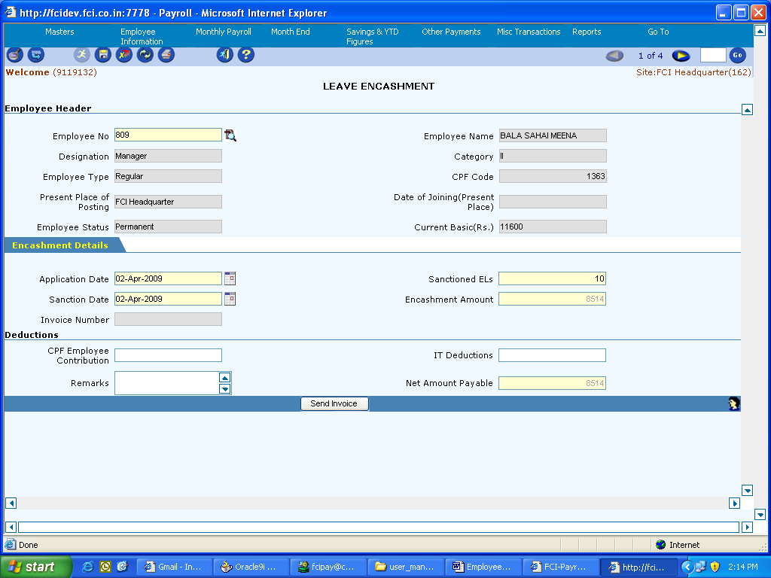

Deployments – 16th May2012 to 31st July 2012

Income Tax Calculation Sheet

Attached Income Tax calculation sheet can be used by sites for calculation of income tax.

Transport Rebate entry screen

A new screen is developed for Transport rebate entry. This is available under savings and YTD menu. User can enter the monthwise applicable rebate thru his screen.

Changes in supplementary payment screen

Following changes are incorporated in Supplementary Payment Screen
- Validation incorporated in supplementary payment not to allow -ve total amount payable.
- Following pay codes are removed from supplementary payment screen:
  - Court Recovery(366)
  - FCI Society Recoveries(396)
  - Bank Loan Recoveries(397)
  - Life Insurance(504)
This has been done to ensure that salary is not paid thru Supplementary payment screen.

Changes in Over and above payment screen

Validation incorporated in Over and Above payment screen for sanction date to be greater than application date, if sanction date is present.

Changes in Maintain Direct Payroll screen

Following pay codes are removed from maintain direct payroll screen:
- Pf arrear(340).

Changes in Internal savings screen

Following pay codes are removed from internal savings screen:

- CPF Deduction(516)

Release incentive thru release salary screen

Release incentive for transferred cases can be released thru Release Incentive option under Release salary screen for DPS and departmental labour.

Changes in Other payments Screens for DPS and Departmental Labour

In labours, immediately after salary completion and before incentive preparation, all other payments are now allowed. Earlier the user has to wait till completion of incentive stage for these payments.

Changes done in the validation of following screens:
- Leave encashment.
- LTC encashment.
- OTA payment.
- Over and Above payment.
- Supplementary payment.

Changes in Attendance Screen DPS and Departmental Labour

The attendance screen will not allow attendance entry for retired employees, even if the retirement is not executed thru the system. Check on retirement date is imposed.

Gang in Labour Information Screen

Gang name is provided in the following screens:
- Departmental labour info
- Departmental labour info (super user)
- DPS labour info.
- DPS labour info (super user)

Changes in pay Code vs Agency Code map screen

Changes in Maintain pay code vs agency code.- The user can now remit to the same agency, for the same pay code but for different employees.

Invoice Report for DPS and Departmental labour

Invoice Report is now made available for DPS and Departmental labour modules.

No CPF Deduction on Non-paid holiday

CPF will not be deducted on Non-paid holiday in Departmental labour.

Labour Payslip for a Deport or a Gang

Labour payslip can be generated for a Depot or a gang

Separate Earning and Deduction Reports for Transferred / Suspended employees after Release Salary

Separate Earning and Deduction reports can be generated for Transferred or suspended employees after release salary.

Calculation of hourly rate for OTA in case of DPS Labour

In case sufficient work is not available for DPS labour due to which actual earnings are less than the MGW, the hourly rate would be worked out by dividing the MGW by effective duty hours ( seven hours) This is applicable on weekdays only.

Payment of MGW in DPS Labour

The payment made to DPS labour should be MGW+IR or Govt of India ( GoI) rates which is inclusive of IR (which ever is higher).

Temporary Advance Limit in DPS Labour

The temporary advance maximum limit for DPS labour to be calculated as – MGW*30* no of months allowed for each reason of advance payment made to DPS labour should be MGW+IR or Govt of India ( GoI) rates which is inclusive of IR ( which ever is higher).

Correction in first Sunday marking for split week in DPS Labour

In case of slip week across two months, the first Sunday will be marked as absent when the DPS labour is absent in the last week of last month. The Sunday will be marked as absent automatically on pressing save button.

Please refer to Employee User Guide and Labor User Guide for details.

Note: In Future the Main User Guide will be updated every quarter and the supplementary user guide will be updated every month. In case of early update units will be notified.

Deployments – 01st Aug 2012 to 30st Nov 2012

Pay Slip Report for DPS Labors
Pay Slip Report for DPS labors to be generated depot and gang wise.

Changes in MDP Bulk
Maintain Direct Payroll Bulk user interface is now used only to make following payments.
- Professional Tax
- Labor Welfare Fund
- Contributory Scheme
- Benevolent Fund

Maintain Leave Detail for Departmental & DPS labors.
Check imposed so that labors can not add leaves manually in the maintain leave screen which is supposed to be flowed automatically from attendance.

Employee Master Search
Employee number wise searching criteria is provided in this user interface. The use has to enter the employee no. in the text field provided. Then after pressing the execute button all details of that employee will be fetched.

Work slip of Departmental & DPS labors
- Continuous work (24 hrs) is implemented. (Valid for DEPT and DPS labors)
- Check is imposed not to allow duplicate work slip entries in DEPT and DPS labors. For DEPT labors two work slips are considered duplicate if they are having same operation, norm type, slab(if applicable) and falls within the time frame of start time and end time. For DPS labors two work slips are considered duplicate if they are having same operation and falls within the time frame of start time and end time

Labor Attendance for Departmental & DPS labors
- Not to allow changes in attendance once work slip is filled. The warning message will show for which labor and for which days work slip is filled.
- Two different nomenclatures like ‘C’ and ‘I’ (casual leave and disability leave) are added in handling labor attendance as well as Ancillary labor attendance for departmental labors.

Release Incentive for Departmental and DPS labors in Employee separation.
Release incentive of separated labors can now be done using employee separation user interface. Net incentive of the last month can be seen on the screen.

Festival Advance validation modified for labors
Festival advance can be given just after salary month end in case of labors. Previously it had to be done after completion of incentive.

PLI Advance Payment through PLI Screen
In Employee wise option system calculation of PLI payment is not prorated. The amount which user enters will be the final amount to be paid.

Quarterly E - returns through Discoverer
Process to access the same is as follows.
- Enter Discoverer Login Credentials with FCI Discoverer responsibility.
- Select 'Quarterly E returns' report.
- Enter the following parameters :-

- Site Code (through LOV).
- From Date (in YYYYMM format).
- To Date ( in YYYYMM format)
- Employee Type (e.g. E/L/D).

Release Incentive in Case of Transfer of labors
Release Incentive facility is provided for transferred labors. The joining site will Release the incentive of joined labor using Release Salary screen. A separate tab is provided for the same and user also can check the incentive number generated.

Maintain Employee Promotion/Reversal for DPS Labours
Task Name: Maintain Employee Promotion/Reversal for DPS Labours

Task Description:

The screen allows the user to maintain employees’ promotion or reversal for DPS Labours.

Prerequisites for performing the task:

None

Users who can perform the task:

Users from HR/EDP/Finance departments.

Task Procedure
- In the main menu selectLabour Information→Maintain Employee Promotion/Reversal.
- In Insert mode first select the employee number from the LOV, then type of promotion/reversal.
- Type of Promotion/Reversal is of two types ‘Regular Promotion’ and ‘Reversal/Demotion’.
- Then choose New Designation for the employee you selected in employee number LOV.
- Enter the Promotion/Reversal Effective Date from which date you have to promote/revert the labour.
- All other fields are not mandatory but for information purpose fill those fields also.
- To save a record, click on the Save button. After successfully saving “Data successfully saved is displayed”.
- Once the entry is saved it cannot be reverted i.e. once the entry is made it cannot be deleted.
- To close the screen click on the Exit button.

Field Description:

Field Name | Field Type | Data Type | Description
Employee Number | Mandatory | Number | Select from the LOV
Promotion/ Reversal Type | Mandatory | Character | Select from the LOV
New Designation | Mandatory | Character | Select from the LOV
Promotion/ Reversal Date | Mandatory | Date | Enter the date
Stagnation Increment | Optional | Double | Enter the number with decimal value
Adhoc Promotion End Date | Optional | Date | Enter the date

Maintain Employee Suspension/Revocation for DPS Labours
Task Name: Maintain Employee Promotion/Reversalfor DPS Labours

Task Description:

The screen allows the user to maintain employees’ suspension or revocation of suspension for DPS Labours.

Prerequisites for performing the task:

None

Users who can perform the task:

Users from HR/EDP/Finance departments.

Task Procedure
- In the main menu selectLabour Information→ Maintain Employee Suspension/Revocation Information.
- In Insert mode first select the employee number from the LOV.
- Choose the Suspension Effective date from which you have to suspend the labour.
- Then choose Subsistence allowance and Subsistence Effective Date will automatically be populated by the system i.e. same as Suspension Effective Date.
- To save a record, click on the Save button. After successfully saving “Data successfully saved is displayed”.
- If there is revision of subsistence allowance then user have to go the screen in query mode and put revised subsistence allowance rate.
- Once the entry is saved it cannot be reverted i.e. once the entry is made it cannot be deleted.
- To close the screen click on the Exit button.

Field Description:

Field Name | Field Type | Data Type | Description
Employee Number | Mandatory | Number | Select from the LOV
Suspension Effective Date | Mandatory | Date | Select from the LOV
Subsistence allowance | Mandatory | Number | Enter the number
Subsistence Effective Date | Mandatory | Date | Automatically populated by the system
Suspension Reason | Optional | Character | Enter the reason for suspending the labour

Note: CR 258-If a labor is suspended then he will get all allowances along with HRA except Conveyance Allowance. Basic Pay and DA will remain as earlier i.e. on the basis of subsistence allowance.

DPS Labour ASOR Details

Task Name:Maintain DPS Labour ASOR Details
Task Description:

The screen allows the user to view/create the DPS Labour Above Schedule of rate Details. The Labour ASOR rates are maintained here. User can view the current as well as the previous rates defined.
Prerequisites for performing the task:

None

Users who can perform the task:

Users from HR/EDP/Finance departments.

Task Procedure
- In the main menu selectMasters→Labour ASOR Details
- TheLabour ASOR Detailsscreen appears in Query mode.
- To view all the existing ASOR rates click on the Execute icon.
- To view rates specific to an Effective Date, select the Effective Date and click on the Execute icon.
- To insert new rates, click on the Insert Icon. Select the Effective Date and fill the rates and save the data. Effective Date cannot be lesser than the latest Effective Date. When the new rates are saved, the previous rates are automatically End Dated.
- To save a record, click on the Save button. After successfully saving “Data successfully saved is displayed”.
- GO button can be used to switch between different records.
- To close the screen click on the Exit button.

Field Description (Header)

Field Name | Field Type | Data Type | Description
Effective From | Mandatory | Date | Select the Effective From Date

Field Description (DPS Labour ASOR Details)

Field Name | Field Type | Data Type | Description
Piece of Rate | Mandatory | Numeric | Enter the Piece of Rate
MGW Sardar | Mandatory | Numeric | Enter the Minimum Guarantee Wage for Sardar
MGW Mandal | Mandatory | Numeric | Enter the Minimum Guarantee Wage for Mandal
MGW Ancillary Labour | Mandatory | Numeric | Enter the Minimum Guarantee Wage for Ancillary Labour
MGW Handling Labour | Mandatory | Numeric | Enter the Minimum Guarantee Wage for Handling Labour

Perform Single Month-end (DPS)
Task Name: Perform Single Month-end

Task Description:

The screen allows the user to perform month end for both salary and incentives.

Prerequisites for performing the task:

None

Users who can perform the task:

Users from HR/EDP/Finance departments.

Task Procedure
- In the main menu selectMonthly Payrolltab→ Perform Single Month End
- TheSingle Month End screen appears in Query mode.
- To do the month end for salary and invoices at one go, click on the Perform Month End button. The user have to enter his user id pop up box. After successful execution, the success message is displayed.
- To close the screen click on the Exit button.
- Unit can work simultaneously for salary and incentive part.
- If salary month end is already performed then single month end can’t be performed.
- Incentive initialization can be performed only after Monthly Payroll is computed for salary.
- Undoing the salary would result in undo of salary and incentive, where as undoing the incentive would result in undo of incentive only.
- After performing month end, posting of invoices will be done separately for both salary and invoices through their respective screens. Incentive posting can be done with the selected pay group from the drop down.
- Remittance for salary and incentive is done simultaneously.

LIC Recovery Report (EMPLOYEE/DPS/DEPT)

Task Name: LIC Recovery Report (EMPLOYEE/DPS/Dept.)
Task Description:

LIC recovery report (DPS/Dept.) provides the basis for LIC deduction details of the site. Details include employee name, staff code, LIC policy number and LIC amount of a whole site or for particular labour. The report can also be shown on the basis of particular agency and agency site code.

Prerequisites for performing the task:

None

Users who can perform the task:

Users from HR/EDP/Finance departments.

Task Procedure
- In the main menu select Reports→Remittance Reports→LIC Recovery Report.
- The LIC Recovery Reportscreen appears in Query mode.
- To view LIC details for a particular labour, select employee number from LOV, from year month, to year month& then click on the Generate LIC Recovery Report button.
- To view LIC recovery details for a whole site at one go leave the employee number lov as blank, select year month & then click on the Generate LIC Recovery Report button.
- If the user want to view the report for any particular supplier, select supplier number and supplier site from respective LOV’s
- To close the screen click on the Exit button.

Field Description:

Field Name | Field Type | Data Type | Description
Employee number | Optional | Number | Select employee number from LOV
From Year Month | Mandatory | Date | Enter year month from which the report is needed
To Year Month | Mandatory | Date | Enter year month till which the report is needed
Supplier Number | Optional | Number | Select supplier name from LOV
Supplier Site | Optional | Number | Select supplier site from LOV

Miscellaneous Schedule Report/Bank Loan /FCI Society Recovery Report for (EMPLOYEE/DPS/DEPT)

Task Name: Miscellaneous Schedule Report (EMPLOYEE/DPS/Dept.)
Task Description:

The report gives you the details about various pay codes earnings or deductions given in process of salary and incentive. The pay codes include supplementary payment pay codes, various advances, allowances, loans or others.

Prerequisites for performing the task:

None

Users who can perform the task:

Users from HR/EDP/Finance departments.

Task Procedure
- In the main menu select Reports→Remittance Reports →Miscellaneous Schedule Reports.
- The Miscellaneous schedule Report screen appears in Query mode.
- To view details for a particular year month and pay code, enter yyyymm & select pay code from LOV, then click on the Generate Report button.
- There is also a provision in the report for Bank Loan/FCI Society Recovery. The user can see the report by selecting radio button for the same.
- To view report chooses from yymm, to yymm and pay code for generating report, then click on Bank Loan/FCI Society Recovery Report button.
- If the user wants to generate report for specific supplier number or site. Choose them from LOV, then click on generate report button.
- To close the screen click on the Exit button.

Field Description:

Miscellaneous Schedule Report:

Field Name | Field Type | Data Type | Description
YYYYMM | Mandatory | Date | Enter yearmonth for which the payslip is needed
Supplier Number | Optional | Number | Select supplier name from LOV
Supplier Site | Optional | Number | Select supplier site from LOV
Pay Code | Mandatory | Number | Select Pay code from LOV

Bank Loan/ FCI Society Recovery Report:

Field Name | Field Type | Data Type | Description
From Year Month | Mandatory | Date | Enter year month from which the pay slip is needed
To Year Month | Mandatory | Date | Enter year month up to which the pay slip is needed
Supplier Number | Optional | Number | Select supplier name from LOV
Supplier Site | Optional | Number | Select supplier site from LOV
Pay Code | Mandatory | Number | Select Pay code from LOV

Earning Deduction Report (Departmental/DPS)

The following reports can be generated in the system

Labour salary earning detail

Labour salary earning summary

Labour salary deduction detail

Labour salary deduction summary

Actual work done/incentive earning detail

Actual work done/incentive earning summary

Actual work done/incentive deduction detail

Actual work done/incentive deduction summary

Task Name: Earning deduction report (Departmental/DPS)

Task Description:

The Earning deduction report (DPS/Departmental) Report provides the details of all the earnings and deductions for MGW/salary and actual work done/incentive given to the Labors for a particular month. Report can be taken out within a DO depot wise, gang wise. Summary report can also be taken out within a DO depot wise, gang wise.

Prerequisites for performing the task:

None

Users who can perform the task:

Users from HR/EDP/Finance departments.

Task Procedure
- In the main menu selectReports→Earning deduction report.
- TheEarning deduction report screen appears in Query mode.
- To view earning details for a particular gang, select depot name, year month and gang name & then click on the Generate Report button. To view earning details of all employees in query mode select year month & then click on the Generate Report button. To close the screen click on the Exit button.
- Following reports can be generated by selecting appropriate options:
  - Labour salary earning detail
  - Labour salary earning summary
  - Labour salary deduction detail
  - Labour salary deduction summary
  - Actual work done/incentive earning detail
  - Actual work done/incentive earning summary
  - Actual work done/incentive deduction detail
  - Actual work done/incentive deduction summary.
- If labour is not present in any gang at the time of report generation, then he will not appear in report.

Pay Slip (DPS/Dept.)

Task Name: Pay Slip (DPS/Dept.)
Task Description:

Pay slip (DPS/Dept.)provides the basis for salary details of the labour. Details include basic details, Earning details and deduction details of salary and incentive of a labour.

Prerequisites for performing the task:

None

Users who can perform the task:

Users from HR/EDP/Finance departments.

Task Procedure
- In the main menu select Reports→Salary Reports → Generate Pay slip.
- The Pay slipscreen appears in Query mode.
3. To view incentive details for a particular labour, select employee number from LOV, year month & then click on the Generate Report button. To close the screen click on the Exit button.

Note:
Payslip report of the separated employees will not be available after they are made inactive in the system.

Field Description:

Field Name | Field Type | Data Type | Description
Employee number | Optional | Number | Select employee number from LOV
YYYYMM | Mandatory | Date | Enter yearmonth for which the payslip is needed

Unmatched CPF Details
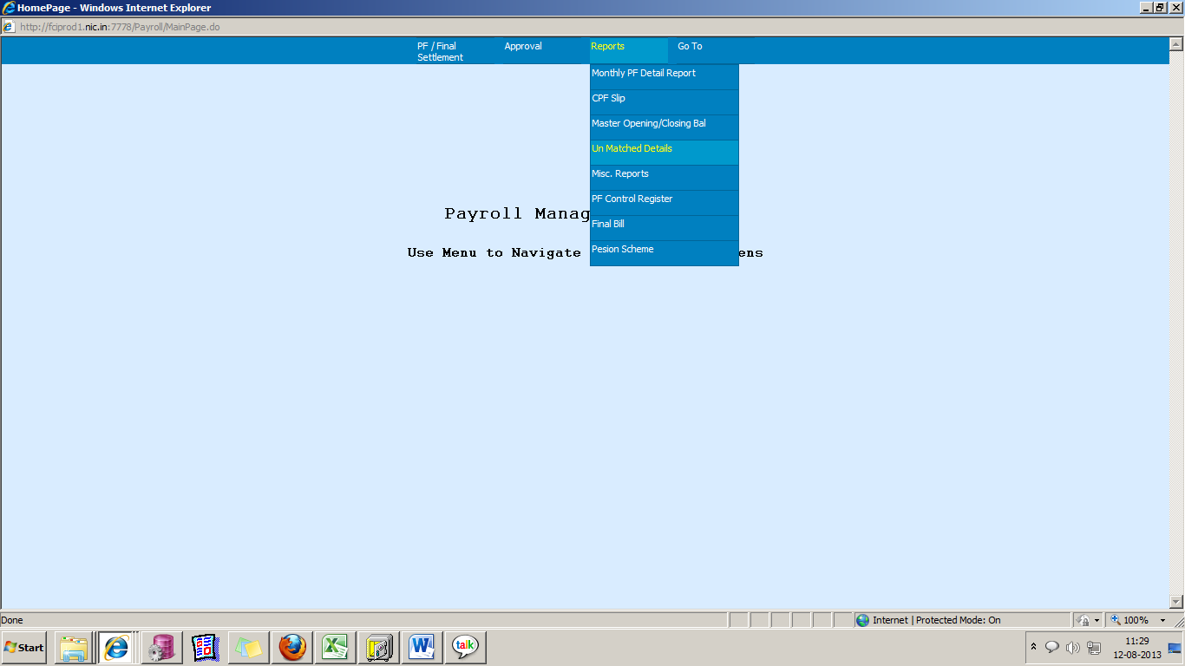

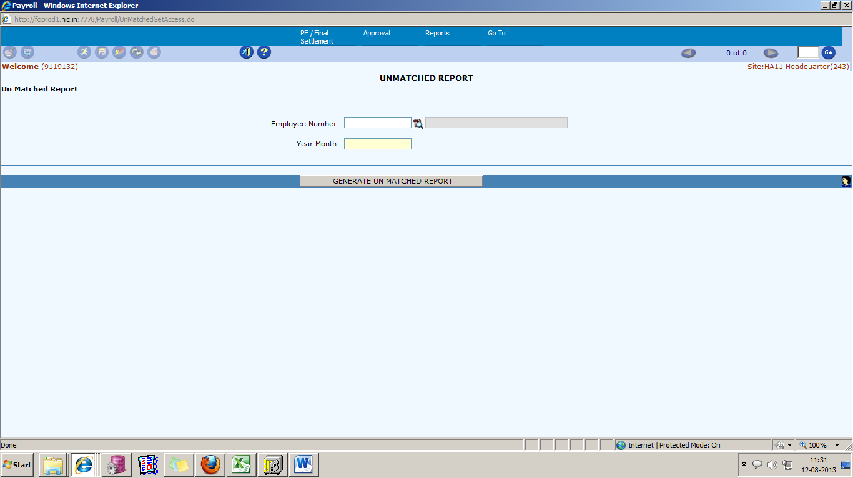

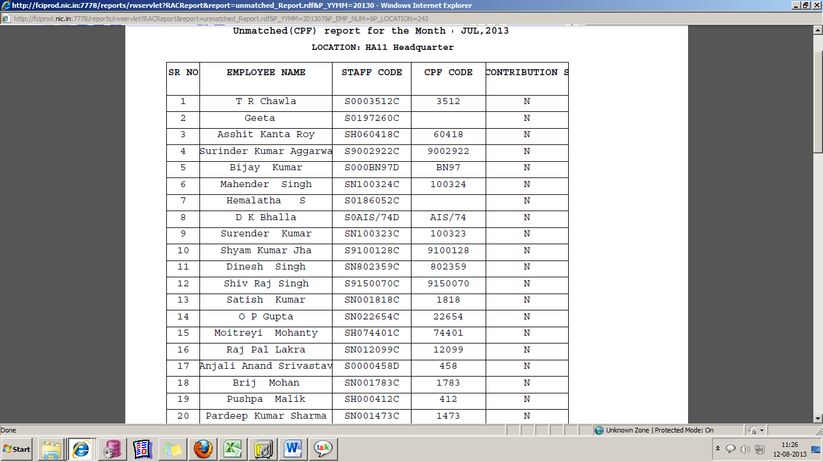

Task Name: Unmatched Details Report

Task Description:

Prerequisites for performing the task:

None

Users who can perform the task:

Users from HR/EDP/Finance departments.

Task Procedure
- The main menu select Reports → Unmatched Report .
- The Unmatched Report screen appears.
- Enter the YEAR_MONTH (YYYYMM) format and employee number (if want to obtain information about specific employee.).
- To generate the report, click on the Generate Unmatched report button.
- To close the screen click on the Exit button.

PF Slip Report

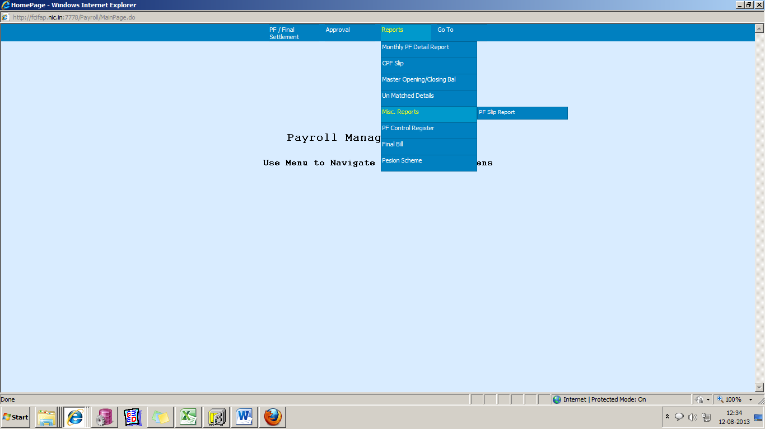

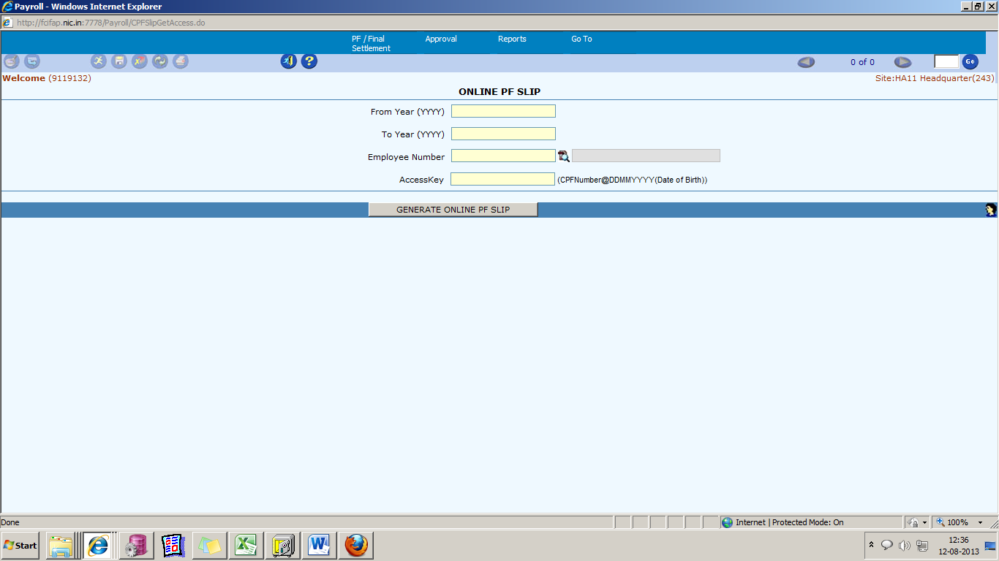

Task Name: Unmatched Details Report

Task Description:

It Generate Pf slip report for the employee for the specific time period entered by the user.
Prerequisites for performing the task:

None

Users who can perform the task:

Users from HR/EDP/Finance departments.

Task Procedure
- The main menu select Reports → Misc Report → PF slip Report .
- The PF slip Report screen appears.
- Enter all the mandatory parameters asked in the screen.
- To generate the report, click on the Generate Online Pf Slip report button.
- To close the screen click on the Exit button.

Final Bill.

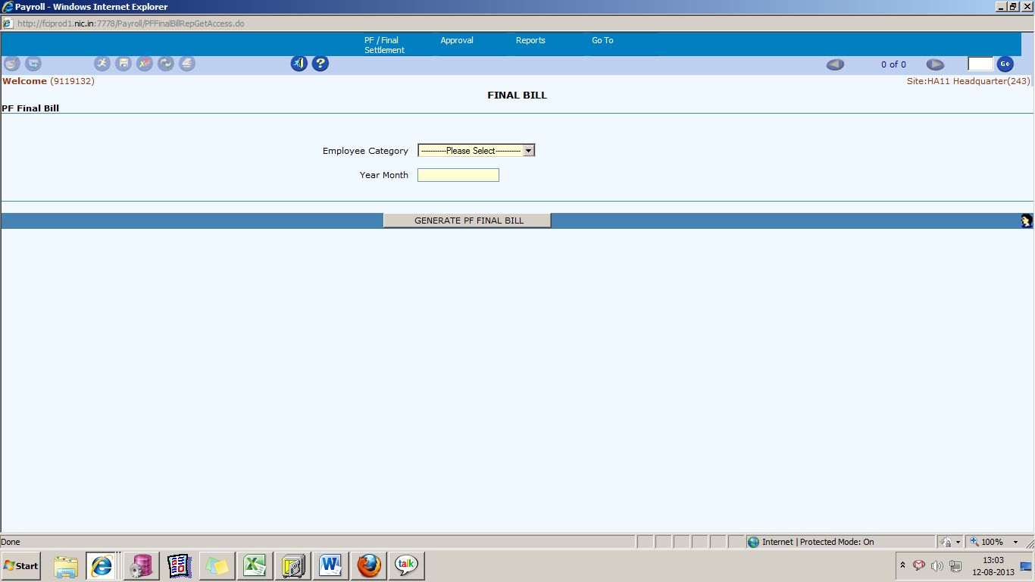
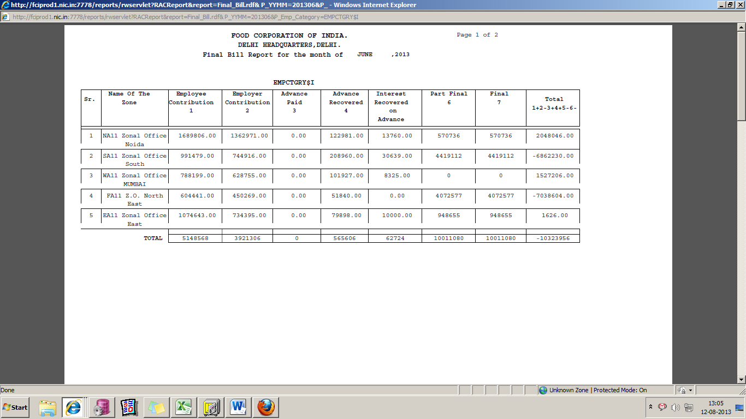

Task Name: Final Bill

Task Description:

It Generate Final bill report for categories of employee for the specific time period entered by the user.
Prerequisites for performing the task:

None

Users who can perform the task:

Users from HR/EDP/Finance departments.

Task Procedure
- The main menu select Reports → Final Bill .
- The Final Bill Report screen appears.
- Enter all the mandatory parameters asked in the screen.
- Select employee category and Year Month.
- To generate the report, click on the Generate PF Final Bill button.
- To close the screen click on the Exit button.

CPF slip.

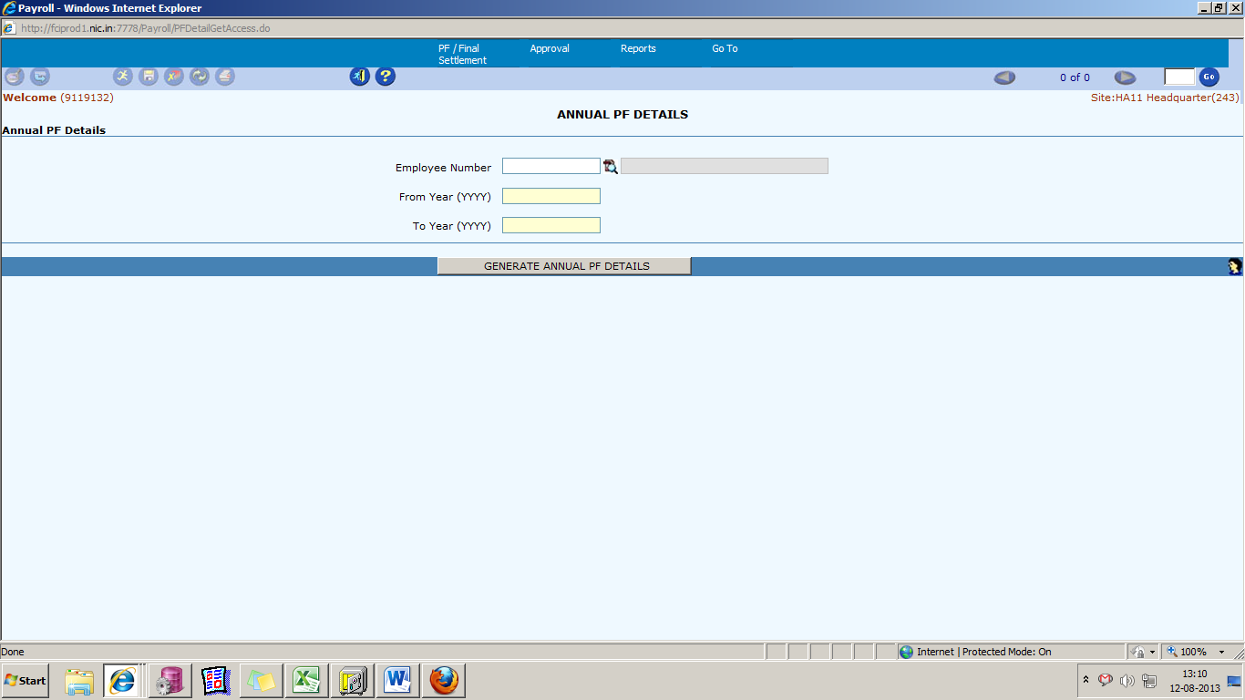

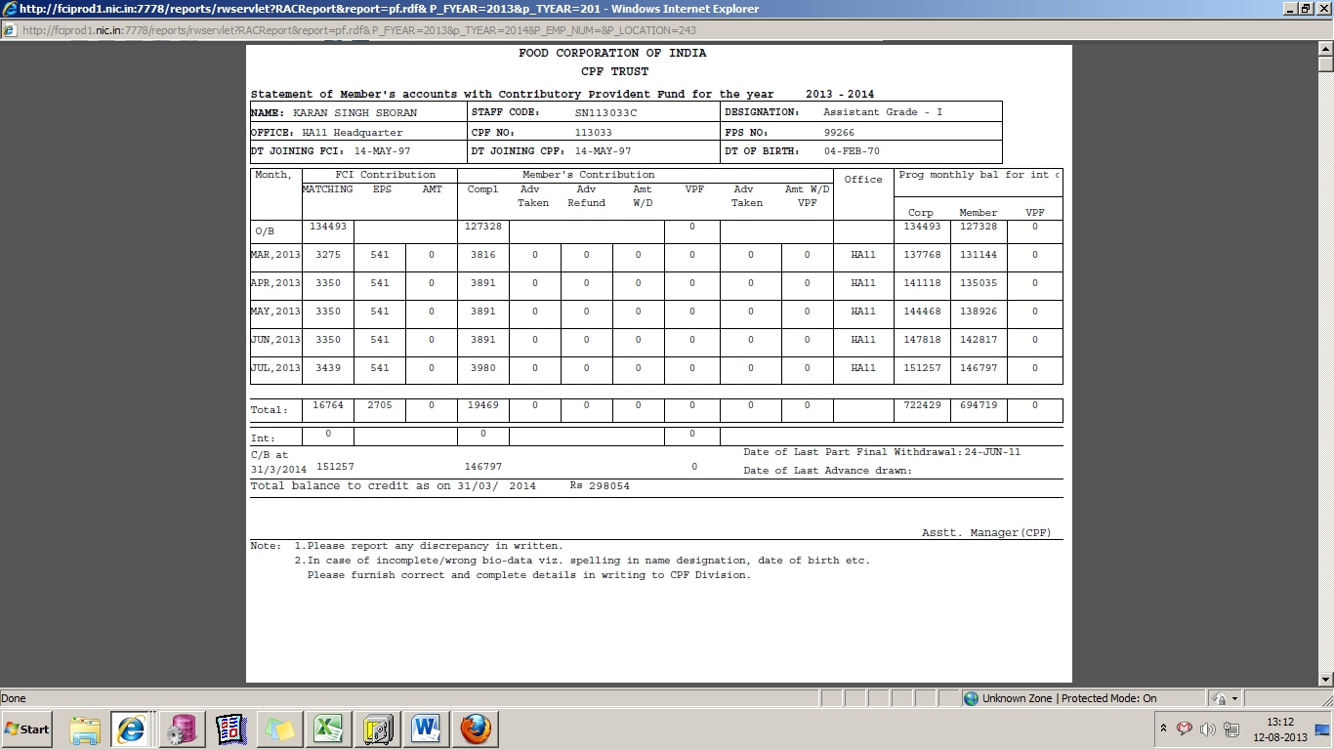

Task Name: CPF Slip

Task Description:

It Generate CPF slip report for employee for the specific time period entered by the user.
Prerequisites for performing the task:

None

Users who can perform the task:

Users from HR/EDP/Finance departments.

Task Procedure
- The main menu select Reports → Final Bill .
- The Annual PF Detail screen appears.
- Enter all the mandatory parameters asked in the screen.
- To generate the report, click on the Generate Annual PF button.
- To close the screen click on the Exit button.

Calculate Interest
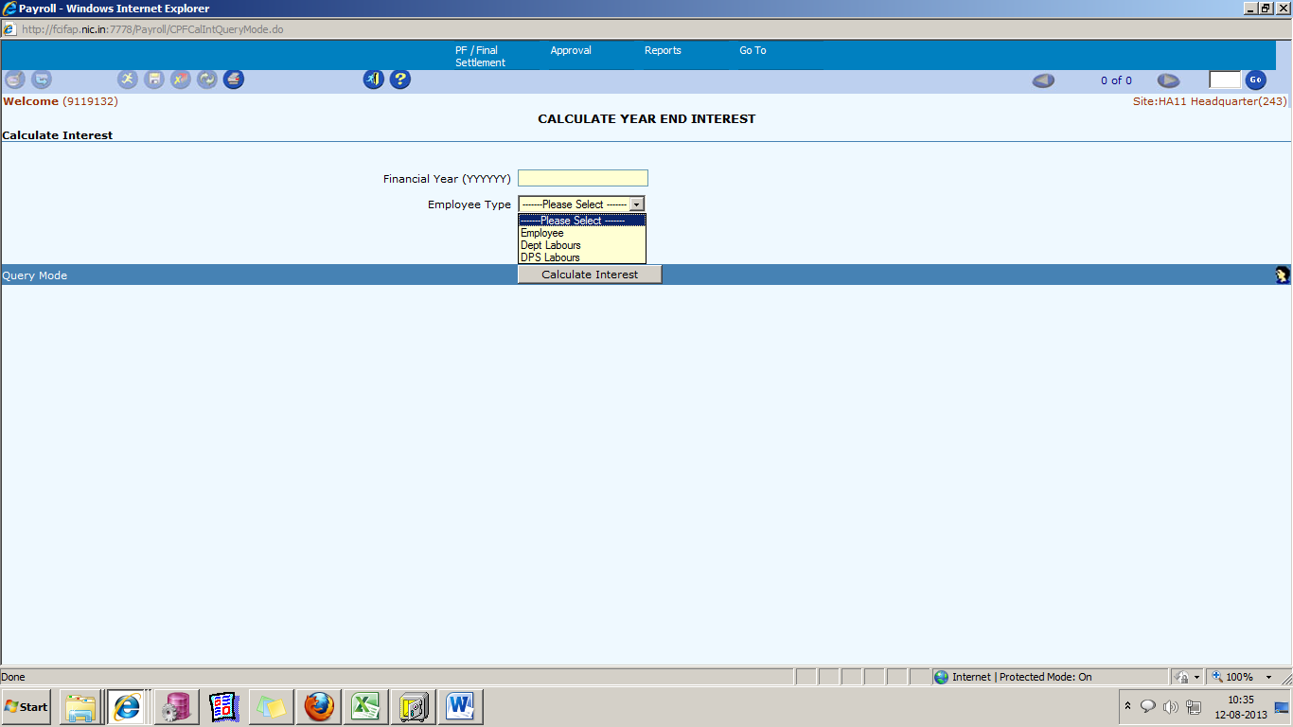

Task Name: Calculate Interest

Task Description:

This process is used to calculate year-end CPF interest for all employees/labor present in payroll from whom CPF final payment is not sanctioned.

Prerequisites for performing the task:

None

Users who can perform the task:

Users from HR/EDP/Finance departments only at Head-Quarter location.

Task Procedure
- The main menu select PF / Final Settlement→ Calculate Interest
- The Calculate Interest screen appears.
- Select financial year and Employee Type (E,L,D).
- To run process click “Calculate Interest” button.
- To close the screen click on the Exit button.

View Parameter
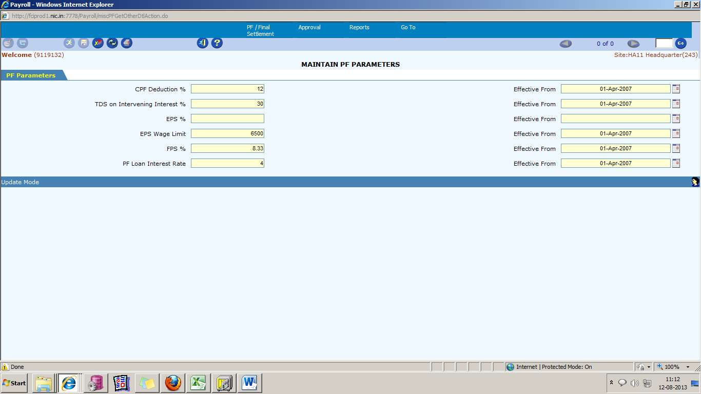

Task Name: Maintain PF Parameters

Task Description:

The screen allows the user to view the PF Parameters like CPF deduction%, EPS %, EPF Wage Limit etc.

Prerequisites for performing the task:

None

Users who can perform the task:

Users from HR/EDP/Finance departments.

Task Procedure
- In the main menu select PF/Final Settlement→ View PF Parameters
- The Maintain PF Parameters appears.
- To get the previously saved PF Parameters, click on the Execute icon. The details are populated.
- To close the screen click on the Exit button.

View PF Interest Rate.
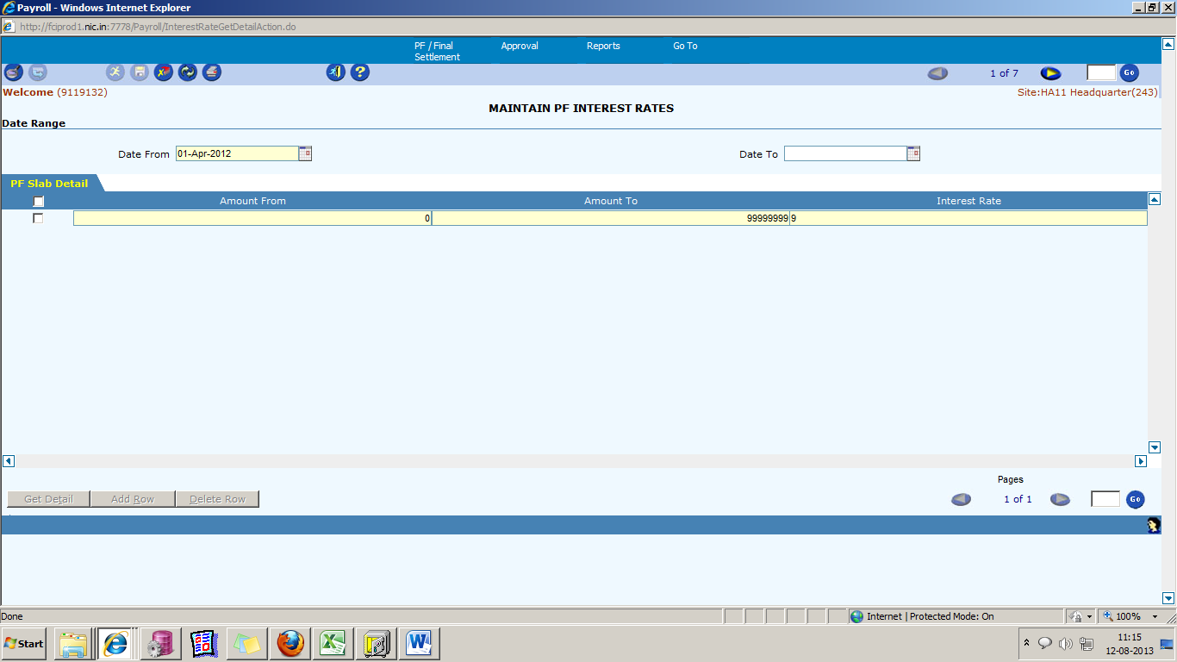

Task Name: View PF Interest Rates

Task Description:

The screen allows the user to maintain the Provident Fund Interest Rates. The slab for the computation of Year End Interest on CPF is maintained in this screen.

Prerequisites for performing the task:

None

Users who can perform the task:

Users from HR/EDP/Finance departments.

Task Procedure
- In the main menu select PF/Final Settlement→ View PF Interest Rates
- The Maintain PF Interest Rates screen appears in Query mode.
- To view all the existing PF Interest Rates, click on the Execute icon. To view/ enter the details specific to an Effective Date, select the Effective Date and then click on the Execute icon. Similarly to view/enter the details specific to an End Date, select the Date To and then click on the Execute icon.
- To get the details, click on the Get Detail button.
- To close the screen click on the Exit button.

Deployments – 1st Dec 2012 to 28th Feb 2013

As per CR 254 following changes are made in system.
- Contribution by employees (except Deputation employees) increases from existing Rs. 10/ per month to Rs. 30/ per month from Dec 2012 salary.
- For October 2012 and November 2012 salary the Benevolent fund difference amount of Rs. 40/ to be entered via Maintain Direct Payroll (Bulk).
- The contributory social security scheme now exists in system.

Deployments – 1st March 2013 to 31st March 2013

Promotion from category 3 to category 2 in deployment cases
For deployment cases, system will generate the arrear payments and recoveries respective there categories of the employee.

If any employee deployed (i.e. promoted from category III or IV to II or I) ,for those employees, user has to enter the promotion entries through employee promotion screen, select promotion type deployment only and enter the promoted basic in basic after promotion field (i.e. effective from 1 July 12 with basic 10,300 Rs.) . When user back or reverse to the original category (i.e. from category II or I to III or IV) arrear payments and recoveries through system only. System consider those promotion entries only which has been created in the running payroll only.

Deployments - – 1st April 2013 to 30th April 2013

Leave functionality in departmental labour
In departmental labour, a new screen has been added namely ‘Current month leaves’ to allow leave entry of labour for current and future months. User to enter leaves via this screen system will automatically insert or update the attendance of labour. Leaves of previous month cannot be modified via this screen.

Basic arrear incentive in departmental labour
For basic arrear cases system will automatically generate basic arrear of incentive along with generation of basic arrear salary . Same can be viewed via reports of incentive.

Suspension in departmental labour
In departmental labour, system will automatically generate salary of suspended labour. User to enter details of suspended labour via ‘employee suspension’, system will generate the salary of labour as per the entered details . User to manually release salary of labour via release salary button on ‘employee suspension’ screen.

Deployments – 1st May 2013 to 31st May 2013

CPF Schedule – eSeva

CPF Schedule e-Seva is now available in production under Discoverer Reports. This can be downloaded to Excel.
Please refer point 8.15 in CPF Manual for detail.

Deployments – 1st June 2013 to 30th June 2013

Handling of deduction more than earning

Handling of cases where deduction is more than earning deployed in the system. Partial deduction enabled for all pay codes except third party recoveries and FCI recoveries.

Posting date of remittance should be last day of the month.

Invoice date of remittance invoices to be last day of the current month or system date whichever is first.

Professional tax handling in labour.

Professional tax would be deducted automatically by the system depending on the slabs defined in the system. Professional tax would be deducted for following states:-
Arunachal, Karnataka, Bihar, Nagaland, Orissa, Assam, Tamilnadu, Andhra Pradesh, Gujarat, West Bengal and Maharashtra.
Professional tax would be deducted automatically from the salary and during incentive calculation gross earning of the labour falls in next slab then differential amount would be automatically deducted from the incentive.

Lease accommodation for dept. labour.

Lease accommodation screen for dept. labour, in case a labour applies for lease accommodation then he would not be entitled for HRA.

Deployments – 1st July 2013 to 31st July 2013

Employee Penalty

The process of imposing penalty on employees is developed and available in employee information menu of employee module. Basically three types of penalties are there monetary recovery, demotion and increment stop.
Separate tabs are also provided for recovery waiver and increment stop waiver. A separate tab is also provided to re-instate dismissed employees.

CR-161 (Employee to Supplier creation process automation)

- All the duplicate/wrong CPF data corrected in Payroll.
- Employee/Labour staff code has been updated.
- Deletion of wrong data in Payroll.
- New validation has been applied in payroll for new entry and existing data.
- Two new screen has been deployed which are given below:
- For details regarding the CR-161 Please refer the approach note attached below.

CPF Approval/Rejection
Through this process CPF will be approved or rejected by Zonal office of that particular zone. Whenever any new employee/labour is created in system it will be approved by CPF division for maintaining authentication of CPF code in system.
CPF will also be approved for employees for whom zone surrender is also initiated. This will also be done by respective Zonal offices.

Zone Surrender
This screen is provided when employee/labour wants to change their zone i.e. it is sole employee wish to change the zone. The screen will also be used when employee is promoted, then also it depends on zonal office to change zone or not.
After saving data in the screen it will go on CPF Approval screen to approve and authenticate it.

Employee Joining (Transfer)

Task Name: Employee Joining

Task Description:

The screen allows the user to view/create Employee Joining/Transfer details. The screen shows, the details of the employees who are transferred to the current location from any other location. The transferred employees can be made to join the current location, using this screen.
Prerequisites for performing the task:

None

Users who can perform the task:

Users from HR/EDP/Finance departments.

Task Procedure
- In the main menu select Employee Information → Employee Joining(Transfer)
- The Employee Joining screen appears in Query mode.
- Select between the New Joinees or Already Joined option from the drop down list to view the details accordingly. To get details of all the employees transferred to this location, click on the Execute button. To get details of a particular employee, select the Employee No & then click on the Execute icon. The details are populated.
- To make an Employee join the current location, select the Joining Date and Joining Time and save the data.
- To save the data click on the Save button. After saving “Data saved successfully” is displayed.
- Go button can be used to switch between different pages.
- To close the screen click on the Exit button.

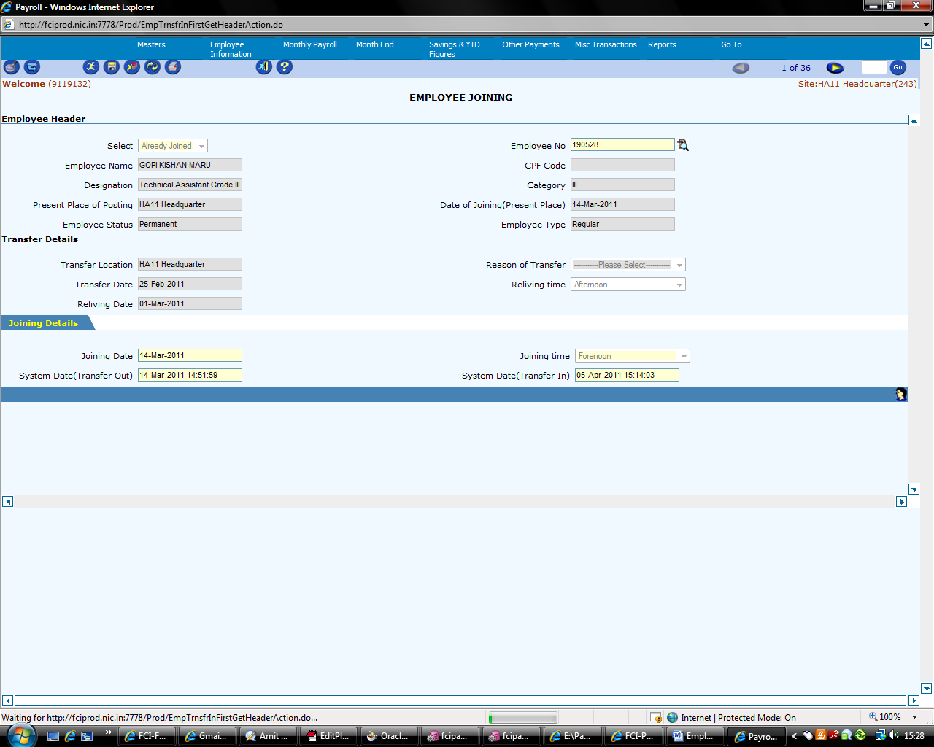

Field Descriptions (Employee Header)

Field Name | Field Type | Data Type | Description
Select | Mandatory | Characters | Select to view details of New Joinees or Already Joined employees
Employee No | Mandatory | Numeric | Select from the LOV
Employee Name | Read Only | Characters | Filled automatically after selecting the Employee No
Designation | Read Only | Characters | Filled automatically after selecting the Employee No
Category | Read Only | Numeric | Filled automatically after selecting the Employee No
Employee Type | Read Only | Characters | Filled automatically after selecting the Employee No
CPF Code | Read Only | Characters | Filled automatically after selecting the Employee No
Present Place of Posting | Read Only | Characters | Filled automatically after selecting the Employee No
Date of Joining (Present Place) | Read Only | Date | Filled automatically after selecting the Employee No
Employee Status | Read Only | Characters | Filled automatically after selecting the Employee No

Field Descriptions (Transfer Details)

Field Name | Field Type | Data Type | Description
Transfer Location | Read Only | Characters | Filled automatically after selecting the Employee No
Reason of transfer | Read Only | Drop Down List | Filled automatically after selecting the Employee No
Transfer Date | Read Only | Date | Filled automatically after selecting the Employee No
Reliving Time | Read Only | Characters | Filled automatically after selecting the Employee No
Reliving date | Read Only | Date | Filled automatically after selecting the Employee No

Field Descriptions (Joining Details)

Field Name | Field Type | Data Type | Description
Joining Date | Mandatory | Date | Select the Date, when the employee will join the current location.
Joining Time | Mandatory | Drop Down List | Select the time, when the employee will join the current location.

Employee Selection Grade/Reversal

Task Name: Employee Selection Grade/Reversal

Task Description:

The screen allows the user to view/create Employee Selection Grade/Reversal details. The designation of the Employee remains the same, his Basic salary is revised and so is the Pay Scale Code.
Prerequisites for performing the task:

None

Users who can perform the task:

Users from HR/EDP/Finance departments.

Task Procedure
- In the main menu select Employee Information → Employee Selection Grade/Reversal
- The Employee Selection Grade Information screen appears in Query mode.
- To view all the employees who have been graded/reversed click on the Execute icon or to view the details of a particular employee select the Employee No & then click on the Execute icon.
- To insert a new employee detail, click on the Insert icon. Select the Employee No from the LOV, the Employee’s details are populated. Fill the Selection Grade details and save the data.
- To save the details, click on the Save button. After successfully saving “Data successfully saved is displayed”.
- GO button can be used to switch between different records.
- To close the screen click on the Exit button.

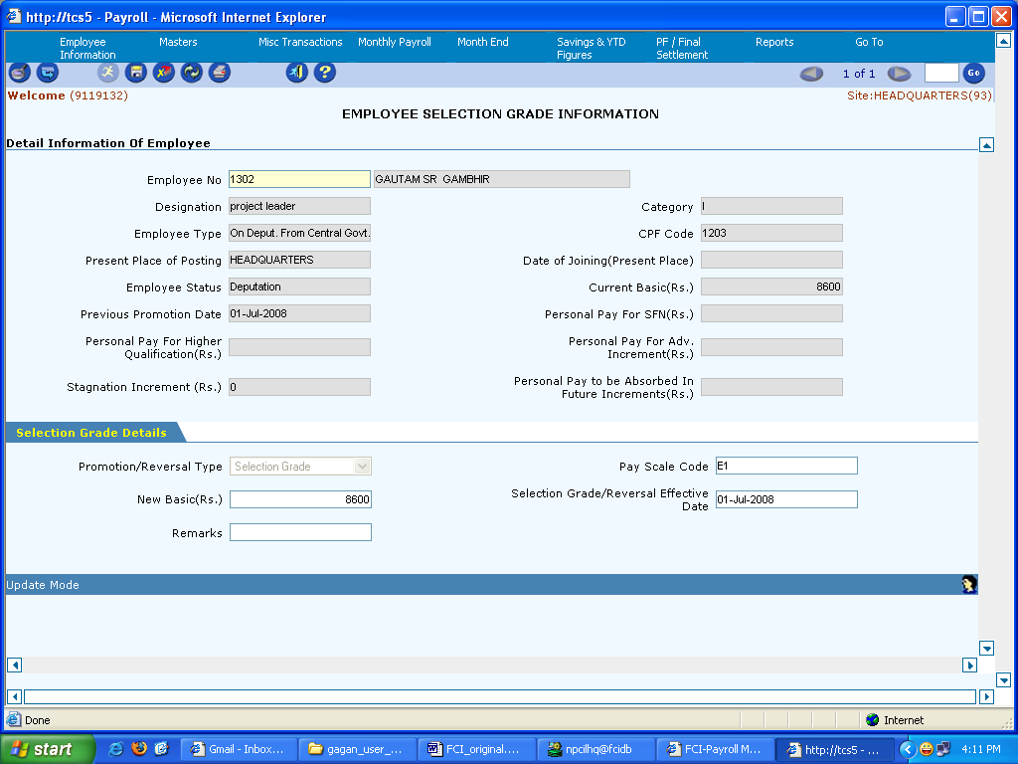

Field Descriptions (Detail information of employee)

Field Name | Field Type | Data Type | Description
Employee No | Mandatory | Numeric | Select Employee No from the LOV
Category | Read Only | Numeric | Filled automatically after selecting the Employee No
Designation | Read Only | Characters | Filled automatically after selecting the Employee No
Employee Type | Read Only | Characters | Filled automatically after selecting the Employee No
CPF Code | Read Only | Numeric | Filled automatically after selecting the Employee No
Present Place of Posting | Read Only | Characters | Filled automatically after selecting the Employee No
Date of Joining (Present Place) | Read Only | Date | Filled automatically after selecting the Employee No
Employee Status | Read Only | Characters | Filled automatically after selecting the Employee No
Current Basic (Rs) | Read Only | Numeric | Filled automatically after selecting the Employee No
Previous Promotion Date | Read Only | Numeric | Filled automatically after selecting the Employee No
Personal Pay for SFN (Rs) | Read Only | Numeric | Filled automatically after selecting the Employee No
Personal Pay for Higher Qualification (Rs) | Read Only | Numeric | Filled automatically after selecting the Employee No
Personal Pay for Adv. Increment (Rs) | Read Only | Numeric | Filled automatically after selecting the Employee No
Stagnation Increment (Rs) | Read Only | Numeric | Filled automatically after selecting the Employee No
Personal Pay to be Absorbed in future increments (Rs) | Read Only | Numeric | Filled automatically after selecting the Employee No

Field Descriptions (Selection Grade Details)

Field Name | Field Type | Data Type | Description
Promotion/Reversal Type | Mandatory | Drop Down List | Select the Promotion/Reversal Type from the Drop Down List
Pay Scale Code | Mandatory | Numeric | Select Pay Scale Code from the LOV
New Basic (Rs) | Mandatory | Numeric | Enter the new basic amount
Selection/ Grade Reversal Effective Date | Mandatory | Date | Select the Effective Date
Remarks | Optional | Characters | Enter the remarks

Employee Separation and Compute Final Settlement

Task Name: Employee Separation and Compute Final Settlement
Task Description:

The screen allows the user to maintain Final Settlement Details of the Employees. The functionality of Employee Separation is required to perform Employee Separation (i.e. Termination, Resignation, Death Cases and Deputation Case) Activity in Payroll Application.

Prerequisites for performing the task:

Month End process should be performed.

Users who can perform the task:

Users from HR/EDP/Finance departments.

Task Procedure
- In the main menu select Employee Information → Employee Separation and Final Settlement
- The Compute Final Settlement screen appears in Query mode.
- To view the existing details of already separated Employees, click on the Execute icon. To view specific Employee details, select the Employee No from the LOV and then click on the Execute icon. The details are populated.
- To separate a new Employee, select the Employee No from the LOV, the Employee Details are populated. To make the separation, select the Separation Date and Separation Type and save the data.
- To get the Deductions details, click on the Get Detail button. The deductions details are populated.
- To add a new Deduction, click on the Add Row button.
- To delete a Deduction, select the row and click on the Delete Row button. Save the data.
- After finalizing and saving the Deduction Details, enter the Final Settlement Parameters. Salary for the month should be processed first, before entering the Final Settlement Parameters. The deductions are settled through the Salary of the Employee, in case the outstanding amount is greater than the salary, then it can be settled through Leave Encashment amount & Gratuity.
- Enter the Leave Encashment and Gratuity details. To enable deductions through the Gratuity amount, select the Adjust from Gratuity checkbox.
- To adjust the deductions, click on the Adjust Deduction button.
- To Release the Salary of the Employee, click on the Release Salary button. Month End process should be performed for the salary to be released.
- To Pay Gratuity to the Employee, click on the Pay Gratuity button. Month End process should be performed.
- To pay the leave encashment, click on the Pay Leave Encashment button. Month End process should be performed.
- To generate the Last Pay Certificate of the Employee, click on the Generate LPC button.
- GO button can be used to switch between different pages.
- To close the screen click on the Exit button.

If deduction is done from any of the income components (earned leave, half pay leave or gratuity) whether partly or fully, then that particular component(s) will be frozen and will not allow further updation by the user.

Also the deduction components will be frozen by after the adjustment is done.
( Refer Supplementary user Guide Section 2.3)

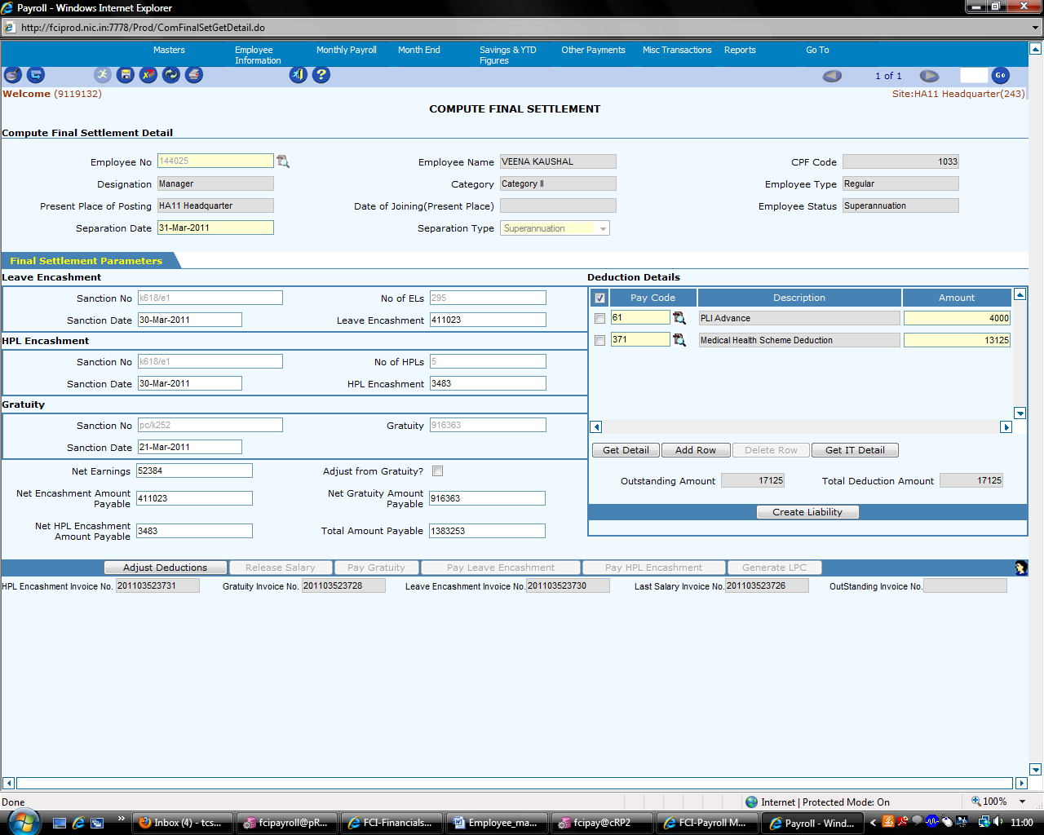

Field Description (Compute Final Settlement Detail)

Field Name | Field Type | Data Type | Description
Employee No | Mandatory | Numeric | Select the Employee No from the LOV
Employee Name | Read Only | Characters | Filled automatically after selecting the Employee No
CPF Code | Read Only | Numeric | Filled automatically after selecting the Employee No
Designation | Read Only | Characters | Filled automatically after selecting the Employee No
Category | Read Only | Characters | Filled automatically after selecting the Employee No
Employee Type | Read Only | Characters | Filled automatically after selecting the Employee No
Present Place of Posting | Read Only | Characters | Filled automatically after selecting the Employee No
Date of Joining (Present Place) | Read Only | Characters | Filled automatically after selecting the Employee No
Employee Status | Read Only | Characters | Filled automatically after selecting the Employee No
Separation Date | Mandatory | Date | Select the Separation Date
Separation Type | Mandatory | Characters | Select the Separation Type from the Drop Down List

Field Description (Leave Encashment)

Field Name | Field Type | Data Type | Description
Sanction No | Optional | Numeric | Sanction number
No of ELs | Optional | Numeric | Number of Earned Leaves
Sanction Date | Optional | Date | Sanction Date
Leave Encashment | Read Only | Numeric | Calculated automatically

Field Description (Gratuity)

Field Name | Field Type | Data Type | Description
Sanction No | Optional | Numeric | Sanction Number
Gratuity | Optional | Numeric | Gratuity Amount
Sanction Date | Optional | Date | Sanction Date
Net Earnings | Mandatory | Numeric | Net Earnings Amount
Adjust from Gratuity? | Check box | Check box | Select to adjust from the Gratuity Amount
Net Encashment Amount Payable | Mandatory | Numeric | Net Encashment Amount Payable
Net Gratuity Amount Payable | Mandatory | Numeric | Net Gratuity Amount Payable

Field Description (Deductions Details)

Field Name | Field Type | Data Type | Description
Pay Code | Mandatory | Numeric | Select from the LOV
Description | Read Only | Characters | Filled automatically after selecting the Pay Code
Amount | Mandatory | Numeric | Enter the Amount
Out Standing Amount | Read Only | Numeric | Out Standing Amount is filled
Total Deduction Amount | Read Only | Numeric | Total Deduction Amount is filled

NOTE Please press tab on the keyboard after entering the no of leaves so that Leave Encashment Amount will get automatically updated.

Maintain Employee Suspension/Revocation

Task Name: Maintain Employee Suspension/Revocation

Task Description:

This screen allows the user to maintain the Employee Suspension/Revocation Details. An Employee can be suspended/ revoked from the services using this screen. When the Employee is suspended his salary is stopped and can be released thereafter using this screen. Updation is allowed in the screen.

Prerequisites for performing the task:

Any user who has the knowledge and permission of the payroll section can use the screen.

Users who can perform the task:

Person from EDP/Finance departments who are dealing with Payroll.

Task Procedure
- From the main menu select Employee Information → Maintain Employee Suspension.
- To view all the suspended employee’s details, click on the Execute icon. To view details particular to an employee, select the Employee No from the LOV and then click on the Execute icon.
- To suspend a new Employee click on the Insert icon, select the Employee No from the LOV. The Employee Details are populated.
- To enter the Suspension Details, click on the Suspension tab. To enter the Revocation Details, click on the Revocation tab. To release the salary of the employee, click on the Salary Release tab, enter the Year Month and then click on the Release Salary button. Salary of the month should be processed before the salary is released. Data must be saved before switching between the different tabs.
- To save the data click on the Save button. After successful saving, message “Data Saved Successfully” is displayed.
- GO button can be used to switch between different records.
- To close the screen click on the Exit button.

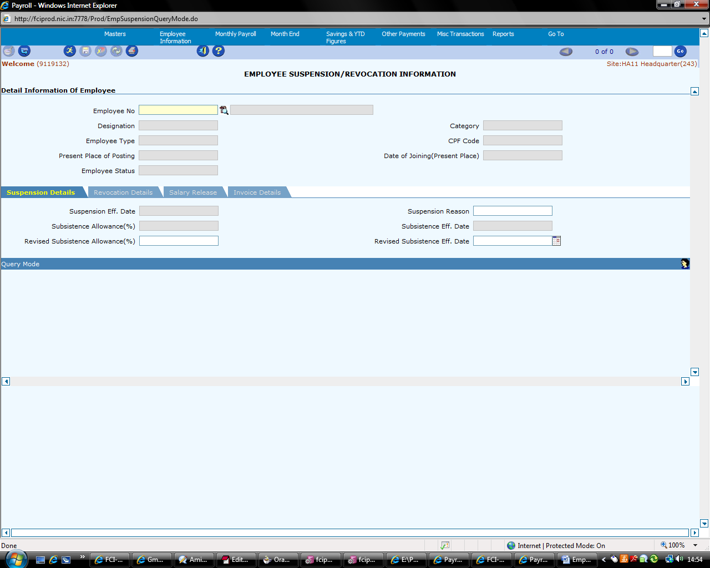

Field Description (Detail information of Employee)

Field Name | Field Type | Data Type | Description
Employee No | Mandatory | Numeric | Select from LOV
Designation | Read Only | Characters | Filled automatically after selecting the Employee No
Category | Read Only | Characters | Filled automatically after selecting the Employee No
Employee Type | Read Only | Characters | Filled automatically after selecting the Employee No
CPF Code | Read Only | Numeric | Filled automatically after selecting the Employee No
Present Place of Posting | Read Only | Characters | Filled automatically after selecting the Employee No
Date of Joining(Present Place) | Read Only | Date | Filled automatically after selecting the Employee No
Employee Status | Read Only | Characters | Filled automatically after selecting the Employee No

Field Description (Suspension Details)

Field Name | Field Type | Data Type | Description
Suspension Eff Date | Mandatory | Date | Select the Suspension Date
Suspension Reason | Non Mandatory | Characters | Enter the Suspension Reason
Subsistence Allowance (%) | Mandatory | Numeric | Enter the Subsistence Allowance percentage
Subsistence Eff Date | Mandatory | Date | Select the Subsistence Effective Date

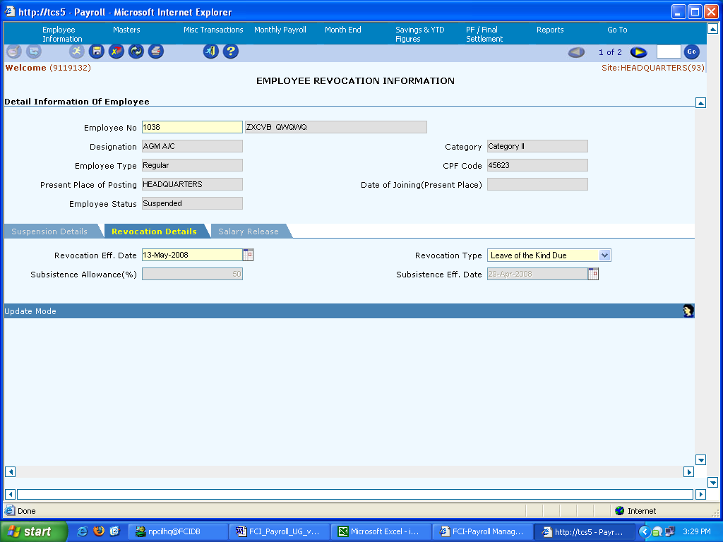

Field Description (Revocation Details)

Field Name | Field Type | Data Type | Description
Revocation Eff. Date | Mandatory | Date | Select the Revocation Effective Date
Revocation Type | Mandatory | Characters | Select the Revocation Type from the Drop Down List
Subsistence Allowance (%) | Read Only | Numeric | Filled automatically
Subsistence Eff. Date | Read Only | Date | Filled automatically

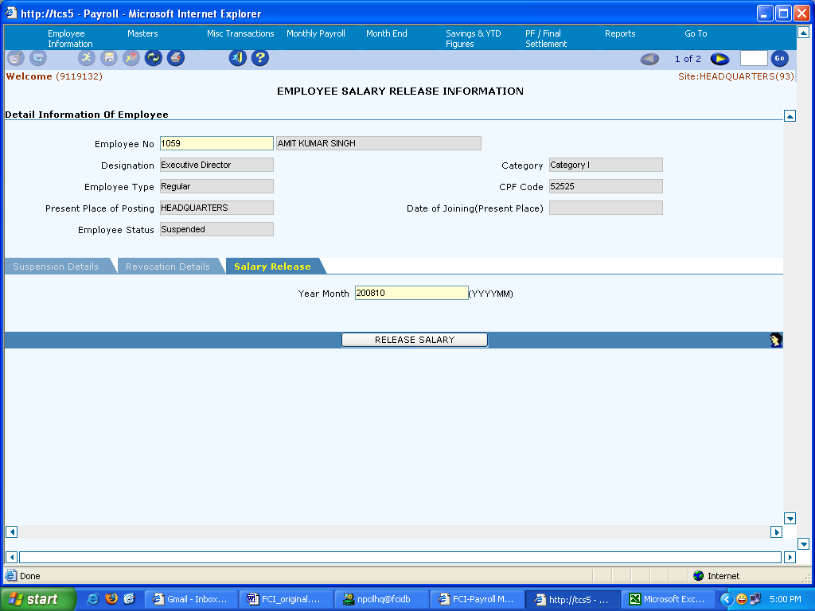

Field Description (Salary Release)

Field Name | Field Type | Data Type | Description
Year Month | Mandatory | Numeric | Enter the Year Month

PM Relief Fund
Note: With Reference to CR 290: We have created a process for deducting a fixed amount from an employee’s salary towards PM Relief Fund (pay code - 398). This has been done while computing monthly payroll of July 2013 only .

Deployments – 1st Aug 2013 to 31st Aug 2013

Arrear Report (DEPARTMENTAL LABOURS)

Task Name: Arrear Report
Task Description:

The Arrear Report will be used to get details of Arrears (Incentive/Salary) of all Dept. Labors at given location. This will be on demand report.
.

Prerequisites for performing the task:

None

Users who can perform the task:

Users from HR/EDP/Finance departments.

Task Procedure
- In the main menu select Reports → Incentive Report →Arrear Report
- The Arrear Report screen appears in Query mode.
- To view the report, enter the Year Month and click on the Generate Report button.
- To close the screen click on the Exit button.

Field Description (Details)

Field Name | Field Type | Data Type | Description
Start Month | Mandatory | NUMBER | specify start value of period For Which report should be generated
End Month | Mandatory | NUMBER | specify end value of period For Which report should be generated
Location | Optional | NUMBER | Enter depot for which report needs to be generated
Gang No | Optional | NUMBER | Enter gang id for which report needs to be generated
Employee Number | Optinal | NUMBER | Enter employee number
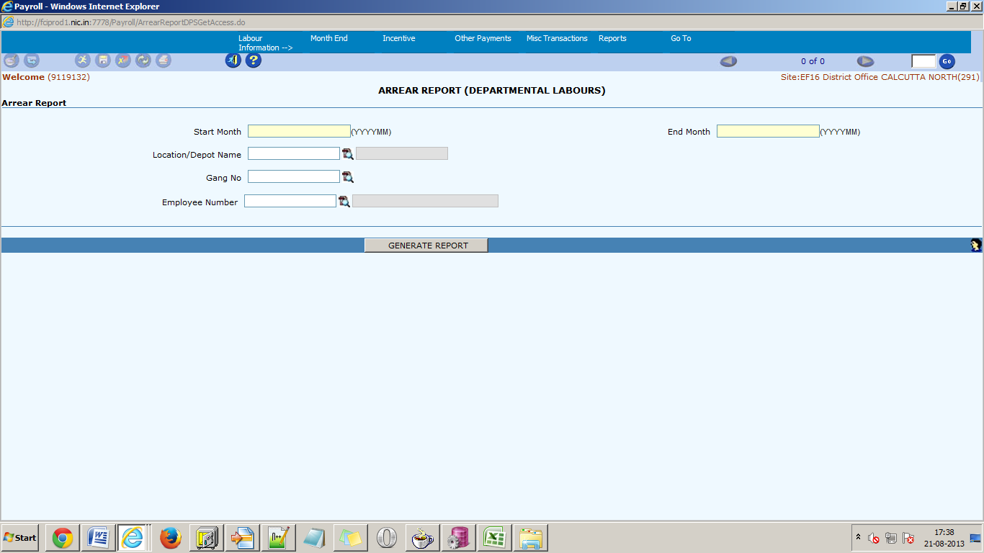

Over and Above Arrear

Task Name: Arrear generation and Undo arrear for Over and Above Components.

Task Description:
This screen allows user to generate arrear payments.

Prerequisites for performing the task:

None

Users who can perform the task:

Users from EDP department who are dealing with Payroll.

Task Procedure
- In the main menu select Other Payments → Arrear Payments(LE)
- The Arrear Payments (LE) screen appears in Query mode.
- To view details of arrear payments generated, click on the Execute icon. To view details specific to an specific period, enter start year month and end year month and then click on the Execute icon.
- To undo the payment, click on the UNDO ARREAR button. Details of all the payments generated earlier would be deleted except for those whose invoices are already sent.
- To generate arrears, Open screen in New Mode and enter the details in specific fields of Start Year Month, End Year Month, DA Type and then click on Generate Arrear button.
- To view the details of generated arrears Open Arrear Payment screen (Details mentioned in next heading.).
- GO button can be used to switch between records.
- To close the screen click on the Exit button.

Note:
  - Arrear from screen should be run right after basic arrear or DA/HRA ARREAR generation process.
  - Payments will be generated for a month only when either Basic arrear or DA/HRA ARREAR or both Basic arrear and DA/HRA ARREAR has already been generated for that year month.
  - Undo Arrear will be Allowed in only Two stages:
  - When Payroll is in un-initialized state i.e. salary calculation of that month has yet not been started.
  - When Month end of salary process has already been done.
  - Undo arrear will delete the details of all the payments generated except for those whose invoices are already sent.
  - For those whose recovery (not payments only recoveries) has been generated via arrear generation process, undo done after month-end will not delete their details.

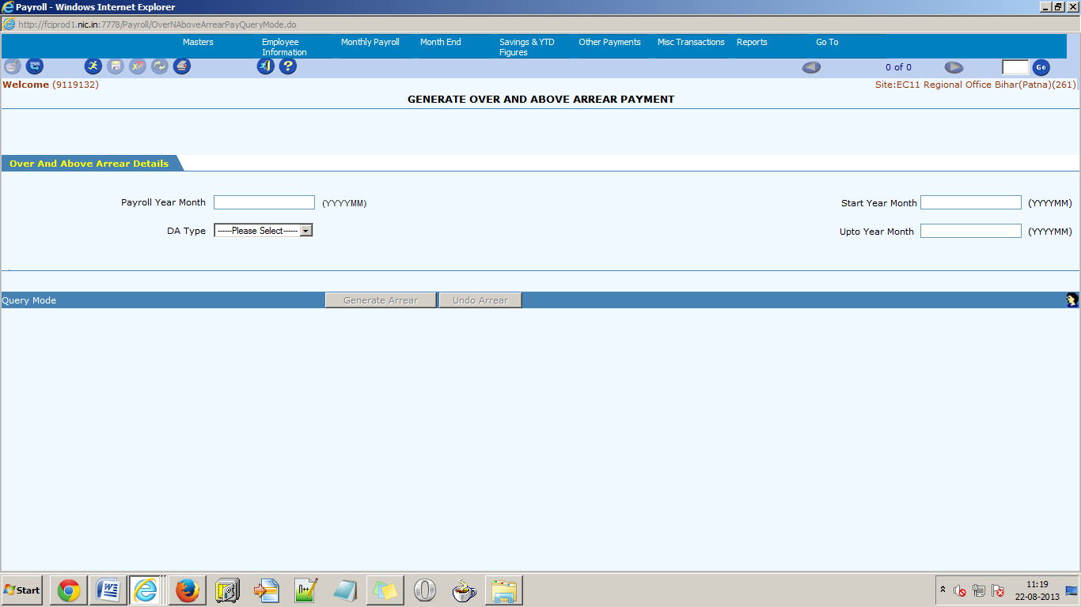
Arrear Payments (LE) in Query Mode

Field Descriptions (Query Mode)

Field Name | Field Type | Data Type | Description
Payroll Year Month | Optional | Numeric | Enter Payroll Year Month for which generated payments needs to be queried.
Start Year Month | Optional | Numeric | Enter Start Year Month for which generated payments needs to be queried.
End Year Month | Optional | Numeric | Enter End Year Month for which generated payments needs to be queried.
DA Type | Optional | Characters | Select DA type from drop down.

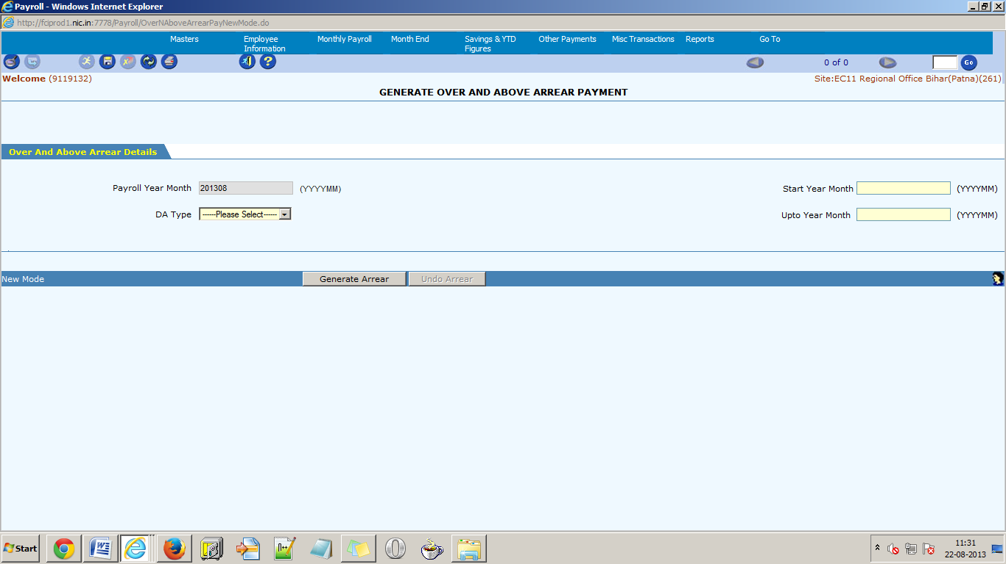
Arrear Payment (LE) in insert mode

Field Descriptions (Insert Mode)

Field Name | Field Type | Data Type | Description
Payroll Year Month | Read-Only | Numeric | Current Payroll Month of site Auto populated.
Start Year Month | Mandatory | Numeric | Enter Start Year Month for which generated payments needs to be generated.
End Year Month | Mandatory | Numeric | Enter End Year Month for which generated payments needs to be generated.
DA Type | Mandatory | Characters | Select DA type from drop down.

12.View Location Details

Task Name: View Location Details

Task Description:

This screen allows the user to maintain the location details. The View Location Locations Screen will be used to view various Locations and their corresponding contact details that are specific to FCI.

Prerequisites for performing the task:

Any user who has the knowledge and permission of the payroll section can use the screen.

Users who can perform the task:

Person from EDP/Finance departments who are dealing with Payroll.

Task Procedure
- From the main menu select Masters → Apps Integration Master → View Location Details
- The View Location Details screen appears in Query mode.
- To view existing details, first select the Location Type and click on the Get Detail button. The details are populated.
- All the details are only for the view purpose, except for the Depots, where new details can be added.
- New row can only be inserted in the Depot section. Click on the Add Row button and a new row is inserted at the end.
- To delete the row, select the row, click on the Delete Row button. Already saved rows cannot be deleted.
- To save the data click on the Save button. After successful saving, message “Data Saved Successfully” is displayed.
- To close the screen click on the Exit button.

13.Maintain Employee Designation For 6th Pay

Task Name: Maintain Employee Designation For 6th Pay

Task Description:

This screen allows the user to maintain : Maintain Employee Designation For 6th Pay. Maintain Employee Designation For 6th Pay Screen will be used to capture employee designation for 6th Pay that are specific to FCI.

Prerequisites for performing the task:

Any user who has the knowledge and permission of the payroll section can use the screen.

Users who can perform the task:

Person from EDP/Finance departments who are dealing with Payroll.

Task Procedure
1.From the main menu select Masters → Payroll Masters → Maintain Employee Designation For 6th Pay.
2.The Maintain Employee Designation For 6th Pay screen appears in Query mode.
3.To view existing details, first select the Pay Code and click on the Get Detail button. The details are populated.
4.New row can only be inserted by Clicking on the Add Row button and a new row is inserted at the end.
5.To delete the row, select the row, click on the Delete Row button.
6.To save the data click on the Save button. After successful saving, message “Data Saved Successfully” is displayed.
7.To close the screen click on the Exit button.

14.Maintain Interest Rates of Loan

Task Name: Maintain Interest Rate of Loan

Task Description:

This screen maintains the interest rates that are applicable for a particular type of loan for a definite period of time. The rates thus maintained are taken into account for computing interest for the various types of loans. Interest rates differ for different types of loan and also for different slabs. When payroll computation takes place, the system automatically fetches the interest rate that is applicable for a particular loan and calculates the interest accordingly. The interest rates as well as the principal amounts and validity dates can be updated in case of revision.

Prerequisites for performing the task:

The relevant loan type should exist in the module and the interest rates on various loans relevant to the organization should be known before performing this task.

Users who can perform the task:

Users from HR/EDP departments who are dealing with Payroll/HR.

Task Procedure
- From the main menu select Masters → Payroll Masters → Maintain Loan Interest Rates.
- The Maintain Interest Rates on Loans screen appears in Query mode.
- Select the Loan type from the LOV to view the specific loan type records and then click on Get Detail or Click on the Get detail button, to view all the records.
- For inserting a new row into the grid click on the Add Row button. A new blank row is inserted at the end of the grid.
- To delete a row, select the row and click on the Delete Row button. Already saved rows cannot be deleted.
- To save the data click on the Save button. After successful saving, message “Data Saved Successfully” is displayed.
- GO button can be used to switch between records.
- To close the screen click on the Exit button.

15.Miscellaneous Allowance Six Pay
Task Name: Miscellaneous Allowance Six Pay
Task Description:

This screen allows the user to maintain Miscellaneous Allowance Six Pay. Miscellaneous Allowance Six Pay Screen will be used to capture rate of miscellaneous allowances for 6th Pay that are specific to FCI.

Prerequisites for performing the task:

Any user who has the knowledge and permission of the payroll section can use the screen.

Users who can perform the task:

Person from EDP/Finance departments who are dealing with Payroll.

Task Procedure
1.From the main menu select Masters → Payroll Masters → Miscellaneous Allowance Six Pay.
2.The Miscellaneous Allowance Six Pay screen appears in Query mode.
3.To view existing details, first select the Pay Code and click on the Get Detail button. The details are populated.
4.New row can only be inserted by Clicking on the Add Row button and a new row is inserted at the end.
5.To delete the row, select the row, click on the Delete Row button.
6.To save the data click on the Save button. After successful saving, message “Data Saved Successfully” is displayed.
7.To close the screen click on the Exit button.

16.Special Compensatory Allowance 6 pc

Task Name: Spl Compensatory Allowance 6 pc
Task Description:

This screen allows the user to maintain Spl Compensatory Allowance 6 pc. Spl Compensatory Allowance 6 pc Screen will be used to capture rate of special compensatory allowances for 6th Pay that are specific to FCI.

Prerequisites for performing the task:

Any user who has the knowledge and permission of the payroll section can use the screen.

Users who can perform the task:

Person from EDP/Finance departments who are dealing with Payroll.

Task Procedure
1.From the main menu select Masters → Payroll Masters → Spl Compensatory Allowance 6 pc.
2.The Spl Compensatory Allowance 6 pcscreen appears in Query mode.
3.To view existing details, first select the Pay Code and click on the Get Detail button. The details are populated.
4.New row can only be inserted by Clicking on the Add Row button and a new row is inserted at the end.
5.To delete the row, select the row, click on the Delete Row button.
6.To save the data click on the Save button. After successful saving, message “Data Saved Successfully” is displayed.
7.To close the screen click on the Exit button.

17.View City Type and Location Mapping
Task Name: View City Type Location Mapping

Task Description:

This screen allows the user to view mapping of Location with its respective City Type.

Prerequisites for performing the task:

Any user who has the knowledge and permission of the payroll section can use the screen.

Users who can perform the task:

Person from EDP/Finance departments who are dealing with Payroll.

Task Procedure
- From the main menu select Masters → Payroll Masters → View City Type & Location Mapping
- The View City Type Location Mapping screen appears in Query mode.
- To view the existing details/ add new, first click on the Get Detail button.
- For inserting a new row into the grid click on the Add Row button. A new blank row is inserted at the end.
- Now the HRA city type, remote area type, population type, MGW type, effective from should be selected if applicable.
- To delete a row, select the row then click on the Delete Row button. Already saved rows cannot be deleted.
- An existing record can be updated by adding a new row. But keep in mind that user can only add a new row after end dating the existing row. So that there will be only one record which is valid and whose end date is blank.
- To save the data click on the Save button. After successful saving, message “Data Saved Successfully” is displayed.
- GO button can be used to switch between different pages.
- To close the screen click on the Exit button.

18.Lease Accommodation Details

Task Name: Lease Accommodation Details

Task Description:

This screen allows user to view/create lease accommodation details of the employees of the organization. Lease Amount is charged only for Self Lease and 3rd Party Lease Accommodation. No License Fee or Lease Amount is charged for Spouse Accommodation.
Prerequisites for performing the task:

None

Users who can perform the task:

Users from EDP department who are dealing with Payroll.

Task Procedure
- In the main menu select Misc Transactions → Lease Accommodation Details
- The Lease Accommodation Details screen appears in Query mode.
- To view details of all the employees who have availed lease accommodation, click on the Execute icon. To view details specific to an employee, select the Employee No from the LOV and then click on the Execute icon.
- To Update the Lease Accommodation details for an employee, End date all the previously saved records, by selecting the To Date, save the data and then add a new row by clicking on the Add Row button.
- To delete a row, select the row and then click on the Delete Row button. Already saved rows cannot be deleted.
- To insert a new Lease Accommodation Entry for an Employee, click on the Insert icon. Select the Employee No from the LOV, fill the details and Save the data.
- To save the data, click on the Save icon. After successfully saving, the message “Data saved successfully” is displayed.
- GO button can be used to switch between records.
- To close the screen click on the Exit button.

19.Loan/Advance Details(Admin)
Task Name: Maintain Loan/Advance Details(Admin)

Task Description:

This screen maintains the details regarding the disbursal of the loan/advances to the employees of the organization.

Prerequisites for performing the task:

The relevant loan type should exist in the module.

Users who can perform the task:

Users from HR/EDP departments who are dealing with Payroll/HR.

Task Procedure
1.From the main menu select Misc Transactions→ Loan/Advance Details(Admin)
2.The Loan/Advance Details(Admin) screen appears in Query mode.
3.To view all the loans disbursed, click on the Execute icon. To view loans disbursed, specific to an employee, select the Employee No from the LOV and then click on the Execute icon.
4.To disburse a new loan to this employee, click on the Add Row button. A new blank row is inserted at the end. Enter the relevant details and click on the save button.
5.To delete a row, select the row and click on the Delete Row button. Already saved rows cannot be deleted.
6.To disburse a new loan, click on the Insert icon. Select the Employee No from the LOV, fill in the relevant details and save the data.
7.To save the data click on the Save button. After successful saving, message “Data Saved Successfully” is displayed.
8.GO button can be used to switch between records.
9.To close the screen click on the Exit button.

Note
1.Whenever a new loan is disbursed, an invoice is send to the Accounts Payable Module for payment to employee.

20.Loan/Advance Details(Bulk)

Task Name: Maintain Loan/Advance Details(Bulk)

Task Description:

This screen maintains the details regarding the disbursal of the loan/advances to the employees of the organization.

Prerequisites for performing the task:

The relevant loan type should exist in the module.

Users who can perform the task:

Users from HR/EDP departments who are dealing with Payroll/HR.

Task Procedure
- From the main menu select Misc Transactions→ Loan/Advance Details(Bulk)
- The Loan/Advance Details (Bulk) screen appears in Query mode.
- To view all the loans disbursed, click on the Execute icon. To view loans disbursed, specific to an employee, select the Employee No from the LOV and then click on the Execute icon.
- To disburse a new loan to this employee, click on the Add Row button. A new blank row is inserted at the end. Enter the relevant details and click on the save button.
- To delete a row, select the row and click on the Delete Row button. Already saved rows cannot be deleted.
- To disburse a new loan, click on the Insert icon. Select the Employee No from the LOV, fill in the relevant details and save the data.
- To save the data click on the Save button. After successful saving, message “Data Saved Successfully” is displayed.
- GO button can be used to switch between records.
- To close the screen click on the Exit button.

Note
Whenever a new loan is disbursed, an invoice is send to the Accounts Payable Module for payment to employee.

21.Loan/Advance Details(Super User)

Task Name: Maintain Loan/Advance Details

Task Description:

This screen maintains the details regarding the disbursal of the loan/advances to the employees of the organization.

Prerequisites for performing the task:

The relevant loan type should exist in the module.

Users who can perform the task:

Users from HR/EDP departments who are dealing with Payroll/HR.

Task Procedure
- From the main menu select Misc Transactions→ Loan/Advance Details(Super User)
- The Loan/Advance Details(Super User) screen appears in Query mode.
- To view all the loans disbursed, click on the Execute icon. To view loans disbursed, specific to an employee, select the Employee No from the LOV and then click on the Execute icon.
- To disburse a new loan to this employee, click on the Add Row button. A new blank row is inserted at the end. Enter the relevant details and click on the save button.
- To delete a row, select the row and click on the Delete Row button. Already saved rows cannot be deleted.
- To disburse a new loan, click on the Insert icon. Select the Employee No from the LOV, fill in the relevant details and save the data.
- To save the data click on the Save button. After successful saving, message “Data Saved Successfully” is displayed.
- GO button can be used to switch between records.
- To close the screen click on the Exit button.

Note
Whenever a new loan is disbursed, an invoice is send to the Accounts Payable Module for payment to employee.

22.Maintain Direct Payroll transaction(Bulk)

Task Name: Maintain Direct Payroll Transactions

Task Description:

This function maintains all adhoc payments or deductions that are made through payroll. This function deals with the miscellaneous payments or deductions that may be very adhoc or remainder from the past payroll computations. Payments or recovery can be made spanning any time period or at a single transaction. This functionality enables the user to deal with any payment/recovery that is not within the scope of the regular payroll process e.g. the excess third party lease amount can be recovered from employees salary by entering an instruction using this functionality. Other recoveries like, Society recoveries, court recoveries, bank loan recoveries, backdated leave recoveries can also be handled thru this screen. This function takes care of any income tax implications for the adhoc payment/deduction. During insertion, Effective Year Month cannot be lesser than the current Year Month. No Updation is allowed in the screen. During payroll processing insertion and deletion is not allowed in the screen. Entries which have been processed during the payroll cannot be deleted from the screen.

Prerequisites for performing the task:

None

Users who can perform the task:

Users from EDP/Finance departments having appropriate access rights.

Task Procedure
- In the main menu select Misc. Transactions → Maintain Direct Payroll.
- The Maintain Direct Payroll Transaction screen appears in Query mode.
- Three option buttons (Employee Wise, Pay Code Wise, and Miscellaneous) are present. These are provided for the convenience of data entry and viewing.
- To view details specific to an employee select the employee wise option and select the Employee no. To view details specific to a pay code, select the Pay code wise option and select the Pay code. To view all the details select the miscellaneous option.
- To get the details, click on the Get detail button.
- To insert a new transaction, click on the Insert toolbar icon and Select the respective tab.
- For inserting a new row into the grid click on the Add Row button. An empty new row is added at the end of the list.
- For deleting a row of the grid, select the row and click on the Delete Row button. The selected row is deleted.
- To save the changes click on the Save button. After successful saving, message “Data Saved Successfully” is displayed.
- GO button can be used to switch between different records.
- To close the screen click on the Exit button.

Note
- Once Monthly Payroll has been run for the month, the records are locked and no data modification is allowed on the record.
- To modify the record for a particular employee Undo the Monthly payroll for the particular employee and then you can proceed to do any changes.
- If you are inserting a new record after Monthly Payroll has been run, then the valid from Year month for the new entered record should not be lesser than the current year month.

23.Post Year End Remittances to AP

Task Name: Post Year End Remittances to AP

Task Description:
This process posts the consolidated Remittances of the location to the Accounts Payable module of that location.

Prerequisites for performing the task:

Month End Updates should be performed and salary Invoices must be posted.

Users who can perform the task:

Users from EDP department who are dealing with Payroll.

Task Procedure
- In the main screen, select Month End → Post Year End Remittances to AP.
- The Post Year End Remittances to AP screen appears in Query mode.
- Click on the Post Year End Remittances to AP button to start the execution of the process.
- After successful execution, the success message is displayed.
- To close the screen click on the Exit button.

Important Note: The Invoice Number follows the nomenclature (YYYYMMNNNNNN) where YYYYMM is the Payroll Year-Month, NNNNNN is running serial number. User can search the invoice thru AP Invoices Enquiry screen in Oracle Apps for a particular month giving the supplier name/supplier number and Year-Month in YYYYMM format. The invoice date is the system date on which the invoice is sent from the payroll system.

24.Arrear Payment(LE)

Task Name: Arrear generation and Undo arrear for Over and Above Components.

Task Description:
This screen allows user to generate arrear payments.

Prerequisites for performing the task:

None

Users who can perform the task:

Users from EDP department who are dealing with Payroll.

Task Procedure
- In the main menu select Other Payments → Arrear Payments(LE)
- The Arrear Payments (LE) screen appears in Query mode.
- To view details of arrear payments generated, click on the Execute icon. To view details specific to an specific period, enter start year month and end year month and then click on the Execute icon.
- To undo the payment, click on the UNDO ARREAR button. Details of all the payments generated earlier would be deleted except for those whose invoices are already sent.
- To generate arrears, Open screen in New Mode and enter the details in specific fields of Start Year Month, End Year Month, DA Type and then click on Generate Arrear button.
- To view the details of generated arrears Open Arrear Payment screen (Details mentioned in next heading.).
- GO button can be used to switch between records.
- To close the screen click on the Exit button.

Note:
  - Arrear from screen should be run right after basic arrear or DA/HRA ARREAR generation process.
  - Payments will be generated for a month only when either Basic arrear or DA/HRA ARREAR or both Basic arrear and DA/HRA ARREAR has already been generated for that year month.
  - Undo Arrear will be Allowed in only Two stages:
  - When Payroll is in un-initialized state i.e. salary calculation of that month has yet not been started.
  - When Month end of salary process has already been done.
  - Undo arrear will delete the details of all the payments generated except for those whose invoices are already sent.
  - For those whose recovery (not payments only recoveries) has been generated via arrear generation process, undo done after month-end will not delete their details.

25.IT Supplimentary Payment Report

- Task Name: IT Supplimentary Payment Report
Task Description:

IT Supplimentary Payment Report Reports will be used for generating IT Supplimentary Payment Report for employees at particular location for given duration of Year Month.

Prerequisites for performing the task:

None

Users who can perform the task:

Users from HR/EDP/Finance departments.

Task Procedure
1. In the main menu select Reports → Income Tax Reports
2. The IT Supplimentary Payment Report screen appears in Query mode.
3. To view the report, enter the Year Month and click on the GENERATE SUPPLEMENTARY PAYMENT REPORT button.
4.To close the screen click on the Exit button.

26.Advance Outstanding Report

Task Name: Advance Outstanding Report
Task Description:

Advance Outstanding Reports will be used for generating Advance Outstanding Report for employees at particular location for given duration of Year Month.

Prerequisites for performing the task:

None

Users who can perform the task:

Users from HR/EDP/Finance departments.

Task Procedure
1. In the main menu select Reports → Loan And Advances Reports
2. The Advance Outstanding Report screen appears in Query mode.
3. To view the report, enter the Year Month and click on the ADVANCE OUTSTANDING REPORT button.
4.To close the screen click on the Exit button.

27.Loan Outstanding Report

1.Task Name: Loan Outstanding Report
Task Description:

Loan Outstanding Reports will be used for generating Loan Outstanding Reports for employees at particular location for given duration of Year Month.

Prerequisites for performing the task:

None

Users who can perform the task:

Users from HR/EDP/Finance departments.

Task Procedure
1. In the main menu select Reports → Loan And Advances Reports
2. The Loan Outstanding Report screen appears in Query mode.
3. To view the report, enter the Year Month and click on the LOAN OUTSTANDING REPORT button.
4.To close the screen click on the Exit button.

28.Loan Sanctions Report

1.Task Name: Loan Sanctions Report
Task Description:

Loan Sanctions Reports will be used for generating Loan Sanctions Reports for employees at particular location for given duration of Year Month.

Prerequisites for performing the task:

None

Users who can perform the task:

Users from HR/EDP/Finance departments.

Task Procedure
1. In the main menu select Reports → Loan Sanctions Report
2. The Loan Sanctions Report screen appears in Query mode.
3. To view the report, enter the Year Month and click on the LOAN REPAYMENT REPORT button.
4.To close the screen click on the Exit button.

29.Loan/Advance Sanctions Report

Task Name: Loan/Advance Sanctions Report
Task Description:

The Loan/Advance Sanctions Report will be used for generating employees Loan/Advance Sanctions Report for employees at particular location for given duration of Year Month.

Prerequisites for performing the task:

None

Users who can perform the task:

Users from HR/EDP/Finance departments.

Task Procedure
1. In the main menu select Reports → Loan and Advances Report
2. The Loan and Advances Report screen appears in Query mode.
3. To view the report, enter the Year Month and click on the Loan/Advance Sanctions Report button.
4.To close the screen click on the Exit button.

30.DA/HRA ARREAR Report

Task Name: DA/HRA ARREARs
Task Description:

The DA/HRA ARREARs Report will be used for generating employees DA/HRA ARREARs Report for employees at particular location for given duration of Year Month.

Prerequisites for performing the task:

None

Users who can perform the task:

Users from HR/EDP/Finance departments.

Task Procedure
1. In the main menu select Reports → DA/HRA arrear Report
2. The → DA/HRA arrear Report screen appears in Query mode.
3. To view the report, enter the Year Month and click on the Generate Arrear Report button.
4.To close the screen click on the Exit button.

31.Maintain Cafeteria Approach Details

Task Name: Maintain Cafeteria Approach Details

Task Description:

This screen allows the user to maintain the Cafeteria Approach details. The Maintain Cafeteria Approach Screen will be used to capture various Pay Codes that are specific to FCI.

Prerequisites for performing the task:

Any user who has the knowledge and permission of the payroll section can use the screen.

Users who can perform the task:

Person from EDP/Finance departments who are dealing with Payroll.

Task Procedure
- From the main menu select Masters → Payroll Masters → Maintain Cafeteria Approach Details
- The Maintain Cafeteria Approach Details screen appears in Query mode.
- To view existing details, first select the Pay Code and click on the Get Detail button. The details are populated.
- New row can only be inserted by Clicking on the Add Row button and a new row is inserted at the end.
- To delete the row, select the row, click on the Delete Row button.
- To save the data click on the Save button. After successful saving, message “Data Saved Successfully” is displayed.
- To close the screen click on the Exit button.

32.Employee Transfer

Task Name: Employee Transfer

Task Description:

The screen allows the user to view/create Employee Transfer details. The screen is used to transfer employees of the current location to some other location. The screen shows the details of the transferred employee, till he joins at the other location.
Prerequisites for performing the task:

None

Users who can perform the task:

Users from HR/EDP/Finance departments.

Task Procedure
- In the main menu select Employee Information → Employee Transfer
- The Employee Transfer screen appears in Query mode.
- To get details of all the transferred employees, click on the Execute button. To view details specific to an employee, select the Employee No from the LOV and then click on the Execute icon.
- To transfer a new employee, click on the Insert icon. Fill in the details and save the data.
- To save a detail click on the Save button. After saving “Data saved successfully” is displayed.
- GO button can be used to switch between different records.
- To Generate the Last Pay Certificate of the employee, click on the Generate LPC button.
- To cancel the transfer of an employee, fetch the details of the employee, by selecting the Employee No and clicking on Execute icon and then click on the Cancel Transfer button.
- To close the screen click on the Exit button.

The List of Values for selection of the employees to show all the employees for which the salary was made in a unit so that LPC can be taken out any time
( Refer Supplementary user Guide Section 4.4)

33.Maintain Employee Details

Task Name: Maintain Employee Details

Task Description:

This screen allows the user to maintain the Employee details. A new employee can be made to join the organization using this screen. The screen also maintains the financial details (like pay scale type, increment status, pay status etc.) of the employees.

Prerequisites for performing the task:

Any user who has the knowledge and permission of the payroll section can use the screen.

Users who can perform the task:

Person from EDP/Finance departments who are dealing with Payroll.

Task Procedure
- From the main menu select Employee Information → Maintain Employee Details
- The Employee information screen appears in Query mode. To view the details of all the employees of the current location, click on the Execute icon. To view details, specific to a field, select the respective field on the screen and then click on the Execute icon.
- To insert a new employee into the organization, click on the Insert toolbar icon. Enter all the relevant details and save the data.
- To enter/view the Payroll details, click on the Payroll Details. To enter/view the Payroll Flag details, click on the Payroll Flag Details. To enter/view the HRMS Details, click on the HRMS Details. To enter/view Address Details click on the Address Details. Enter the details and save the data.
- To save the data click on the Save button. After successful saving, message “Data Saved Successfully” is displayed.
- GO button can be used to switch between different pages.
- To close the screen click on the Exit button.

34.Maintain Employee Details(Super User)

The employee data loaded into the system is as on 31st March 2008. The employee data is to be updated for the cut-over date using the Maintain Employee Details ( Super User ) Screen.

Task Name: Maintain Employee Details ( Super User)

Task Description:

This screen allows the user to modify the Employee details. The access to this screen is restricted to the Super user only. The employee details can be modified thru this screen. The screen also maintains the financial details (like pay scale type, increment status, pay status etc.) of the employees.

Prerequisites for performing the task:

Any user who has the super user permission can use the screen.

Users who can perform the task:

Person from EDP/Finance departments who are dealing with Payroll.

Task Procedure
- From the main menu select Employee Information → Maintain Employee Details (Super user)
- The Employee information (super user) screen appears in Query mode. To view the details of all the employees of the current location, click on the Execute icon. To view details, specific to a field, select the respective field on the screen and then click on the Execute icon.
- If some Employee information is not coming correct, update the field
In addition, rectify the Payroll related details of the employee for Six Pay Commission requirements..
- Change the employee Pay Revision Flag to ‘Revised Pay Scale’.
- Update the designation to the correct designation. This will set the proper category, pay band / scale and grade pay for the employee as per the revised scale. It is important to re-enter the designation for the first time for setting up the proper pay-band/ scale and grade pay.
- To enter/view the Payroll details, click on the Payroll Details. To enter/view the Payroll Flag details, click on the Payroll Flag Details. To enter/view the HRMS Details, click on the HRMS Details. To enter/view Address Details click on the Address Details. Enter the details and save the data.
- To save the data click on the Save button. After successful saving, message “Data Saved Successfully” is displayed.
- GO button can be used to switch between different pages.
- To close the screen click on the Exit button.

35.Employee Increment Information

Task Name: Employee Increment Information

Task Description:

This screen allows the user to maintain the Employee Increment details. The Employee’s basic pay gets incremented, the increment can be stopped or released using this screen.

Prerequisites for performing the task:

Any user who has the knowledge and permission of the payroll section can use the screen.

Users who can perform the task:

Person from EDP/Finance departments who are dealing with Payroll.

Task Procedure
- From the main menu select Employee Information → Maintain Employee Increment
- The Employee Increment screen appears in Query mode. To view the details of the Employees who have already got increment, select the Employee No from the LOV and click on the Execute icon.
- To increment a new Employee, click on the Insert toolbar icon.
- Select the Employee No from the LOV, the detail information of the Employee is populated.
- To enter the Advance Increment Details, click on the Advance Increment tab, enter the relevant details and save the data. Employee’s basic pay gets incremented in accordance to the no. of advance increments given.
- To enter the Stop/Release Increment details, click on Stop/Release tab. Select the Employee No from the LOV, employee details are populated. Enter the Increment status and Increment Effective Date and then save the data.
- To save the data click on the Save button. After successful saving, message “Data Saved Successfully” is displayed.
- GO button can be used to switch between different pages.
- To close the screen click on the Exit button.

36.Maintain Employee Leave

Task Name: Maintain Employee Leave

Task Description:

The screen allows the user to view/create Employee Leave details. Applied leaves can also be cancelled using this screen.
Prerequisites for performing the task:

None

Users who can perform the task:

Users from HR/EDP/Finance departments.

Task Procedure
- In the main menu select Employee Information → Maintain Employee Leave
- The Maintain Employee Leave screen appears in Query mode.
- User can view/create the leave details for all the employees as well as for a particular employee, by selecting the respective option. For viewing the details of a particular employee, select the Employee no from the LOV and click on Get Detail button. To view/enter details specific to a Year Month period, user can enter the From & To Year Month and then click on Get Detail button.
- To add a new row, click on the Add Row button, a new row is added at the end.
- To delete a row select the row and click on the Delete Row button. Already saved rows cannot be deleted.
- To cancel a particular leave, select the leave and click on the Cancel Leave button.
- To insert a new leave detail, click on the Insert icon. Add a row, fill the relevant fields and save the data.
- To save leave details click on the Save button. After saving “Data saved successfully” is displayed.
- GO button can be used to switch between different pages.
- To close the screen click on the Exit button.

Note:
EOL Leaves can be converted to LWP or vice versa through Maintain Employee Leaves screen.
If the labour is taking one LWP in week, the coming Sunday he will be getting MGW and count of LWP will increase to the no. of LWP entered.
LWP will be similar to other leaves already present in the system with only exception of Sunday.
These can be cancelled or approved in the next month through maintain leave screen.
Labour attendance screen will not allow user to enter more than 15 leaves for one calendar year.
As the leaves are cancelled or approved afterwards then the labour will get arrear or amount will be deducted from the labour’s account.

Change wrt CR - 147 :
A new leave type is added in Maintain Employee Leave screen ( for Emloyee Module), leave nomenclature as “Special Causal leave”.

37.Employee Reinstate details

Task Name: Maintain Employee Reinstate details

Task Description:

The screen allows the user to view/create Employee Reinstate details. Any Employee who has been separated from the organization and after a period of time, the Site wants to re-join him, back into the organization.This screen is useful for employees/labours, who have not attained the age of 60 years.This functionality does not generate the arrear automatically. Hence the user has to use the arrear functionality separately (if applicable).
Prerequisites for performing the task:

None

Users who can perform the task:

Users from HR/EDP/Finance departments.

Task Procedure
- In the main menu select Employee Information → Maintain Employee Reinstate
- The Employee Reinstate screen appears in Query mode.
- To view all the existing reinstate details, click on the Execute icon. To view details specific to an Employee, select the Employee No from the LOV and then click on the Execute icon
- To reinstate a new Employee, click on the Insert icon. Select the Employee No from the LOV, the Employee details are populated. Enter the reinstate details and save the data.
- To save the data click on the Save button. After saving “Data saved successfully” is displayed.
- Go button can be used to switch between different pages.
- To close the screen click on the Exit button.

Maintain Location Details

Task Name: Maintain Location Details

Task Description:

This screen allows the user to maintain the location details. The Maintain Locations Screen will be used to capture various Locations and their corresponding contact details that are specific to FCI.

Prerequisites for performing the task:

Any user who has the knowledge and permission of the payroll section can use the screen.

Users who can perform the task:

Person from EDP/Finance departments who are dealing with Payroll.

Task Procedure
- From the main menu select Masters → Apps Integration Master → Maintain Location Details
- The Maintain Location Details screen appears in Query mode.
- To view existing details, first select the Location Type and click on the Get Detail button. The details are populated.
- All the details are only for the view purpose, except for the Depots, where new details can be added.
- New row can only be inserted in the Depot section. Click on the Add Row button and a new row is inserted at the end.
- To delete the row, select the row, click on the Delete Row button. Already saved rows cannot be deleted.
- To save the data click on the Save button. After successful saving, message “Data Saved Successfully” is displayed.
- To close the screen click on the Exit button.

39.Maintain DA Rates

Task Name: Maintain DA Rates

Task Description:

This screen maintains the Dearness Allowance Rates. There are different slabs of basic with boundary minimum (low basic) and maximum values (high basic). The DA rates changes quarterly for IDA and half yearly for CDA.
A standard slab of lower limit 0 and upper limit 99999 is used.

Prerequisites for performing the task:

The user should know DA slabs & rates before performing this task.

Users who can perform the task:

Users from HR/EDP departments who are dealing with Payroll.

Task Procedure
- From the main menu select Masters → Payroll Masters → Maintain DA rates
- The Maintain DA Rates screen appears in Query mode.
- Select between the IDA or CDA tab option.
- To view all the existing details, click on the Execute icon. To view details specific to a Year Month, select the Year Month and then click on the Execute icon.
- To insert a new DA rate record, click on the Insert icon. Enter the Year and Month. Click on the Add Row button, to insert a new row. Year Month cannot be lesser than the previous Year Month.
- To delete a row, select the row and click on the Delete Row button. Already saved rows cannot be deleted.
- To save the data click on the Save button. After successful saving, message “Data Saved Successfully” is displayed.
- GO button can be used to switch between pages, in case of multiple record pages.
- To close the screen click on the Exit button.

40.Maintain Employee Designation

Task Name: Maintain Employee Designation

Task Description:

The screen allows user to enter / view details of Employee Designation.
The Maintain Designation Screen will be used to capture various Posts that are specific to FCI and link them with Employee Category and Pay scale.

Prerequisites for performing the task:

The user should know the pay scale codes before performing this task.

Users who can perform the task:

Authorized usage. Only those can use who have access to the screen.

Task Procedure
1. From the main menu select Masters → Payroll Masters → Maintain Designation
- The Maintain Employee Designation screen appears in Query mode.
- To view existing records/add new record click on the Get detail button.
- For inserting a new record click on the Add Row button. Fill in the required fields. If the designation belongs to the board then click on the board flag checkbox.
- To delete a row select the row and click on the Delete Row button. Already saved rows cannot be deleted.
- Modification in the rows is allowed.
- To save the data click on the Save button. After successful saving, message “Data Saved Successfully” is displayed.
- GO button can be used to switch between pages, if there are multiple record pages.
- To close the screen click on the Exit button.

41.Maintain HRA Rates

Task Name: Maintain HRA Rates

Task Description:

The screen allows user to enter / view details for House Rent Allowance.
All employees not having company provided Accommodation are entitled to HRA. Based on this, the payroll is run for the employee. This value is fixed for employees in a particular class of cities, and a fixed percentage of the basic salary is given to him as HRA basing on his city. This fixed value is updated in case of revision of the amount.

Prerequisites for performing the task:

The user should know HRA slabs & rates before performing this task.

Users who can perform the task:

Person from EDP/Finance departments who are dealing with Payroll.

Task Procedure
- From the main menu select Masters → Payroll Masters → Maintain HRA Rates.
- The Maintain HRA Rates screen appears in Query mode.
- To view existing HRA details click on the Get Detail button.
- For inserting a new row into the grid click on the Add Row button. A new blank row is inserted at the end. Insertion of duplicate row i.e. same combination of Type & Type of City is not allowed.
- Updation of existing records is allowed by changing the Effective Date & then entering the HRA percentage. On Updation the previous record automatically gets an end date.
- To delete a row while entering data, select the row and click on the Delete Row button. Already saved rows cannot be deleted.
- To save a row, click on the Save button. After successful saving, message “Data Saved Successfully” is displayed.
- GO button can be used to switch between pages, if there are multiple record pages.
- To close the screen click on the button Exit.

42.Maintain Pay Codes

Task Name: Maintain Pay Codes

Task Description:

This screen allows the user to maintain the various pay codes against which payments and recoveries are to be affected in salary. Pay codes are created in order to track the different areas of payments or deductions for an employee. All salary transactions eventually correspond to one pay code or other.

Prerequisites for performing the task:

All earning and deduction components along with the details relevant to the organisation should be known before performing this task.

Users who can perform the task:

Users from HR/EDP/Finance departments who are dealing with Payroll.

Task Procedure
- In the main screen, click on Masters → Payroll Masters → Maintain Pay Codes
- The Maintain Pay Codes screen appears in Query mode.
- To view the details, click on the Get Detail button.
- Updation is allowed in the screen but deletion is not allowed.
- GO button can be used to switch between different pages.
- To save the data click on the Save button. After successful saving, message “Data Saved Successfully” is displayed.
- To close the screen click on the Exit button.

43.Maintain Pay Scale

Task Name: Maintain Pay Scale

Task Description:

This screen maintains the pay scales for both IDA & CDA patterns.

Prerequisites for performing the task:

User should have the prior knowledge of the IDA & CDA pay scales patterns.
Users who can perform the task:

Users from HR/EDP departments who are dealing with Payroll/HR.

Task Procedure
- From the main menu select Masters → Payroll Masters → Maintain Pay Scales.
- The Maintain Pay Scales screen appears in Query mode.
- For viewing all the existing details click on the Execute toolbar icon. The header details get displayed.
- To view/insert details particular to a Revision Year Month, select the Revision Year Month, and then click on the Execute icon. Similarly to view/insert details particular to a Pay Scale code, select the Pay Scale Code, and then click on the Execute icon.
- Two tabs are available corresponding to IDA Pattern and CDA pattern
- To view the detail portion click on the Get Detail button.
- To add a new Pay Scale record click on the Insert toolbar icon. Enter the Revision Year Month & Pay Scale code and then click on the Add Row button. To add multiple slabs under the same pay scale click on the Add Row button.
- To delete a row select the row and then click on the delete row button. Already saved records cannot be deleted.
- To save the data click on the Save button. After successful saving, message “Data Saved Successfully” is displayed.
- GO button can be used to switch between different pages.
- To close the screen click on the Exit button.

44.Maintain Transport Allowance

Task Name: Maintain Transport Allowance

Task Description:

The screen allows user to enter / view details for Maintain Transport Allowances. Transport allowance is given depending on the IDA/CDA pattern categories. There are also special allowances for physically handicapped employees.
Special Conveyance allowance to handicapped people is paid at double the normal rates.

Users who can perform the task:

Person from EDP/Finance departments who are dealing with Payroll.

Task Procedure
- From the main menu select Masters → Payroll Masters → Maintain Transport Allowance.
- The Maintain Transport Allowance screen appears in Query mode.
- To view all the existing records click on the Execute icon. The header record gets populated.
- To view the detail portion click on the Get Detail button. The details records are populated.
- To view/enter record of a particular Type of City, select the Type of City from the drop down list and then click on the Execute icon. Similarly to view/enter records of a particular Effective Date, select the Effective Date and then click on the Execute icon. If no records are found, the message “No matching record is retrieved” is displayed.
- For inserting new record click on the Insert button. Enter values for Effective Date and select Type of city from the drop down list. Select the tab (IDA/ CDA) where you want to enter the data and then click on the Add row button to insert a blank row in the detail part.
- If the same record is inserted with a new Effective date, the previous record automatically gets an end date at the backend.
- To save the data click on the Save button. After successful saving, message “Data Saved Successfully” is displayed.
- To delete a row, select the row and click on the Delete Row button. Already saved records can’t be deleted.
- GO button can be used to switch between pages, if there are multiple record pages.
- To close the screen click on the Exit button.

45.Maintain House Rent Receipt Details

Task Name: Maintain House Rent Receipt Details

Task Description:

The screen allows the user to view/create House Rent Receipt Details for the Employees of the organization.
Prerequisites for performing the task:

None

Users who can perform the task:

Users from HR/EDP/Finance departments.

Task Procedure
- In the main menu select Misc Transactions → House Rent Receipt
- The Maintain House Rent Receipt Details screen appears in Query mode.
- To view the House Rent Receipts details, of an employee select the Employee No from the LOV and click on the Execute icon. To view details specific to a Financial Year, enter the Financial Year also and then click on Execute icon
- To insert a new House Rent Receipt, click on the Insert icon. Select the Employee from the LOV, enter the Financial Year and the Rent Amount and click on the Get Detail button. The entered Rent Amount is filled automatically corresponding for every month of the Financial Year. Updation of Rent Amount is allowed.
- To save a record, click on the Save button. After successfully saving “Data successfully saved is displayed”.
- To close the screen click on the Exit button.

46.Medical Reimbursement ( Bulk)

The Medical Reimbursement (Bulk) will be used to pay the medical reimbursement to all the employees of a site excluding some employees which can be selected from a list.
This screen takes the employee number of all those employees which are to be excluded from the payment of medical reimbursement. The payment is will be given to the rest of the employees.
This screen takes medical amount , date, quarter, monthyear, taxable indicator, medical code ‘ and ‘Employee Number’ of all those employees which are to be excluded from the reimbursement payment from LOV as inputs.
In the Employee Number to be excluded LOV, list of all those employees which are to be excluded from the payment of medical reimbursement are to be selected. By pressing save button the list of the employee which are to be excluded are shown in the detail box. The payment will be made to the rest of the employees on pressing the Save button..
The ‘Employee Number’, ‘Employee Name’, ‘Designation’, ‘Category’ and ‘Present Place of Posting’ of the employees which are excluded from making the payment are shown in the detail block on pressing the Get Detail button.

Validation included to check the retirement date for section of eligible employees for medical reimbursement to avoid the Medical reimbursement to retired employee even if the separation is not initiated thru the payroll system.

( Also Refer Supplementary user Guide Section 4.3)

Task Name: Medical Reimbursement ( Bulk)

Task Description:

The Medical Reimbursement (Bulk) will be used to pay the medical reimbursement to all the employees of a site excluding some employees which can be selected from a list.
This screen takes the employee number of all those employees which are to be excluded from the payment of medical reimbursement. The payment is will be given to the rest of the employees.
Prerequisites for performing the task:

None

Users who can perform the task:

Users from EDP/Finance departments having appropriate access rights.

Task Procedure
- In the main menu select Misc. Transactions → Medical Reimbursement ( Bulk).
- The Medical Reimbursement ( Bulk) screen appears in Query mode.
- To view details of employee which are excluded for Bulk Payment, query the details for a particular quarter, year month and press execute.
- The master block is populated for the records fetched using the query.
- Go into the detail block and Press Get Detail button.
- The details of the employees which are excluded for the bulk payment are displayed on the screen.
- In order to a medical reimbursement in Bulk press ‘Insert ‘ button. System comes in the insert mode.
- This screen takes medical amount , date, quarter, monthyear, taxable indicator, medical code .
- Select the ‘Employee Number’ of all those employees which are to be excluded from the reimbursement payment from LOV as inputs.
- Press Save Button.
- Press Get Detail Button in the Detail Block
- The ‘Employee Number’, ‘Employee Name’, ‘Designation’, ‘Category’ and ‘Present Place of Posting’ of the employees which are excluded from making the payment are shown in the detail block.
- To close the screen click on the Exit button.

Note
- Once Monthly Payroll has been run for the month, the records are locked and no data modification is allowed on the record.
- To modify the record for a particular employee Undo the Monthly payroll for the particular employee and then you can proceed to do any changes.
- If you are inserting a new record after Monthly Payroll has been run, then the valid from Year month for the new entered record should not be lesser than the current year month.

If medical code is quarterly payment, then only category III & IV employees will be fetched in the employee LOV.
For indoor and outdoor treatments, only category I & II employees will be fetched in the employee LOV.
( Refer Supplementary user Guide Section 2.4)

47.Generate DA/HRA ARREAR

Task Name: Generate DA/HRA ARREAR

Task Description:

The screen computes DA/HRA ARREAR for employees based on the changed value of DA rate of IDA/CDA pattern. Data is entered and saved for calculation of DA/HRA ARREAR amount. Then DA/HRA ARREAR is computed for all the employees of the location. If required, due to any reason, DA/HRA ARREAR calculation can be reversed and re-generated.

Prerequisites for performing the task:

None

Users who can perform the task:

Users from EDP department who are dealing with Payroll.

Task Procedure
- In the main menu select Monthly Payroll → Generate DA/HRA ARREAR.
- The Generate DA/HRA ARREAR screen appears in Query mode.
- To execute all the records, click on the Execute icon.
- To execute records, specific to a Payroll Year Month, select the Payroll Year Month from the LOV and then click on the Execute icon.
- To insert a new set of record click on the Insert toolbar icon. Select the Payroll Year Month. Enter Start Year Month, DA Type, Up to Year Month.
- To save the data click on the Save button. After successful saving, message “Data Saved Successfully” is displayed.
- Data should be saved before clicking on the Generate DA/HRA ARREAR button to generate the arrear.
- Click on the Undo DA/HRA ARREAR button to undo the arrear in case of any error.
- GO button can be used to switch between records.
- To close the screen click on the Exit button.

48.Arrear Payments

Task Name: Arrear Payments for Over and Above Salary Components.

Task Description:
This screen allows user to view and make arrear payments. Income Tax is auto computed for the month of March.
Prerequisites for performing the task:

None

Users who can perform the task:

Users from EDP department who are dealing with Payroll.

Task Procedure
- In the main menu select Other Payments → Arrear Payments
- The Arrear Payments screen appears in Query mode.
- To view details of all the employees who have availed or eligible for arrear payments, click on the Execute icon. To view details specific to an Employee, select the Employee No from the LOV and then click on the Execute icon.
- To make the payment, click on the Send Invoice button. Invoice is send to the Accounts Payable module of the Oracle Apps. Invoice Id field is filled automatically.
- GO button can be used to switch between records.
- To close the screen click on the Exit button.

49.LTC Encashment

Task Name: LTC Encashment

Task Description:

The screen allows the user to view/create Leave Travel Concession details. Income Tax is auto computated for the month of March.
Prerequisites for performing the task:

Salary of the month for which leave encashment is availed, should be processed first.

Users who can perform the task:

Users from HR/EDP/Finance departments.

Task Procedure
- In the main menu select Other payments → LTC Encashment
- The LTC Encashment screen appears in Query mode.
- To get details of all the employees who have availed LTC encashment, click on the Execute icon. To view records of a particular Employee, select the Employee No from the LOV and then click on the Execute icon.
- To make a new encashment, click on the Insert icon. Fill the relevant details and save the data. LTC encashment cannot be availed more than once in a block year. Income Tax deductions will be disabled for the month of February till 31st March. Income Tax due thereafter will be deducted automatically.
- To save a record click on the Save button. After saving “Data saved successfully” is displayed.
- To send the invoice click on the Send Invoice button.
- GO button can be used to switch between different records.
- To close the screen click on the Exit button.

50.OTA Payment

Task Name: OTA Payment

Task Description:

The screen allows user to enter / view details of Over Time Allowance payments for the employees of the organization. Income Tax can also be deducted from OTA if User wishes and is auto computed for the month of March.
There is ceiling of 1/3 of Gross Earnings (i.e. DA, DP, NPA, HRA, CCA, Spl Pay cash, Spl Pay Stagnation Increment, Spl Pay for Sports, Personal pay for higher education, Personal pay for small family allowance, Personal pay as Advance Increment, Personal Pay for Hindi and SCA ) on OTA payment and a ceiling of 90 hrs for DRIVER designation. This ceiling can be overridden by selecting appropriate option from screen.

Prerequisites for performing the task:

Any user who has the knowledge and permission of the payroll section can use the screen. Salary of the month for which the OTA is being claimed should be processed first.

Users who can perform the task:

Authorized usage. Only those can use who have access and permission to the screen.

Task Procedure
- From the main menu select Other Payments → OTA Payment.
- The OTA Payment screen appears in Query mode.
- To view details of all the employees who have availed OTA payment, click on the Execute icon. To view specific employee detail, select the employee no. from the LOV and then click on the Execute icon.
- To view the Payment details, click on the Get Detail button.
- To make a new OTA Payment, click on the Insert icon. Select the Employee No from the LOV and fill the relevant details. Fill the Payment Details by clicking on the Get Detail button.
- To add a row in Payment Details, click on the Add Row button and fill the OTA Hours and OTA Rate, the Emoluments are calculated automatically.
- To delete a row, select the row and click on the Delete Row button.
- To save the data click on the Save button. After successful saving, message “Data Saved Successfully” is displayed.
- If Deduction data have to be added then click on Deduction Details Header, click on Get Detail button then click on the Add Row button, select Pay Code from LOV, fill the amount and save the data by clicking Save button. After successful saving, message “Data Saved Successfully” is displayed.
- To delete a row, select the row and click on the Delete Row button.
- To send the Invoice, click on the Send Invoice button. Invoice is send to the Accounts Payable module of the Oracle Apps and the Invoice ID field id filled. No Updation is allowed after the Invoice is sent.
- GO button can be used to switch between pages.
- To close the screen click on the Exit button.

51.Over & Above Payment

Task Name: Over & Above Payment

Task Description:

The screen allows user to enter / view details of Over & Above payments for the employees of the organization. Income Tax is auto computated for the month of March.
Following types of payments can be done through this:

  - HOUSE MESSANGER PAYMENT
  - OVERTIME ALLOWANCE
  - CHILDREN EDUCATION ALLOW
  - REIM. OF CONVEYANCE
  - NIGHT SHIFT ALLOWANCE
  - PLI PAYMENT
  - COMPUTER ALLOWANCE
  - CASH INCENTIVE
  - OUT OF POCKET ALLOWANCE
  - Hindi Incentive Payment

Prerequisites for performing the task:

Any user who has the knowledge and permission of the payroll section can use the screen.

Users who can perform the task:

Authorized usage. Only those can use who have access and permission to the screen.

Task Procedure
- From the main menu select Other Payments → Over & Above Payment.
- The Over & above Payment screen appears in Query mode.
- To view details of all the employees who have availed Over & Above payment, click on the Execute icon. To view specific employee detail, select the employee no. from the LOV and then click on the Execute icon.
- To make a new Payment, click on the Insert icon. Select the Employee No from the LOV and fill the relevant details and save the data.
- To save the data click on the Save button. After successful saving, message “Data Saved Successfully” is displayed.
- To send the Invoice, click on the Send Invoice button. Invoice is send to the Accounts Payable module of the Oracle Apps and the Invoice ID field id filled.
- GO button can be used to switch between pages.
- To close the screen click on the Exit button.

52.PLI Payment

Task Name: PLI Payment

Task Description:

The screen allows user to enter / view PLI Advance payment details or PLI Final payment details for the employees of the organization.

Prerequisites for performing the task:

Any user who has the knowledge and permission of the payroll section can use the screen.

Users who can perform the task:

Authorized usage. Only those can use who have access and permission to the screen.

Task Procedure
- From the main menu select Other Payments → PLI Payment.
- The PLI Payment screen appears in Query mode.
- To view details of all the employees who have got either PLI Advance Payment or PLI Final Payment, select PLI Type from drop down list, enter Financial Year (YYYYYY) (Optional), and click on the Execute icon. Then click on Get Detail button to view the details of all the employees of entered Financial Year. To view specific employee PLI Payment details, select PLI Type from drop down list, enter Financial Year (YYYYYY) (Optional), select the employee no. from the LOV and then click on the Execute icon. Then click on Get Detail button to view the details of selected employee of entered Financial Year. Details include Employee No., Name, Designation, Previous PLI paid amount, PLI amount, Income tax, Leave Adjustment, and Net payable amount.
- To make a new Payment in case of ALL, click on the Insert icon. Select PLI Type, enter Financial Year (YYYYYY), and fill the relevant details, if any particular employee has to be excluded then click Add Row button, Select the Employee No from the LOV in Employees to be excluded Tab, To remove any added employee from exclusion, select the check box present against the desired employee row, click Delete Row button and Then save the data. To make a new Payment in case of single employee, click on the Insert icon. Select PLI Type, enter Financial Year (YYYYYY), Select the Employee No from the LOV and fill the relevant details, and then save the data.
- To save the data click on the Save button. After successful saving, message “Data Saved Successfully” is displayed.
- GO button can be used to switch between pages.
- To close the screen click on the Exit button.

53.Supplementary Payment

Task Name: Supplementary Payment

Task Description:

The screen allows paying arrear for the employees of the organization.

Prerequisites for performing the task:

Any user who has the knowledge and permission of the payroll section can use the screen.

Users who can perform the task:

Authorized usage. Only those can use who have access and permission to the screen.

Task Procedure
- From the main menu select Other Payments → Supplementary Payment.
- The Supplementary Payment screen appears in Query mode.
- To view details of all the employees who have received arrear Payment, select an Employee from the Employee LOV (Keep in mind that only those employees whose arrear has been paid can be searched in Query Mode). Then click on the Execute icon. Then click on Get Detail button to view the details. By default selected employees first transaction can be viewed. If the selected employee has been paid through multiple transactions then no. of transactions can be viewed at top right corner of the screen. Click on Header Next button and then click on the Get Detail button to view this employee’s second transaction and so on. Details include Pay Code, Pay Code Description, Pay Year, Pay Mode and amount to be paid.

- To make a new Payment, click on the Insert icon. Select an Employee from the Employee LOV then click Add Row button. Now fill in the details in the newly added row. Select the pay code from the Pay Code Lov. Pay code description will auto populate. Then fill in the pay year month (keep in mind that this year month cannot exceed the current year month). Then select the pay mode from the pay mode combo box. The combo contains four entries (1, 4 – arrear payment & 2, 5 – arrear deduction). Now enter the amount. Depending on the pay mode the CPF will be calculated. If income tax is supposed to be paid then fill in the tax amount at the bottom right corner of the screen in the text box provided for income tax.

- After filling up the relevant data click on the Save button. After successful saving, message “Data Saved Successfully” will be displayed. Now at the bottom of the screen you can find calculated CPF if applicable and NET AMOUNT. Now if another payment is needed to be done for the same employee & for the same transaction then go to execute mode. Then select the proper transaction and repeat the above operation again. If another payment is needed to be done for the same employee but in a completely different transaction then user can go into the insert mode by clicking on the Insert button and repeat the above operation.

- Now invoice of the employee can be sent by clicking on the send invoice button present at the bottom of the screen. When the user will click on the button the message ‘do you want to send invoice’, will pop up. Invoice will be sent depending on the user’s confirmation of the message. Once the invoice is sent successfully the message ‘Invoice is sent successfully’, will populate. The relevant invoice no will populate in the invoice no box present at the employee footer. Now the user cannot perform any modification on this employee for this transaction.

- GO button can be used to switch between pages.
- To close the screen click on the Exit button.

54.Maintain Direct Payroll Audit Report
Task Name: Maintain Direct Payroll Audit Report
Task Description:

The Maintain Direct Payroll Audit Report will be used for generating employees Maintain Direct Payroll Audit Report for given employee at particular location for given duration of Year Month.

Prerequisites for performing the task:

None

Users who can perform the task:

Users from HR/EDP/Finance departments.

Task Procedure
1. In the main menu select Reports → Miscellaneous Report
2. The Miscellaneous Report Maintain Direct Payroll Audit Report screen appears in Query mode.
3. To view the report, enter the Year Month and click on the Generate Direct Payroll Audit Report.
4.To close the screen click on the Exit button.

55.Medical Register Report
Task Name: Medical Register Report
Task Description:

The Medical Register Report will be used for generating employees Medical Register Report for given employee at particular location for given duration of Year Month.

Prerequisites for performing the task:

None

Users who can perform the task:

Users from HR/EDP/Finance departments.

Task Procedure
1. In the main menu select Reports → Miscellaneous Report
2. The Miscellaneous Report ->Medical Register Report screen appears in Query mode.
3. To view the report, enter the Year Month and click on the Generate Medical Register Report.
4.To close the screen click on the Exit button.

56.Pay Not Drawn Details
Task Name: Pay Not Drawn Details Report
Task Description:

The Pay Not Drawn Details Report will be used for generating list of all employees at particular location for given Year Month who have not drawn their pay.

Prerequisites for performing the task:

None

Users who can perform the task:

Users from HR/EDP/Finance departments.

Task Procedure
- In the main menu select Reports → Miscellaneous Reports
- The Pay Not Drawn Details Report screen appears in Query mode.
- To view the report, enter the Year Month, Employee No. To view the report for a particular Employee, select the Employee No or CPF code from the LOV and then click on the button.
- To close the screen click on the Exit button.

57.BF Recovery Report
Task Name: BF Recovery Report
Task Description:

The BF Recovery Report will be used to get details of deduction of Benevolent Fund recovery of all employees at given location.
Report will be available for duration entered through ‘From Year Month’ and ‘To Year Month’ fields on screen
.

Prerequisites for performing the task:

None

Users who can perform the task:

Users from HR/EDP/Finance departments.

Task Procedure
- In the main menu select Reports →Remittance reports -> BF Recovery Report
- The BF Recovery Report screen appears in Query mode.
- To view the report, enter the From Year Month, To Year Month and click on the BF Recovery Report button. To view the report for a particular Employee, select the Employee No or CPF code from the LOV click on the BF Recovery Report button.
- To close the screen click on the Exit button.

58. License Fee Recovery Report
Task Name: License Fee Recovery Report
Task Description:

The License Fee Recovery Report will be used to get details of deduction of License Fee of all employees at given location.
Report will be available for duration entered through ‘From Year Month’ and ‘To Year Month’ fields on screen
.

Prerequisites for performing the task:

None

Users who can perform the task:

Users from HR/EDP/Finance departments.

Task Procedure
- In the main menu select Reports →Remittance reports -> License Fee Recovery Report
- The License Fee Recovery Report screen appears in Query mode.
- To view the report, enter the From Year Month, To Year Month and click on the License Fee Recovery Report button. To view the report for a particular Employee, select the Employee No or CPF code from the LOV click on the License Fee Recovery Report button.
- To close the screen click on the Exit button.

59.Medical Health Scheme Deduction Report

Task Name: Medical Health Scheme Deduction Report
Task Description:

The Medical Health Scheme Deduction Report will be used to get details of Medical Health Deduction of all employees at given location.
Report will be available for a particular employee, Location as well as for a particular period.
.

Prerequisites for performing the task:

None

Users who can perform the task:

Users from HR/EDP/Finance departments.

Task Procedure
- In the main menu select Reports → Medical Health Scheme Deduction Report
- The Medical Health Scheme Deduction Report screen appears in Query mode.
- To view the report, enter the From Year Month, To Year Month and click on the Generate Med Health Scheme Deduction Report button. To view the report for a particular Employee, select the Employee No or CPF code from the LOV and then click on the button.
- To close the screen click on the Exit button.

60.CPF Deduction Report

Task Name: CPF Deduction Reports
Task Description:

The CPF Deduction Reports will be used for generating employees CPF Deduction Reports for employees at particular location for given duration of Year Month.

Prerequisites for performing the task:

None

Users who can perform the task:

Users from HR/EDP/Finance departments.

Task Procedure
1. In the main menu select Reports → Miscellaneous Report
2. The Miscellaneous Report screen appears in Query mode.
3. To view the report, enter the Year Month and click on the Generate CPF Deduction Report button.
4.To close the screen click on the Exit button.

61.Monthly PF Detail Report
Task Name: Monthly PF Detail Reports
Task Description:

The Monthly PF Detail Reports will be used for generating employees Monthly PF Detail Reports for employees at particular location for given duration of Year Month.

Prerequisites for performing the task:

None

Users who can perform the task:

Users from HR/EDP/Finance departments.

Task Procedure
1. In the main menu select Reports → Remittance Report
2. The Remittance Report screen appears in Query mode.
3. To view the report, enter the Year Month and click on the Generate Monthly PF Details button.
4.To close the screen click on the Exit button.

62.Professional Tax Schedule Report
Task Name: PF Detail Reports
Task Description:

The PF Detail Reports will be used for generating employees Monthly PF Detail Reports for employees at particular location for given duration of Year Month.

Prerequisites for performing the task:

None

Users who can perform the task:

Users from HR/EDP/Finance departments.

Task Procedure
1. In the main menu select Reports → Remittance Report
2. The Remittance Report screen appears in Query mode.
3. To view the report, enter the Year Month and click on the GENERATE PROFESSIONAL TAX SCHEDULE REPORT button.
4.To close the screen click on the Exit button.

63.Deduction Details Report

Task Name: Deduction Details Report
Task Description:

The Deduction Report will be used for getting deduction details of all employees at given location. This will be a monthly report.

Enter Category as 1,2,3,4, All.The report will be generated for the respective category.

For Employee Pay Code Description of ‘BASIC’ will be shown as ‘BASIC’ and for Labour, it will be ‘PAY’.

Prerequisites for performing the task:

None

Users who can perform the task:

Users from HR/EDP/Finance departments.

Task Procedure
- In the main menu select Reports → Deduction Details Report
- The Deduction Details Report screen appears in Query mode.
- To view the report, enter the Year Month and click on the Generate Deduction Details Report button.
- To close the screen click on the Exit button.

64.Deduction Depot wise Report
Task Description:

The DeductionDepoWise Report will be used for generating employees DeductionDepoWise Report for employees at particular location for given Year Month.

Prerequisites for performing the task:

None

Users who can perform the task:

Users from HR/EDP/Finance departments.

Task Procedure
1. In the main menu select Salary Reports → Deduction DepoWise Report
2. The Deduction DepoWise Report screen appears in Query mode.
3. To view the report, enter the Year Month and click on the Generate Deduction Detail Report button.
4.To close the screen click on the Exit button.

65.Earnings Details Report

Task Name: Earnings Details Report
Task Description:

The Earnings Report will be used for getting earning details of all employees at given location. This will be a monthly report.

Enter Category as 1,2,3,4, All. The report will be generated for the respective category.

For Employee Pay Code Description of ‘BASIC’ will be shown as ‘BASIC’ and for Labour, it will be ‘PAY’.

Prerequisites for performing the task:

None

Users who can perform the task:

Users from HR/EDP/Finance departments.

Task Procedure
- In the main menu select Reports → Earnings Details Report
- The Earnings Details Report screen appears in Query mode.
- To view the report, enter the Year Month and click on the Generate Earnings Details Report button.
- To close the screen click on the Exit button.

Generate Pay Slip Report

Task Name: Pay Slips Report
Task Description:

The Pay-Slip Report will be used for generating individual employee pay-slip or pay-slip for all employees at particular location for given Year Month.
Report Details includes Earning components, Deduction components, Loan/Advance/Other Recovery Installments details i.e. No of Paid/Unpaid Installments, Projection i.e. (Taxable Earning, Income Tax), YTD i.e. (Taxable Earning, Income Tax, Professional Tax, CPF, VPF) and Annual Details i.e. (Transport, HR Rebate, Rebate u/s 80) also.

Prerequisites for performing the task:

None

Users who can perform the task:

Users from HR/EDP/Finance departments.

Task Procedure
- In the main menu select Reports → Generate Pay Slip
- The Pay Slip Report screen appears in Query mode.
- To view the report, enter the Year Month and click on the Generate Pay Slip Report button. To view the report for a particular Employee, select the Employee No or CPF code from the LOV and then click on the button.
- To close the screen click on the Exit button.

Note:

Payslip report of the separated employees will not be available after they are made inactive in the system.

67.Salary Control Register Report
Task Name: Salary Control Register Report
Task Description:

The Salary Control Register Report will be used to get details of salary details and invoice details of all employees at given location.
Report will be available for a particular employee, Location as well as for a particular period.

Prerequisites for performing the task:

None

Users who can perform the task:

Users from HR/EDP/Finance departments.

Task Procedure
- In the main menu select Reports →Salary Reports → Salary control register
- The Salary control register Report screen appears in Query mode.
- To view the report, enter the From Year Month, To Year Month and click on the Salary control register Report button. To view the report for a particular Employee, select the Employee No or CPF code from the LOV and then click on the button.
- To close the screen click on the Exit button.

68.Maintain Annual Income
Task Name: Maintain Annual Income

Task Description:

The screen allows the user to enter/ view year to month income details, savings and tax amounts prior to the cut-over date for the Financial Year if the Go-live date is not on the Financial Year start date. The system will consider the above details for income tax forecast for rest of the year.

During the payroll process, no Updation or deletion is allowed in the screen.
.
Prerequisites for performing the task:

None

Users who can perform the task:

Users from HR/EDP/Finance departments.

Task Procedure
- In the main menu select Savings & YTD Figures → Maintain Annual Income
- The Maintain Annual Income screen appears in Query mode.
- Select the Financial Year from the LOV.
- Select the Employee No from LOV
- Press Execute to Query the income details of an employee is already entered into the system.
- To insert a new Record, click on the Insert icon. Enter the Financial Year and Select the employee no.
- Enter the year to month income details, savings and tax amounts prior to the cut-over date for the Financial Year.
- To close the screen click on the Exit button.

69.Maintain Detail Income

Task Name: Maintain Detail Income

Task Description:

The screen allows the user to enter/ view year to month income details, savings and tax amounts prior to the cut-over date for the Financial Year if the Go-live date is not on the Financial Year start date. The system will consider the above details for income tax forecast for rest of the year.

During the payroll process, no Updation or deletion is allowed in the screen.
.
Prerequisites for performing the task:

None

Users who can perform the task:

Users from HR/EDP/Finance departments.

Task Procedure
- In the main menu select Savings & YTD Figures → Maintain Detail Income
- The Maintain Detail Income screen appears in Query mode.
- Select the Financial Year from the LOV.
- Select the Employee No from LOV
- Press Execute to Query the income details of an employee is already entered into the system.
- To insert a new Record, click on the Insert icon. Enter the Financial Year and Select the employee no.
- Enter the year to month income details, savings and tax amounts prior to the cut-over date for the Financial Year.
- To close the screen click on the Exit button.

70.Maintain External Savings

Task Name: Maintain External Savings

Task Description:

The screen allows the user to view/create External Savings Details. It configures the different external savings that are to be declared by the employee in order to get tax benefits only without affecting the salary. Once external savings are declared, they can be used to recalculate the projected and later actual YTD figures During the payroll process, no Updation or deletion is allowed in the screen.
.
Prerequisites for performing the task:

None

Users who can perform the task:

Users from HR/EDP/Finance departments.

Task Procedure
- In the main menu select Savings & YTD Figures → Maintain External Savings
- The Maintain External Savings screen appears in Query mode.
- Select the Financial Year from the LOV.
- Select between the Savings Code Wise/ Employee Code Wise/ Miscellaneous options. To view/enter External Savings details, Savings Code wise, select the Savings Code option and then select the Saving Code. To view/enter details Employee Wise, select the Employee Wise option and then select the Employee No. To view all the details select the miscellaneous option.
- To get the details, click on the Get Detail button.
- To insert a new External Saving, click on the Insert icon. Enter the Financial Year and Select the respective tab option.
- To add a row, click on the Add row button.
- To delete a row, select the row and then click on the Delete Row button.
- To save a saving, click on the Save button. After successfully saving, the message “Data successfully saved is displayed”.
- GO button can be used to switch between different pages.
- To close the screen click on the Exit button.

71.Maintain Internal Savings

Task Name: Maintain Internal Savings

Task Description:

The screen allows the user to view/create Internal Savings Details of the Employees. The screen maintains all the savings that are done through the salary. It configures the different internal savings that are directly used by the organization for tax deduction at source. The Saving’s Valid up to Year Month cannot be lesser than the current year month. Updation/Deletion of internal savings is not allowed after the savings have been processed.
Prerequisites for performing the task:

None

Users who can perform the task:

Users from HR/EDP/Finance departments.

Task Procedure
- In the main menu select Savings & YTD Figures → Maintain Internal Savings
- The Maintain Internal Savings screen appears in Query mode.
- Select between the Savings Code Wise/ Employee Code Wise/ Miscellaneous options. To view/enter Internal Savings details, Savings Code wise, select the Savings Code option and then select the Saving Code. To view/enter details Employee Wise, select the Employee Wise option and then select the Employee No. To view all the Internal Savings details select the miscellaneous option.
- To get the details of the Savings click on the Get Detail button.
- To insert a new Internal Saving, click on the Insert icon. Select the respective option.
- To add a row, click on the Add row button. A new row is added at the end.
- To delete a row, select the row and then click on the Delete Row button.
- To save a saving, click on the Save button. After successfully saving, the message “Data successfully saved is displayed”.
- GO button can be used to switch between different pages.
- To close the screen click on the Exit button.

72.Maintain Transport Rebate

Task Name: Maintain Transport Rebate.

Task Description:
This screen allows user to maintain transport Rebate.
Prerequisites for performing the task:

None

Users who can perform the task:

Users from EDP department who are dealing with Payroll.

Task Procedure
- In the main menu select Savings&YTD Figures → Transport Rebate
- The Transport Rebate screen appears in Query mode.
- To view details of all the employees who have availed or eligible for arrear payments, click on the Execute icon. To view details specific to an Employee, select the Employee No from the LOV and then click on the Execute icon.
- GO button can be used to switch between records.
- To close the screen click on the Exit button.

73.Employee Promotion/Reversal Information

Note: When an Employee promotes from Category II to Category I, his/her salary will get stopped until and unless it’s new CPF Number will get approved.
This will only be applicable for those employees whose retirement date is less than one year from date of promotion i.e. effective promotion date.

74.Maintain Suspension /Absconding/ Revocation Information

Task Name: Maintain Suspension/Absconding/Revocation Information

Task Description:

This screen allows the user to maintain the Employee Absconding/ Revocation Details. An Employee can be absconded/ revoked from the services using this screen. 1. When the Employee is transfer absconded system make the employee ‘Inactive’, salary will be paid through Basic Arrear Screen when employee joins the next location. Updating is allowed in the screen.
2. In case of stand-alone absconding, when the employee is revoked after absconding, then employee will become ‘A’ active.

Prerequisites for performing the task:

Any user who has the knowledge and permission of the payroll section can use the screen.

Users who can perform the task:

Person from EDP/Finance departments who are dealing with Payroll.

Task Procedure
- From the main menu select Employee Information → Maintain Employee Suspension/Absconding/ Revocation.
- To view all the absconded employee’s details, click on the Execute icon. To view details particular to an employee, select the Employee No from the LOV and then click on the Execute icon.
- To abscond a new Employee click on the Insert icon, select the Employee No from the LOV. The Employee Details are populated.
- To enter the Revocation Details, click on the Revocation tab. Salary of the month will be processed during the salary of the site and released as well. Data must be saved before switching between the different tabs.
- To save the data click on the Save button. After successful saving, message “Data Saved Successfully” is displayed.
- GO button can be used to switch between different records.
- To close the screen click on the Exit button.

Note: When the employee is inactive (I), no changes can be done in Maintain Details screen i.e. no information for the absconded employee can be changed until and unless the employee is revoked.

Note : 1. With Reference to CR 267: When suspension of any labour is null and void i.e. when the suspension and the revocation dates are same, labour will be getting the remaining percent of subsistence allowance from its suspension/revocation date itself.

- With Reference to CR 267: If the labour is suspended on 4th January and unfortunately expires on 20th of February and the site gets the information while running payroll of March ,then he will get the remaining percent of subsistence allowance from 4th January to 20th February.

75.Part-Final can be sanctioned under following Reason head.
- Ready to Built :- Can be paid anytime.
- Before Retirement :- It can be paid within a period of 1 year prior and the retirement date in which 90% of CPF amount can be paid.
- Renovation: - New Renovation Payment can be availed only after 5 years of Ready to Built/Plot Purchase/Construction/Renovation Payment.
- Construction: - Can be paid anytime.
- Plot purchase:- Can be paid anytime.
Part-final can be paid maximum of 6 times, 1 entry for “Before Retirement ”, 4 entry for collectively for “Ready to Built, Construction, Plot purchase” and 1 entry for “Renovation”.

76.System Generated Sanction Number.

With all loan sanctioned from CPF final payment screen, a system generated sanction number will be allocated to it.

The sanction number will be designed in below format.

If zonal office north-east sanction a part final to an employee, than sanction number will be

NE-P-2013-1
NE-P-2013-2
HQ-A-2013-1.
Where NE stands for NORTH-EAST, P stands for part-final and A for cpf-Advance.
“2013” denote current sanction year (for next fiscal year it will be 2014).

Similarly Abbreviation used for all other zones are:-
- North – NO
- South – SO
- East – EA
- West – WE
- North-East – NE
- Headquarter – HQ
Likewise Abbreviation for different loan type:-

- Part-final – P
- Final-payment – F
- Advance –A
This sanction will be displayed in CPF-List of sanction report.
77.CPF rate of Interest.
From 1-Apr-2012 system calculate Interest per annum on CPF balance at 9%(CR-280).

78.Define Cafeteria Approach.

Earlier:
- Executive Directors(ED’s) on CDA pattern are paid transport allowance using employee information screen.
- ED’s on IDA pattern are paid 25% cafeteria allowances i.e. 15% less than the limit of 40%, as the rate of transport allowance is 15% under cafeteria approach. (Official vehicle field is set ‘YES’ for ED’s.
Changes made are as follows:

- ED’s on IDA Pattern
If employee is of ED’s category than applicable BOB percentage will be 40% irrespective of Using Official Vehicle field and if flag is set ‘YES’ than recovery of amount Rs.2000 will be done from employee salary during monthly payroll and if ‘NO’ than no recovery will be there.

- ED’s on CDA pattern.
In case ED’s on CDA pattern if flag in ‘Employee Information’ screen is un-ticked a fixed amount based on present location, pay-band etc. will be paid to ED’s and simultaneously amount of Rs.2000 will be recovered from employee salary during monthly payroll.
79.PF Adjustment report.
Excel report will be in apps.
Report will have following input parameters.

Field Description (Report Parameters)

Field Name | Field Type | Data Type | Description
Parent Zone | Mandatory | Numeric | Enter the Parent Zone Code, for which the report needs to be generated.
From date | Optional | Date | Enter the From date, for which the report needs to be generated
To Year | Optional | Date | Enter the to date, for which the report needs to be generated
YYMM | Optional | Number | Enter the year-month for which all adjustment are done.

NOTE:-
From above optional field either from date, to date or YYMM should be provided as input to view output.

The report will show following detail based on above selected parameters.
Sr. No. | Field Name | Description
1. | EMP NUM | Display employee number of the employee.
2. | NAME | Display employee name.
3. | CPF CODE | Display CPF code of the employee.
4. | FPS NUM | Display current FPS number of the employee.
5. | CATEGORY | Display employee current category.
6. | DESIGNATION | Display current designation of the employee.
7. | HEADER TYPE | Display adjustment is made in monthly entries or against opening balances.
8. | YEAR | Display year for which adjustment is done.
9. | CODE DESC | Display header under which adjustment is made. i.e Employee, Employer,VPF.
10. | ADJUSTMENT AMOUNT | Display Amount adjusted against header type and code desc . It is positive if amount is added and negative when it is negative.
11. | DATE | Display date on which adjustment is made.

Parameter can be entered in two ways.

Method 1.
Parent Zone and YYMM will be entered by user, and system will fetch data accordingly. YYMM describe the month for which adjustment is done.
Method 2.
Parent Zone, From date and To date is entered by user and system will provide data in between data entered in system.

80. LOAN AND ADVANCES ADJUSTMENT SCREEN

Task Name: LOAN AND ADVANCES ADJUSTMENT

Task Description:

The purpose of the screen is to modify opening balance, installment amount or remaining amount of an active loan or advance.

Prerequisites for performing the task:

The loan or advance should be active and user should be authenticated for accessing the screen.

Users who can perform the task:

Users from EDP department who are dealing with Payroll.

Task Procedure

In the main menu select Other Payments→ Loan and Advances Adjustment Screen.

- The Loan and advances adjustment screen appears in query mode.
- To non-enterable field will be provided to enter year month, on basis of which outstanding as on 201303 is calculated. This field will be hard coded for 201304.
- We suppose to provide a separate screen where we will provide an employee LOV and employees will be shown as per their present location. A LOV to search for any active loan and advance of the employee will be provided.
- Then upon executing, the existing active loan or advance will be populated with details like total amount, balance amount, total/principle installments, paid installment and installment amount etc. Please note that, a field will be provided to show balance amount as on 31 March.
- Only Active loan/Advance can be adjusted with this screen.
- The user can modify the outstanding as on entered year month only. The balance amount to be recovered can be increased or decreased. If balance amount is increased then the loan opening balance will increase accordingly and vice versa. The balance amount cannot be less than amount recovered till date. Any odd installment amount or remaining will be adjusted in the last installment.
8. No modification can be performed if period is closed for the month of April in Apps.
9. The loans to be recovered from 201304 or ahead will not be adjusted using this screen.
10. Adjustment in loans cannot be reduced then 1 Rs. As on today. due to consideration of interest calculation functionality.
11. Functionality to be developed to recover remaining Amount at last installment of loans and Advances at place of installment amount.

81. CPF Supplementary Payment
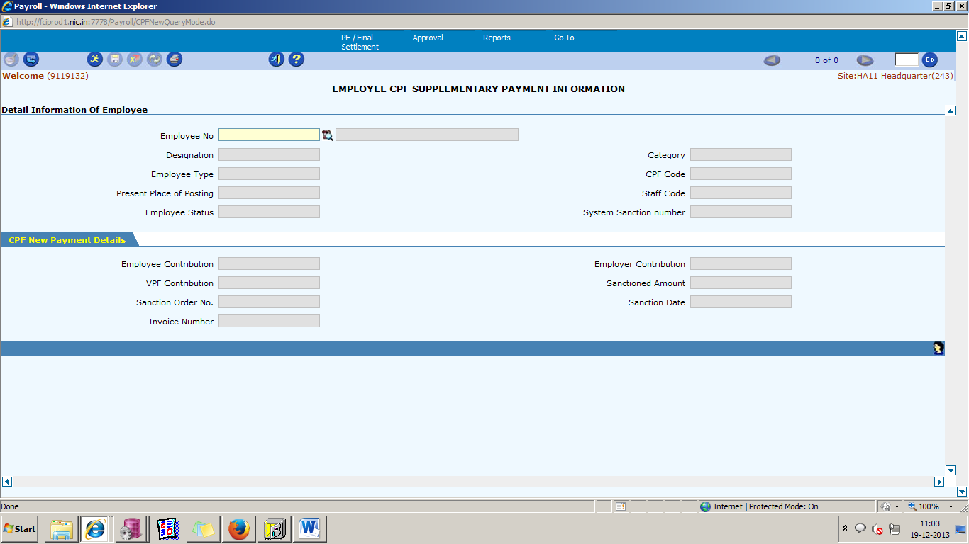

Task Name: CPF Supplementary Payment

Task Description:

The functionality is used to provide CPF final left out payment with CPF trust to whose employee to whom CPF final payment is already paid.
Prerequisites for performing the task:

Final payment is sanctioned to the employee.

Users who can perform the task:

Users from HR/EDP/Finance departments.

Task Procedure
            - In the main menu select PF/Final Settlement→ CPF Supplementary payment.
            - The CPF Supplementary payment screen appears in Query mode.
            - To view all the existing sanction final supplementary payment, click on the Execute icon. To view/ enter the details specific to an employee, select the employee from LOV and then click on the Execute icon.
            - To make fresh entry, click on insert mode, select employee from LOV and click execute button.

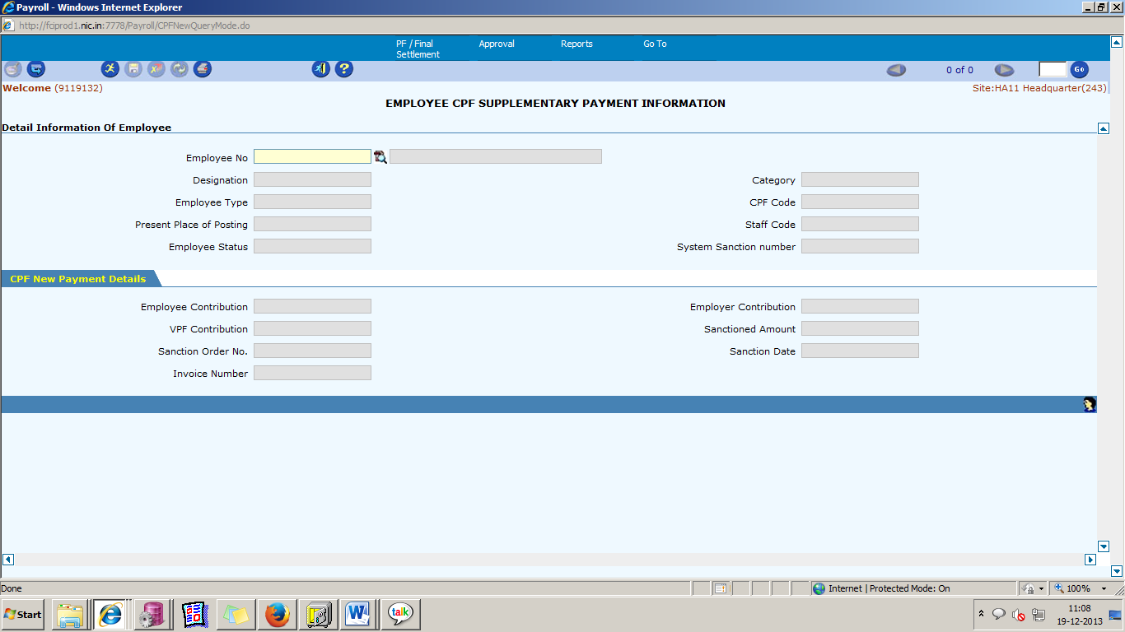

OBJECTIVE :
Functionality to be developed for any CPF final payment left because of below reason.
- Rate of interest get revised for past and employees who are paid within that period need to be paid remaining revised money.
- Others unknown reasons.

New screen will work as below.
- Screen will bring only those employees which are retired and final payment are already done in the system.
- Four additional enterable fields will be provided for entering Employee and Employer amount. Extra amount to be paid will be calculated by end user, and will enter final amount.
- The amounts will flow in APPS in same scheme type and account-code as paid at the time of final payment.
CPF paid through CPF final supplementary screen will be verified in CPF list of sanction, and PF adjustment report (as payment is made through adjustment).

82. Online I.T. Forecast Report
Task Name: Online Pay Slips Report
Task Description:

The IT Forecast Detail Report will be used to get projected tax details of all the employees at given location.
Report will be available for a particular employee for a particular month.

Prerequisites for performing the task:

None

Users who can perform the task:

Users from HR/EDP/Finance departments.

Task Procedure
- In the main menu select Reports → Online IT Forecast Report
- The Online IT Forecast Report screen appears in Query mode.
- To view the report, enter the Year Month, Employee No, Access Key and click on the Generate IT Forecast Report button. To view the report for a particular Employee, select the Employee No or CPF code from the LOV and then click on the button.
- To close the screen click on the Exit button.

Note:
Online IT Forecast Report of the separated employees will not be available after they are made inactive in the system.

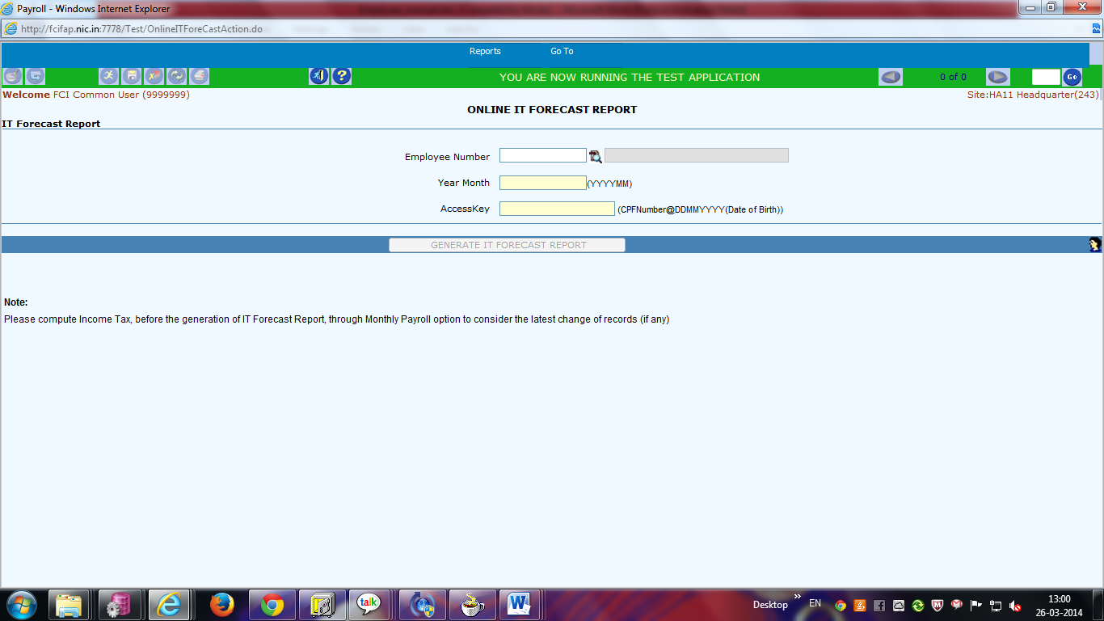

Field Description (Details)

Field Name | Field Type | Data Type | Description
Year Month | Mandatory | Numeric | Enter the Year Month for which the report needs to be generated
Employee Number | Mandatory | Numeric | Select the Employee Number from the LOV
Access Key | Mandatory | Password Type | Enter Password in to Access Key

83. Online Salary Control Register Report
Task Name: Salary Control Register Report
Task Description:

The Salary Control Register Report will be used to get details of salary details and invoice details of all employees at given location.
Report will be available for a particular employee, Location as well as for a particular period.

Prerequisites for performing the task:

None

Users who can perform the task:

Users from HR/EDP/Finance departments.

Task Procedure
- In the main menu select Reports → Online Salary Control Register Report
- The Online Salary Control Register Report screen appears in Query mode.
- To view the report, enter the Year Month, Employee No, Access Key and click on the Generate Salary Control Register Report button. To view the report for a particular Employee, select the Employee No or CPF code from the LOV and then click on the button.
- To close the screen click on the Exit button.

Note:
Online Salary Control Register Report of the separated employees will not be available after they are made inactive in the system.

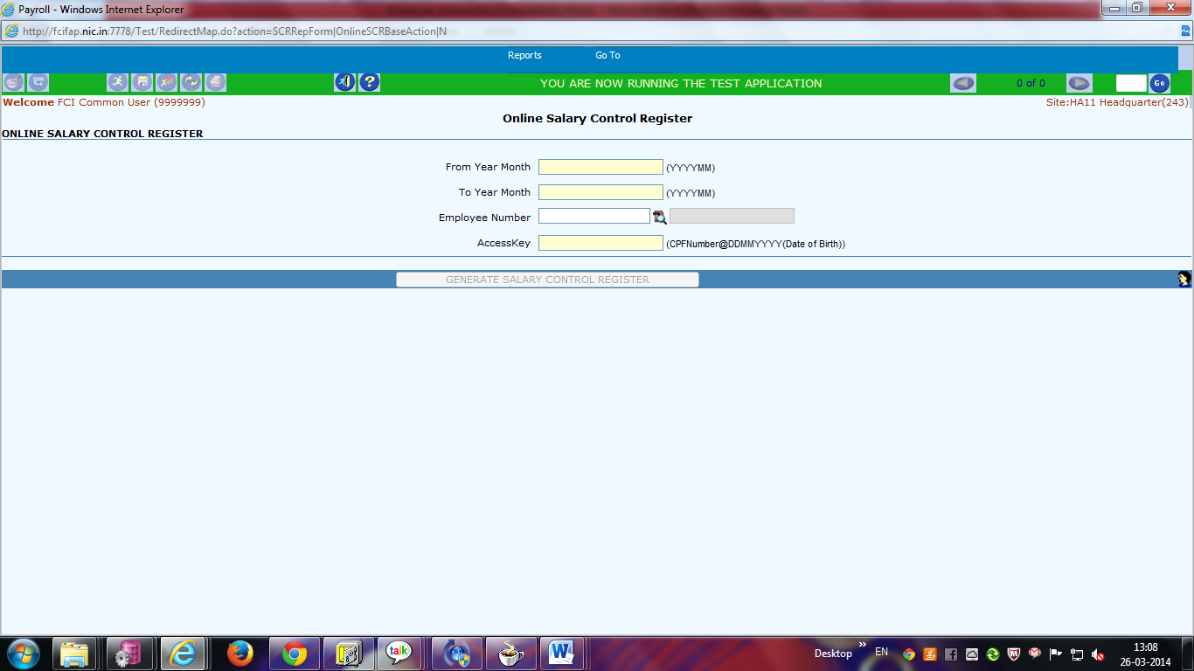

Field Description (Details)

Field Name | Field Type | Data Type | Description
From Year Month | Mandatory | Numeric | Enter the From Year Month for which the report is needed
To Year Month | Mandatory | Numeric | Enter the To Year Month for which the report is needed
Employee Number | Mandatory | Numeric | Select the Employee Number from the LOV
Access Key | Mandatory | Password Type | Enter Password in to Access Key

84. Calculate Labour Incentive

The system will give the same Incentive to each Individual in a gang irrespective to their designation. ( refer to CR- 347)

Now the formula becomes Incentive = (Incentive per individual – MGW of Handing labour).
Suppose a gang has done a work of total Incentive of Rs 1000 so the Incentive given to each labour are:

System Calculation after necessary changes
Designation | Incentive done per gang | MGW of Handling labour | Incentive Paid
Sardar | 1000 | 340 | 660
Mandal | 1000 | 340 | 660
Handling Labour | 1000 | 340 | 660

85. Labor Incentive Details (Departmental/DPS)

Task Name: Labour Incentive Details

Task Description:

The Labor Incentive Detail Report will be used to get the day wise incentive details of particular Employee/Employees/Gang or of all Gangs for particular month at particular location.
Report Details include Pay Type, Pay Date and Incentive.

Prerequisites for performing the task:

None

Users who can perform the task:

Users from HR/EDP/Finance departments.

Task Procedure
- In the main menu select Reports→Labour Incentive Details
- The Labour Incentive Details screen appears in Query mode.
- To view the Labour Incentive Details (Gang wise), select the Gang wise radio button, select Gang Name from LOV and enter Year Month (YYYYMM)& then click on the Generate Report button. To view the details of all Gangs, select the Gang wise radio button, and enter Year Month (YYYYMM) & then click on the Generate Report button. To view the Labor Incentive Details (Employee wise), select the Employee wise radio button, select Employee Name from LOV and enter Year Month (YYYYMM) & then click on the Generate Report button. To view the details of all Employees, select the Employee wise radio button, and enter Year Month (YYYYMM) & then click on the Generate Report button.
- Changes in ‘Incentive Details report ‘screen .Button to be provided to generate incentive details report for a gang day wise. After changes screen would be as follows..
- To close the screen click on the Exit button.

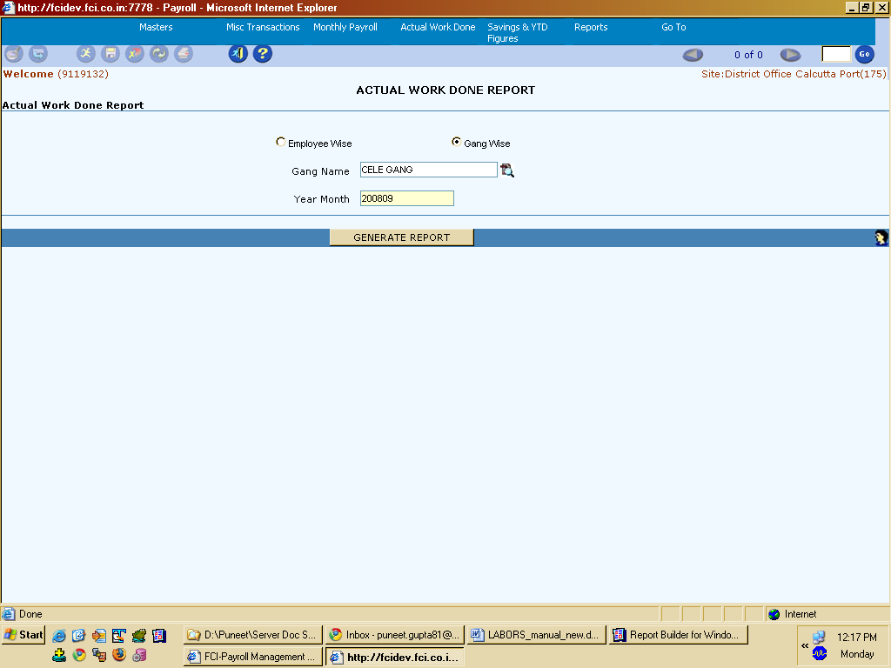

Note:- Changes in ‘Incentive Details report ‘screen .Button to be provided to generate incentive details report for a gang day wise. Screen would be as follows:-

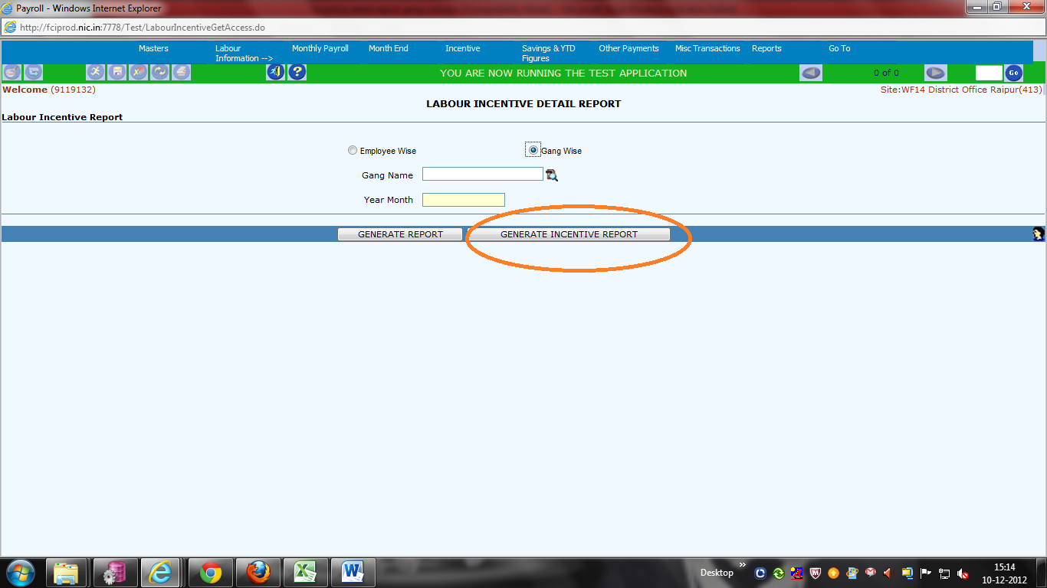

Field Description

Field Name | Field Type | Data Type | Description
Gang Name | Optional | Characters | Select Gang Name from LOV
Year Month | Mandatory | Numeric | Enter the Year Month (YYYYMM) for which the report is needed.

Changes Made in E-seva Report.

A new input parameter is introduced in CPF E-SEVA, This new parameter i. e “REPORT TYPE” will bifurcate CPF E-SEVA into 2 report.

Report Type: When entered 1 will fetch data without Adjustment and with report parameter 2 report will fetch data with adjustment.

86. IOCPF advice and sanction order reports to be generated in the system for CPF Advance, Part final and final payment.

Task Name: IOCPF advice and sanction order reports to be generated in the system
Task Description:

Reports for CPF Advance, Part final and final payment will be generated in the system if a valid sanction order number has been generated in the system. A button (Generate Report) will be provided at the respective sanction screens (Final, Part Final and advance). User will click on the button to generate the respective reports.

Prerequisites for performing the task:

None

Users who can perform the task:

Users from HR/EDP/Finance departments.

Task Procedure
- In the main menu select PF/Final Settlement→Sanction CPF ADVANCE/ Sanction CPF Part Final/Release CPF Final Payment for the respective report of Advance, Final and Part Final.
- The Employee CPF Advance Information/ EMPLOYEE CPF PART FINAL SANCTION / EMPLOYEE CPF FINAL PAYMENT INFORMATION screen appears in Query mode.
- To view the respective report, select the employee number then click on the Generate Report button.
- To close the screen click on the Exit button.

Reports for CPF Advance, Part final and final payment will be generated in the system if a valid sanction order number has been generated in the system. A button (Generate Report) will be provided at the respective sanction screens (Final, Part Final and advance). User will click on the button to generate the respective reports.
Two new reports will be created to show the sanction order and IOCPF advice for CPF advance, part final withdrawal and final payment.

Note:- Changes in ‘Employee CPF Advance Information ‘screen .Button to be provided to generate Report for CPF Advance. Screen would be as follows:-

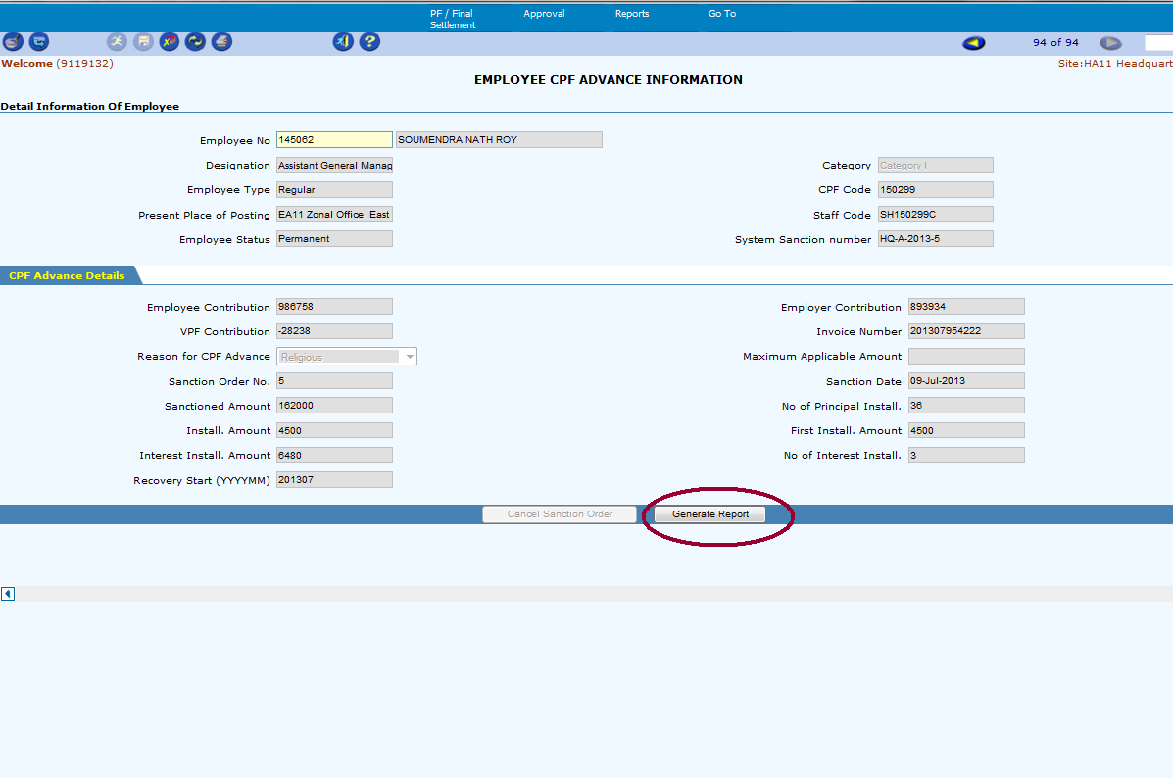

Changes in ‘EMPLOYEE CPF FINAL PAYMENT INFORMATION ‘screen .Button to be provided to generate Report for CPF Final Payment. Screen would be as follows:-

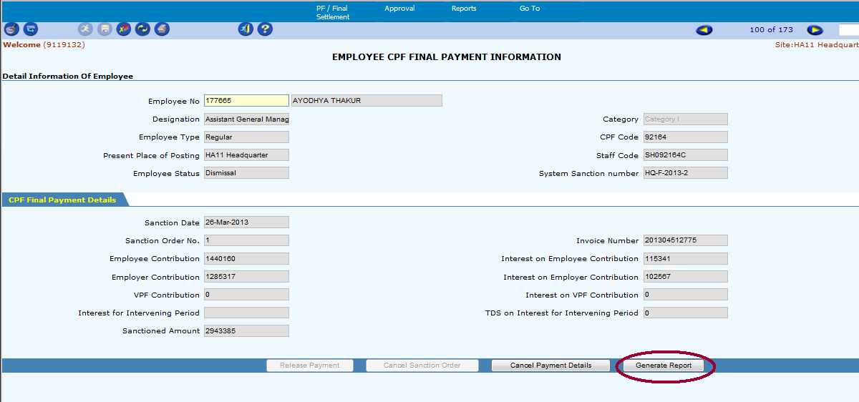

Changes in ‘Employee CPF PART FINAL SANCTION ‘screen .Button to be provided to generate Report for CPF Part Final. Screen would be as follows:-

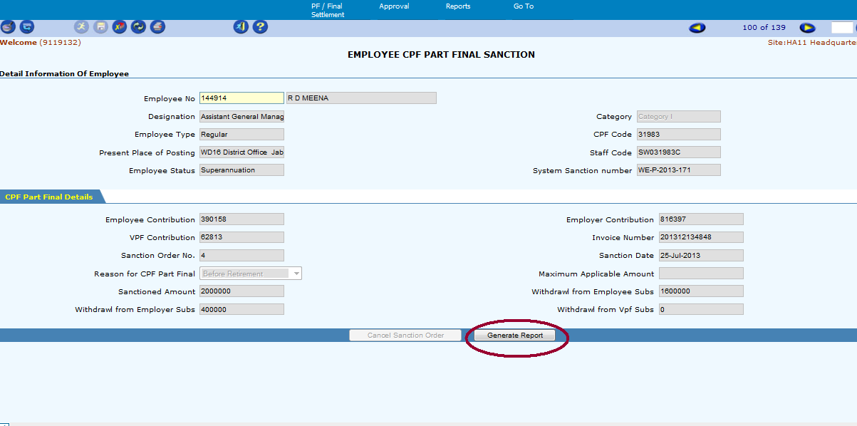

87. Deployments – 1st July 2014 to 31st July 2014

Revision of Wage Structure of Departmental Labour as per CR 383

1.Pay scale for departmental labour is revised.
2. D.A. rate for departmental labour is revised.
3. Transport Allowance Rate should be is revised from (Rs.424 per month + applicable D.A.) to (Rs. 525 p.m. + applicable D.A).
4.Washing allowance Rate is revised from 125 per month to 155. With increase of 25% when D.A. rate cost up by 50%.
5. Other allowances to remain same as being paid in the system currently.

88. Deployments – 1st February 2019 to 28th February 2019
CR- 27 : Opening of pay code of account of head 6136 and 1442

Following new pay codes are created mapped to corresponding account code

Pay Code | Pay Code Description | Taxable | Account Code
304 | LEASE_TAX_BOB_ADJUSTMENT | No | 6136
305 | REIMBURSEMENT ON LEASE PERQUISIVE TAX VALUE | No | 6136
306 | LEASE_TAX_CURR_MONTH_PART | Yes | 1442

Pay code 305 is open in Supplementary screen for Employees.

CR- 18: Creation of pay code of account of head 2727.

Following new pay codes are created mapped to corresponding account code

Pay Code | Pay Code Description | Taxable | Account Code
262 | Interim Relief (Adjustable in Wage Revision) | Yes | 2727

Pay code 262 is open in Supplementary and MDP screen for Employees.

CR-26: Provision of exemption on income tax for Schedule Tribes in NEF region as per section 10(26) of Income Tax Act

To incorporate the provision of exemption on income tax for Schedule Tribes in NEF region as per section 10(26) of Income Tax Act, a new pay code (608) ‘Exemption under section 197’ has been created.
This pay code is opened in ‘Maintain External Savings’ screen.
The user can enter employee wise total exemption amount applicable in a particular financial year in field ‘Amount’ and by selecting field ‘Type’ as ‘Actual’.

CR-77 Creation of reports for leave details.

New report created for employee leave details for the entire site and is+
-
deployed at FCI Payroll User Responsibility.

Report Parameters:

1. Site ID
2. Leave type
3. From Date and To Date

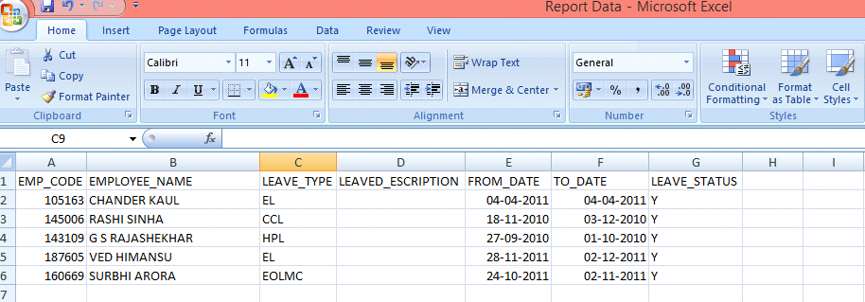

CR-107: Professional tax rate of Maharashtra region w.e.f 01.04.2015 as per Professional Tax Act 1975.

Following professional tax of Maharashtra region have be updated:

Do not exceed rupees 7,500 | Nil
In case of male, exceed Rs. 7,500 but do not exceed rupees 10,000 | 175 per month
In case of female, do not exceed rupees 10,000 | Nil
Exceeds rupees 10,000 | 2,500 per annum to be paid in the following manner :  - Rupees two hundred per month except for the month of February  - Rupees three hundred for the month of February

CR: 171 : Deduction of Professional Tax Under New Tax Regime

As per CR 171, the total income of the individual or Hindu undivided family for the purpose of tax calculation u/s 115BAC shall be computed without any exemption or deduction under the provisions of Section-16 of Income Tax Act.

The professional tax is covered under Section-16 of Income Tax Act and accordingly deduction of same is not allowed for tax calculation u/s 115BAC.

89. PLI Adjustment Screen.

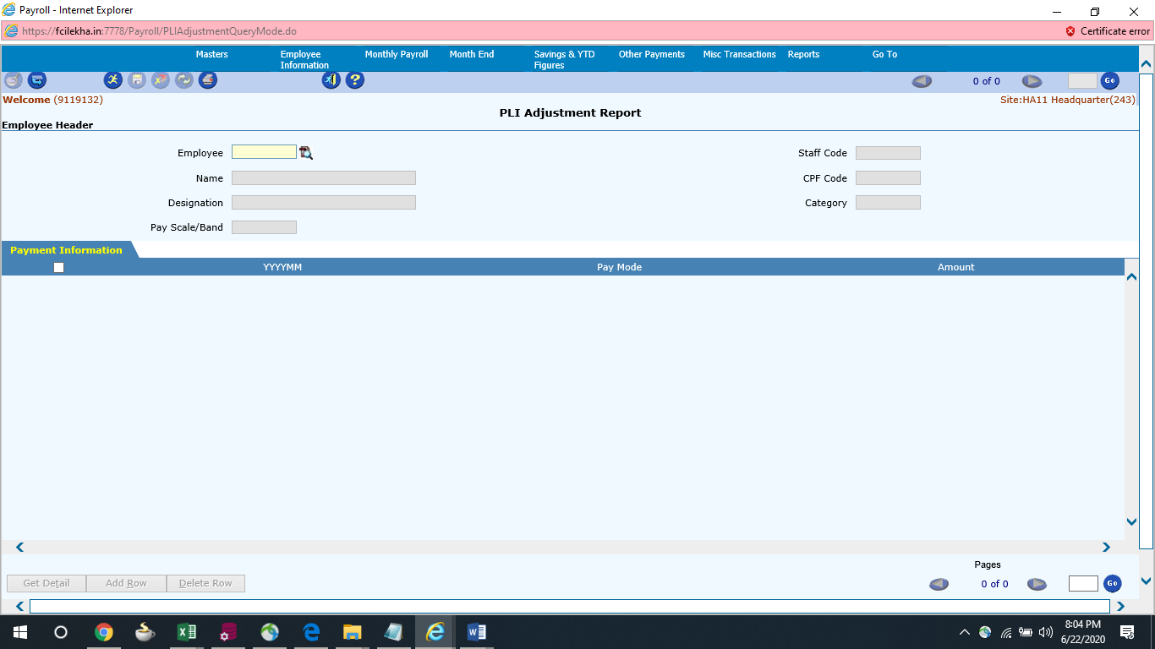

Note 1: the user makes payment directly through Apps, the same is not reflected in payroll schedule. So, when the user tallies the reports of payroll (PLI Advance) with that of apps, mismatch is reported and data fix is required.
Note 2 : PLI Adjustment Screen will provide you the data fix for mismatch in PLI Advance Report what are the changes we made here this is directly reflect in the report.

CR-130: Stop Interim Relief Payment as per circular no.16/2005 dated 09.11.2005.

Interim Relief Payment of following depot have be stopped:

SL No | Depot Name
1. | SC19001- FSD Chalakuda(2683)
2. | SC13002- FSD West Hill(2665)

CR-125: New Income Tax regime proposed by Govt of India in the union budget 2020

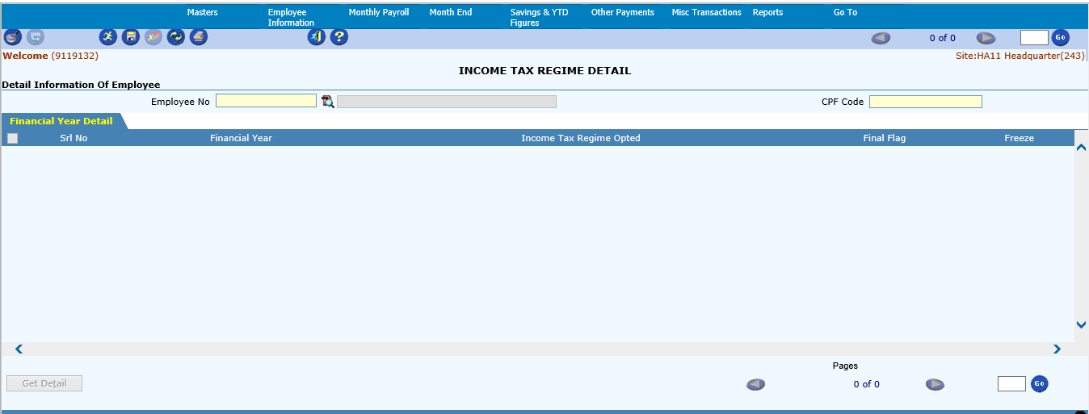

Task Name: Income Tax Regime opted for a F.Y. can be changed
Task Description:

A new screen ‘Income Tax Regime’ has been created to capture income tax regime opted by the employee in a particular Financial Year.
By default, previous F.Y. selection will be carry forwarded to current F.Y.
In case employee wants to opt for a different regime, the same can be updated via this screen.
The user can change the opted income tax regime only once in current F.Y.
No change in opted income tax regime of previous F.Y. will be allowed.
For all new joiners’, system will consider old income tax regime by default which can be updated via this screen.

Prerequisites for performing the task:

None

Users who can perform the task:

Users from HR/EDP/Finance departments.

Task Procedure
- In the main menu select Savings & YTD Figures → Income Tax Regime
- The Income Tax Regime screen appears in Query mode.
- To view and update the details, select the employee number then click on the Execute button and then on Get Detail button.
- Financial year-wise details of the employee will be displayed.
- The user can change the value of ‘Income tax regime opted’ using the dropdown only for current Financial Year (for which the Freeze Flag will be ‘N’)
- Once the income tax opted value has been changed, “Final Flag” value will be changed from ‘N’ to ‘Y’ indicating a change in opted tax regime in a F.Y and no further change is allowed in that particular F.Y.
- After selecting the tax regime, click on Save button.
- To close the screen click on the Exit button.

Based on the regime opted, below mentioned tax rates will be applicable.
Also, all the exemptions and deductions that were being used by taxpayers in the existing regime won’t be available in the new regime.
Slab(₹) | Old Tax Rates | New Tax Rates
0 – 2,50,000 | 0% | 0%
2,50,000 – 5,00,000 | 5% | 5%
5,00,000 – 7,50,000 | 20% | 10%
7,50,000 – 10,00,000 | 20% | 15%
10,00,000 – 12,50,000 | 30% | 20%
12,50,000 – 15,00,000 | 30% | 25%
15,00,000 & above | 30% | 30%

90. REPORT.

Report Name : FCI Payroll IT Regime Detail Report

Report Parameters :
Unit (Hierarchy based)
Employee Type
Financial Year

Report can be run from FCI Payroll User responsibility

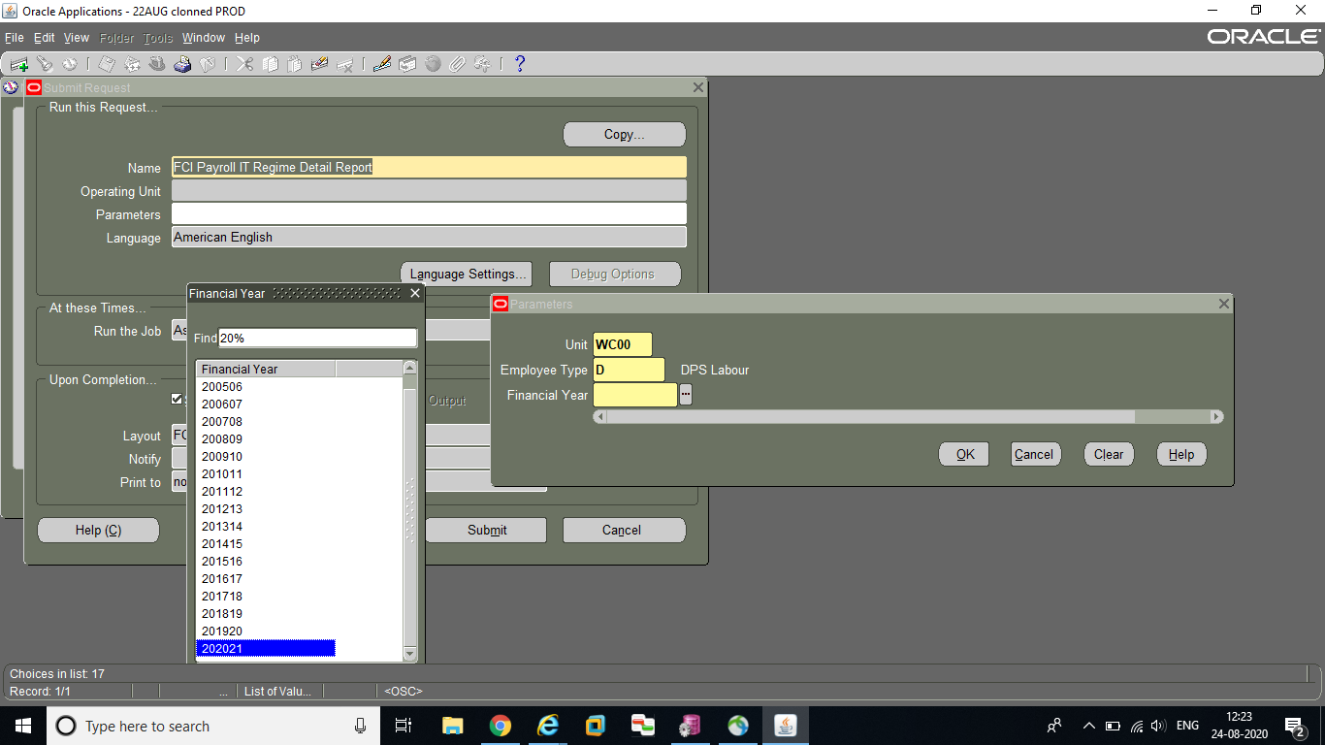

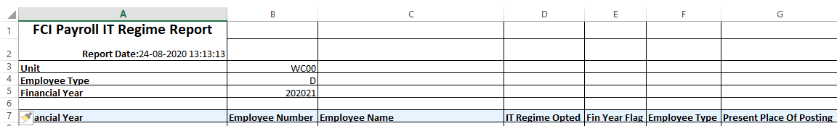

91. MODIFICATION IN ANNUAL INCREMENT.

CR-216: changes of increment date for employees who join on or after 01/01/2016

As per FCI, annual increment of employees of the corporation will be regulated as under

1) Employees who joined /will be joining on or after 01/Jan/2016

Annual Increment shall fall due on the first date of next month after completion of one year of service period in the corporation. For example, if an employee joins the corporation on 02/Jan/2016, his annual increment shall fall due on 01/Feb/2017.

2) Employees who joined the corporation before 01/Jan/2016

Annual Increment shall be applicable from first January of every year.

BASIC HISTORY EVENT SCREEN

Task Name: Basic History Event Screen
Task Description:

A new screen ‘Basic History Event Screen’ has been created to modify the basic history of employees after the 3rd PRC fixation date

Prerequisites for performing the task:

None

Users who can perform the task:

Screen is available at Headquarter Level Only.

Task Procedure
- In the main menu select Employee Information → Basic History Event Screen
- The Basic History Event Screen appears in Query mode only.
- To view and update the details, select the employee number then click on the Execute button and then on Get Detail button.
- Event wise details will be displayed.
- The user can select the flag as “No” for which event is not required and user can update the required basic for the event type ”Promotion Reversal” only .
- After the above changes, click on Save button
- Once the data has been saved, “Freezed Flag” value will be changed from ‘Not Freezed’ to ‘Freezed’ indicating a change in basic history details and no further change is allowed in that particular F.Y.
- To close the screen click on the Exit button.

92. reports Moved from Discoverer to Oracle Apps.

92. The following reports Moved from Discoverer to Oracle Apps with FCI Payroll User Responsibility.
1. 24 Q
2. CPF Control Register
3. CPF E Sewa
4. CPF- List of Sanctions
5. CPF Master opening closing balance
6. Earn_ dedn
7. HRMS SUMMARY REPORT
8. Payroll Employee Master Query Report
9. Payroll Processing Status Report All

93. ADDITIONAL FIELD IN FAP MAINTAIN EMPLOYEE DETAIL.

93. Additional field in FAP Maintain Employee detail (screen) as Member ID.

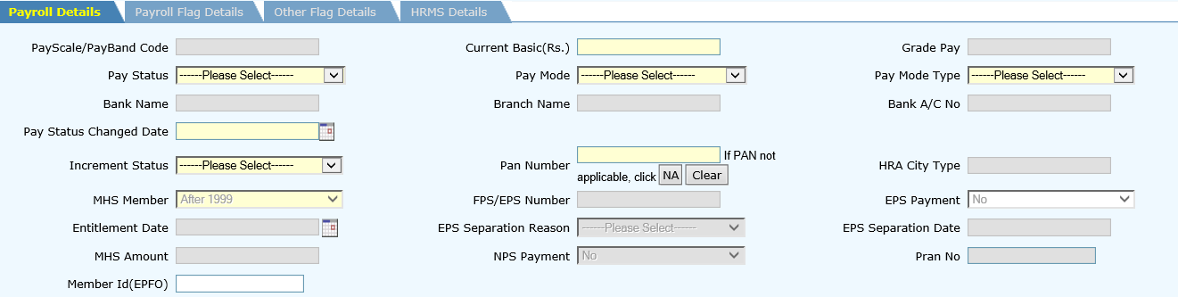

Task Procedure
- In the main menu select Employee Information → Maintain Employee Details
.
- To view and update the Member ID, select the employee number then click on the Execute button.
- Employee Details will be displayed.
- User needs to feed Member Id manually using Employee Information screen.
- After the above changes, click on Save button
- Once the data has been saved, Member ID will be saved in the system.
- To close the screen click on the Exit button.

94. TO GENERATE REPORT FOR NPS.

The existing Pension report for DCPS may be generated on the parameter as below:-
1. For DCPS
2. For NPS
3. For all

Report will be generated in apps with FCI payroll User Responsibility

95. MODIFICATION IN FCI PENSION DETAIL REPORT.

The existing Pension report for DCPS is Modified in a way that report for those employees who opted for DCPS before NPS functionality may reflect if report is generated for previous period as per requirement of DCPS Division.

Report will be generated in apps with FCI payroll User Responsibility.

96. FIELD IN FAP MAINTAIN EMPLOYEE DETAIL (SCREEN) AS NPS PAYMENT,PRAN NO..

Task Procedure
- In the main menu select Employee Information → Maintain Employee Details
.
- To view and update the NPS Flag, PRAN No, select the employee number then click on the Execute button.
- Employee Details will be displayed.
- User needs to feed NPS Flag, PRAN No manually using Employee Information screen.
- After the above changes, click on Save button
- Once the data has been saved, NPS Flag, PRAN No will be saved in the system.
- To close the screen, click on the Exit button.

97. TO INSERT PRAN AND MEMBER ID COLUMN IN EMPLOYEE MASTER QUERY REPORT..

following column included in Employee Master Query Report as below:
1. PRAN
2. Member ID

98. AMENDMENTS IN INCOME TAX ACT MADE VIDE FINANCE ACT, 2023..

With reference to Circular No. 02/2023 dated 27.04.2023 regarding amendments in Income tax Act made vide Finance Act, 2023 and clarification received from Finance Division, Hqrs vide email dated 03.05.2023 (copy attached), some amendments have been made through Finance Act, 2023 in various taxes in respect of Financial Year 2023-24 (Assessment Year 2024-25) which have to be updated in Payroll module as below:
01. for Section 87A and 115BAC, Income tax slabs to updated as per circular
02. New tax regime is the default tax regime applicable to all.
03. Standard deduction of Rs. 50000 or amount of salary whichever is less is allowed by clause (ia) of Section 16 is applicable under New Tax Regime.

99.HRMS PAYROLL INTEGRATION

Following Functionalities have been integrated in order to get and process requests from HRMS

New Screen Are Developed in Employee Module

1.Mobile Reimbursement

Navigation: Employee Payroll =>Allowance and Reimbursement=>Mobile Reimbursement
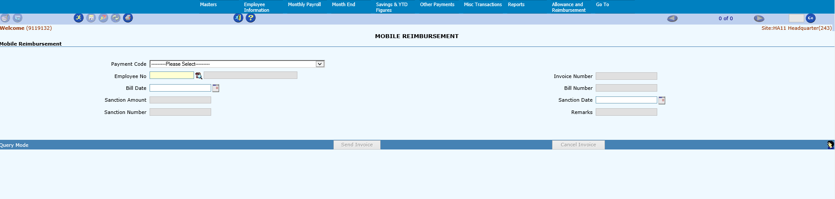

2.Laptop Reimbursement

Navigation: Employee Payroll =>Allowance and Reimbursement=>laptop Reimbursement
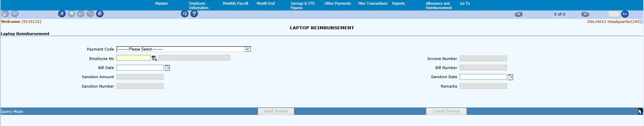
3.Telephone/Data Communication Reimbursement

Navigation: Employee Payroll =>Allowance and Reimbursement=>Telephone/data communication Reimbursement
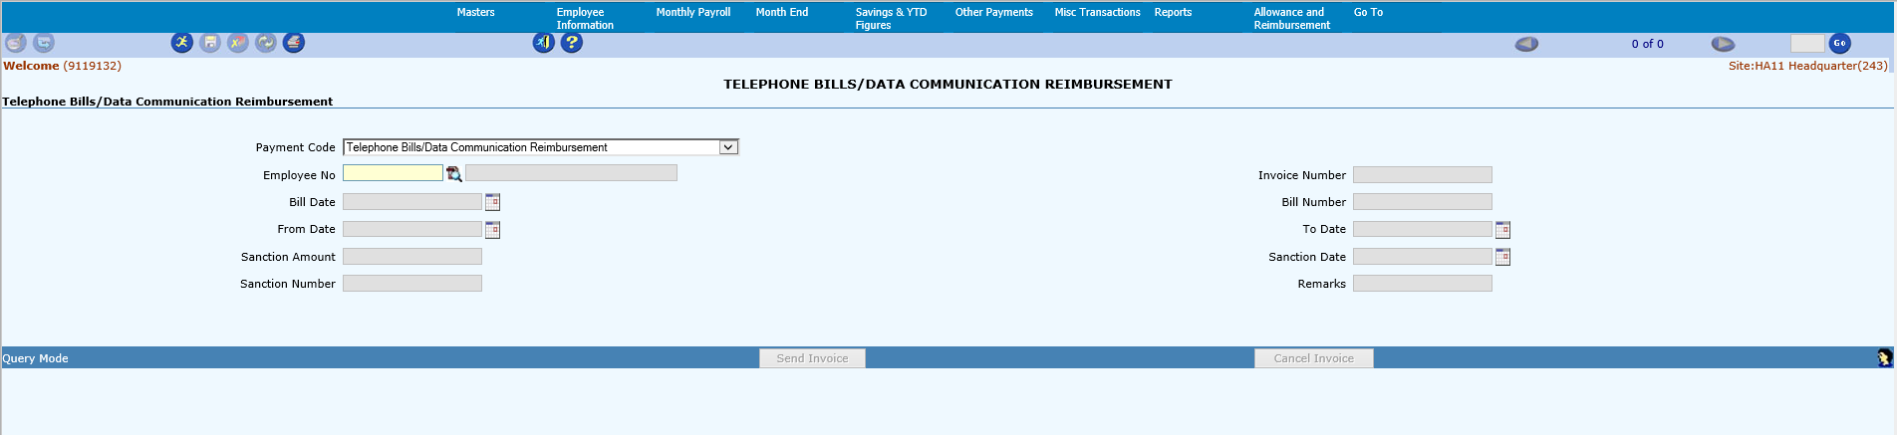
4.Briefcase Reimbursement

Navigation: Employee Payroll =>Allowance and Reimbursement=>Briefcase Reimbursement
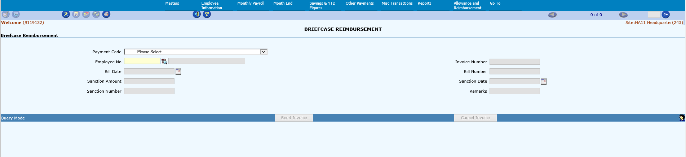

5.Laptop AMC

Navigation: Employee Payroll =>Allowance and Reimbursement=>Laptop AMC
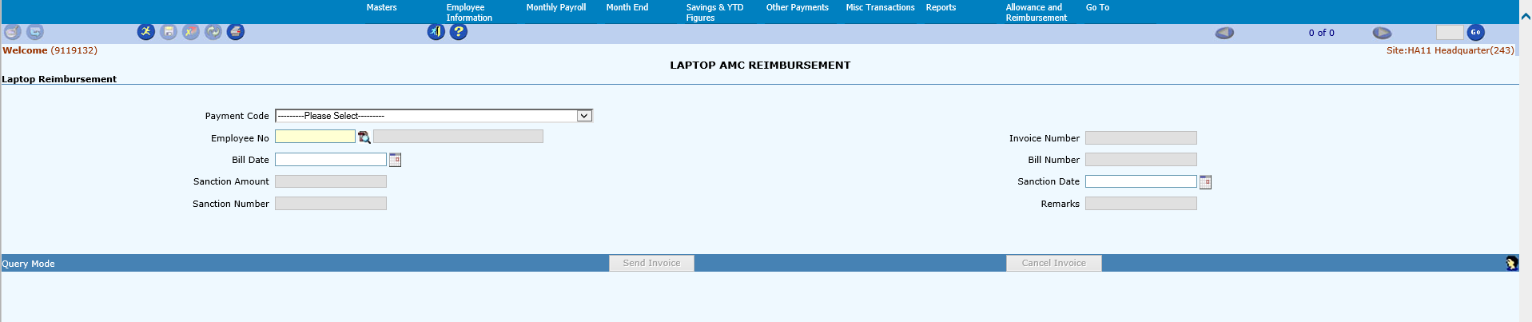
6.LTC Hometown Advance

Navigation: Employee Payroll =>Allowance and Reimbursement=>LTC Hometown
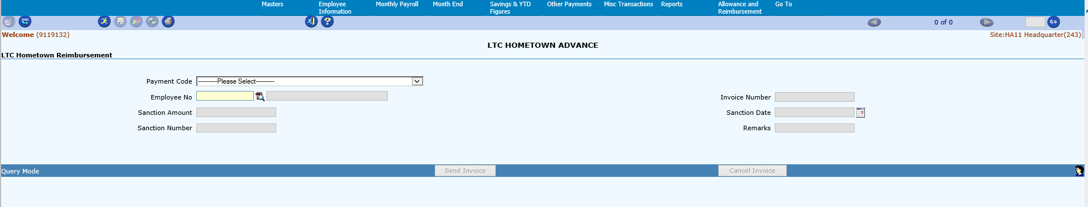

7.Local Travel Allowance

Navigation: Employee Payroll =>Allowance and Reimbursement=>Local Travel Allowance
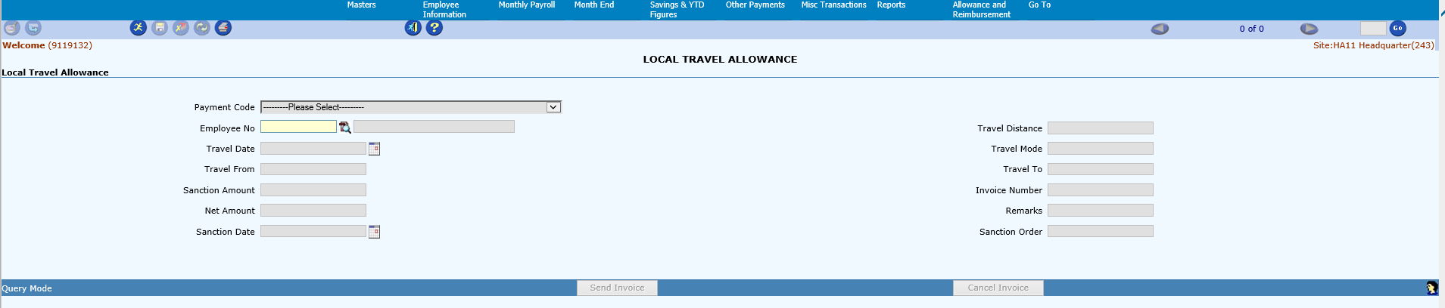

8.Newspaper Allowance

Navigation: Employee Payroll =>Allowance and Reimbursement=>Newspaper Allowance
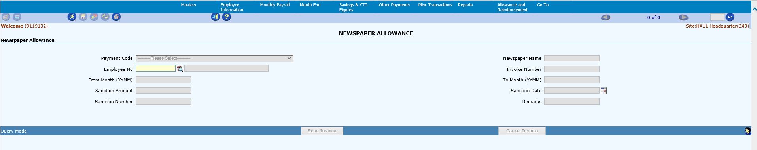

Note: For these functionalities, HRMS users will submit the requests in HRMS, and it will get
flow to FAP-Payroll application through implemented APIs.
In Payroll application, users can check the requests and send the invoice incase
required.
Currently, all the invoices will flow directly in Oracle Apps payable module.

Following are the existing Functionalities which are integrated with HRMS

1. LTC Encashment

2.Loan and Advance

Note: For these functionalities, HRMS users will submit the requests in HRMS, and it will get
flow to FAP-Payroll application through implemented APIs.
In Payroll application, users can check the requests and Feed Required Information
and send the invoice.

Invoices will not be flowed Automatically for these Functionalities.

Along with above Functionalities Cancellation and status are also Implemented in the system.

